**HACKATHON QUERIES (1-80)**

1. **Write a query to get a list of patients with event type of EGV and glucose (mgdl) greater than 155 .**

**QUERY:**

| ***-- Select distinct patient IDs, first names, and last names***  **SELECT DISTINCT**  **d.patientid,**  **d.firstname,**  **d.lastname**  **FROM**  **demographics AS d**  **JOIN**  **dexcom AS dx**  **ON**  **d.patientid = dx.patientid**  **JOIN**  **eventtype AS et**  **ON**  **dx.eventid = et.id**  **WHERE**  **et.event_type = 'EGV' *-- Filter for 'EGV' events***  **AND dx.glucose_value_mgdl > 155 *-- Filter for glucose > 155***  **ORDER BY**  **patientid; *-- Order results by patient ID*** |
| --- |

**OUTPUT:**

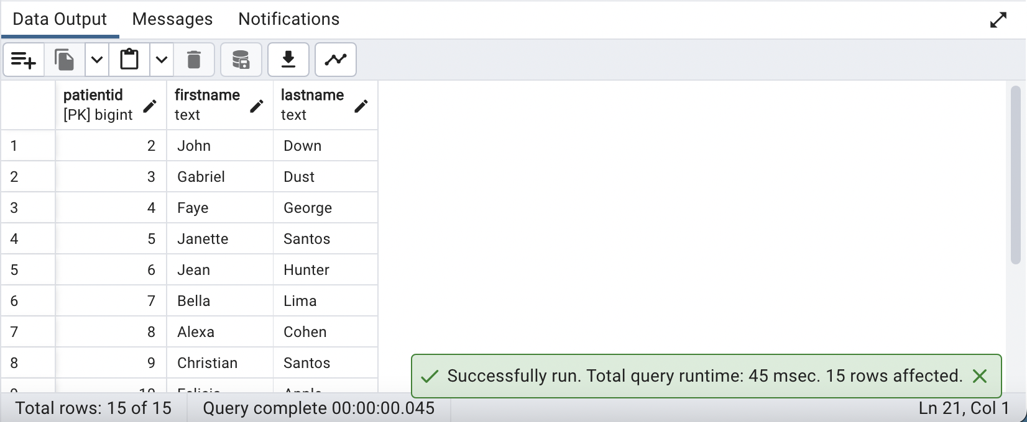

1. **How many patients consumed meals with at least 20 grams of protein in it?**

**QUERY:**

| ***-- Create an index named 'idx_tmp' on the 'foodlog' table to potentially optimize queries***  ***-- involving the 'protein' and 'patientid' columns.***  **CREATE INDEX idx_tmp**  **ON foodlog(protein, patientid);**  ***-- Calculate the count of distinct patient IDs (num_patients) from the 'foodlog' table***  ***-- where the 'protein' value is greater than or equal to 20.***  **SELECT COUNT(DISTINCT f.patientid) AS num_patients**  **FROM foodlog AS f**  **WHERE f.protein >= 20;** |
| --- |

**OUTPUT:**

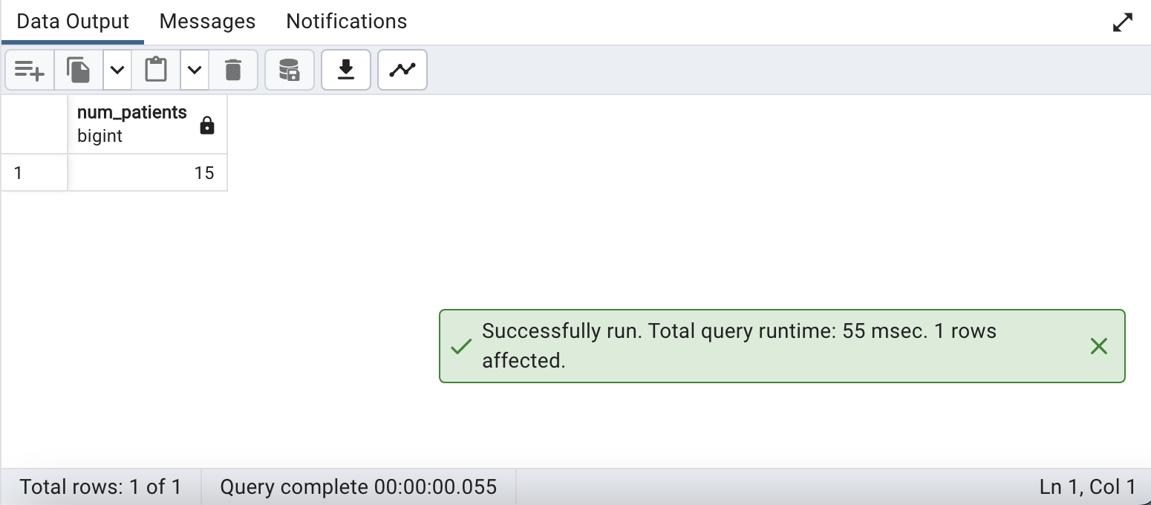

1. **Who consumed maximum calories during dinner? (assuming the dinner time is 6pm-8pm)**

**QUERY:**

| **SELECT**  **patientid,**  **MAX(calorie) AS max_calorie**  **FROM**  **foodlog**  **WHERE**  **EXTRACT(HOUR FROM datetime) BETWEEN 18 AND 20 *-- Filter for evening hours***  **GROUP BY**  **patientid**  **ORDER BY**  **max_calorie DESC *-- Sort by maximum calorie intake in descending order***  **LIMIT 1; *-- Retrieve the top patient*** |
| --- |

**OUTPUT:**

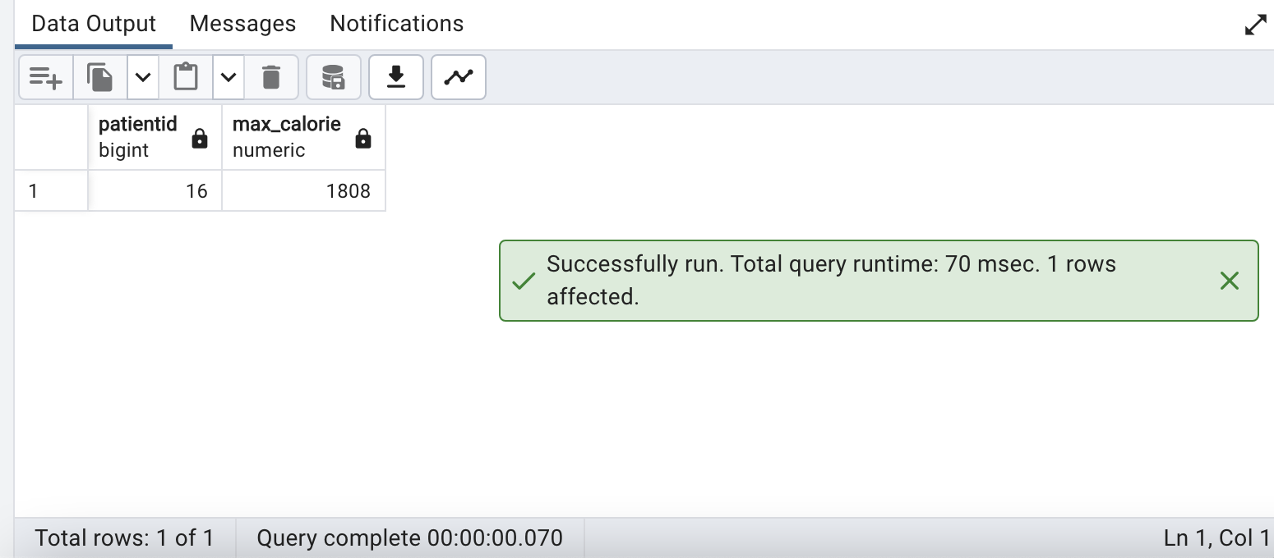

1. **Which patient showed a high level of stress on most days recorded for him/her?**

**QUERY:**

| **SELECT**  **e.patientid,**  **COUNT(*) AS high_stress_days**  **FROM**  **eda AS e**  **JOIN**  **hr AS h**  **ON**  **e.patientid = h.patientid**  **WHERE**  **e.mean_eda > 40 *-- Filter for EDA > 40 (high stress)***  **OR h.mean_hr > 100 *-- Filter for HR > 100 (high stress)***  **GROUP BY**  **e.patientid**  **ORDER BY**  **high_stress_days DESC *-- Order by the count of high-stress days in descending order***  **LIMIT 1; *-- Retrieve the patient with the highest count of high-stress days*** |
| --- |

**OUTPUT:**

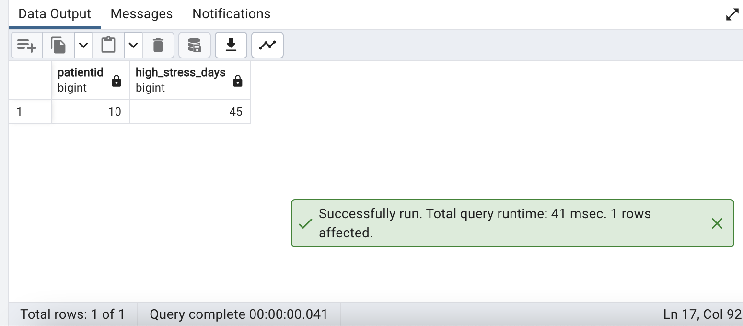

**Output : No values are returned as there is no patient considering EDA>40 and mean HR >100.**

1. **Based on mean HR and HRV alone, which patient would be considered least healthy?**

**QUERY:**

| ***-- Calculate Heart Rate Variability (HRV) and Mean Heart Rate for each patient***  **WITH PatientHealth AS (**  **SELECT**  **ibi.patientid,**  **ROUND(((SUM(ibi.rmssd_ms)::numeric / COUNT(ibi.rmssd_ms)) * 600)::numeric, 2) AS hrv,**  **ROUND(AVG(hr.mean_hr)::numeric, 2) AS mean_hr**  **FROM**  **ibi**  **JOIN**  **hr ON ibi.patientid = hr.patientid**  **GROUP BY**  **ibi.patientid**  **)**  ***-- Find patients with abnormal HRV or Mean Heart Rate***  **SELECT**  **patientid,**  **hrv, *-- Heart Rate Variability (HRV)***  **mean_hr**  **FROM**  **PatientHealth**  **WHERE**  **hrv < 20 OR hrv > 200 *-- Filter for abnormal HRV values***  **OR mean_hr < 60 OR mean_hr > 100 *-- Filter for abnormal Mean Heart Rate values***  **ORDER BY**  **hrv ASC, mean_hr ASC *-- Order by HRV and Mean Heart Rate in ascending order***  **LIMIT 1; *-- Retrieve the patient with the most significant abnormalities*** |
| --- |

**OUTPUT:**

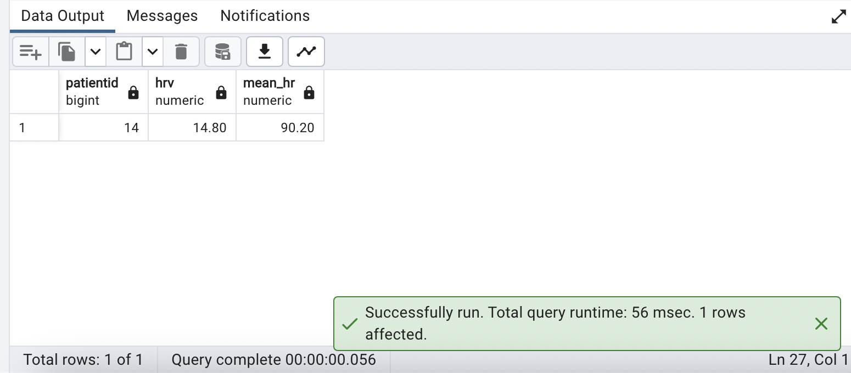

1. **Create a table that stores any Patient Demographics of your choice as the parent table. Create a child table that contains max_EDA and mean_HR per patient and inherits all columns from the parent table**

**QUERY:**

| **CREATE TABLE Patient_Demographics (**  **gender VARCHAR(10),**  **firstname VARCHAR(100),**  **lastname VARCHAR(100),**  **patientid INT PRIMARY KEY,**  **dob DATE,**  **hba1c FLOAT**  **);**  ***-- Create a table for patient statistics, inheriting the structure from Patient_Demographics and including maximum EDA (max_EDA) and mean heart rate (mean_HR).***  **CREATE TABLE Patient_Statistics (**  **max_EDA FLOAT,**  **mean_HR FLOAT**  **) INHERITS (Patient_Demographics);**  ***-- Retrieve all records from the Patient_Statistics table.***  **SELECT * FROM Patient_Statistics;**  ***-- Drop the Patient_Statistics table.***  ***--DROP TABLE IF EXISTS Patient_Statistics;***  ***-- Drop the Patient_Demographics table.***  ***--DROP TABLE IF EXISTS Patient_Demographics;*** |
| --- |

**OUTPUT:**

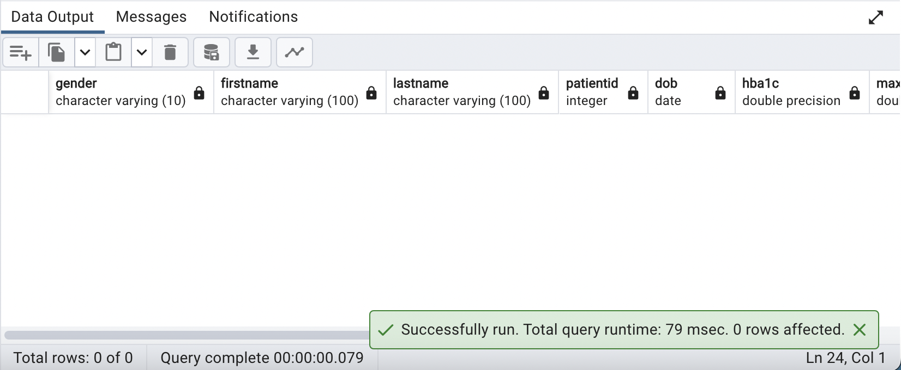

1. **What percentage of the dataset is male vs what percentage is female?**

**QUERY:**

| ***-- Calculate gender distribution***  **SELECT**  **gender, *-- Gender category***  **ROUND((COUNT(*)::DECIMAL / (SELECT COUNT(*) FROM demographics WHERE gender IS NOT NULL)) * 100, 2) AS percentage *-- Calculate the percentage of each gender category***  **FROM demographics**  **WHERE gender IS NOT NULL *-- Exclude NULL gender entries***  **GROUP BY gender; *-- Group by gender for distribution analysis*** |
| --- |

**OUTPUT:**

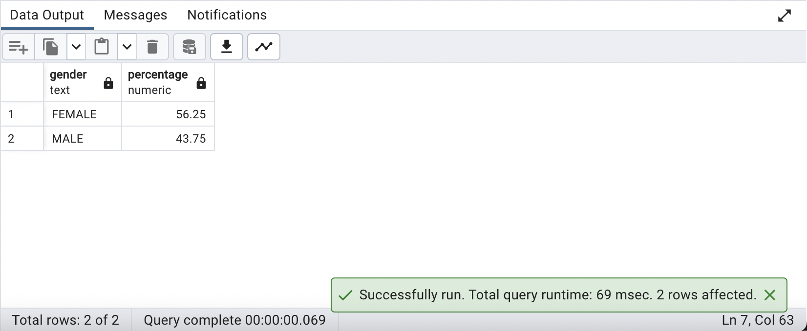

1. **Which patient has the highest max eda?**

**QUERY:**

| ***-- Retrieve the patient with the highest maximum Electrodermal Activity (EDA).***  **SELECT**  **d.firstname,**  **d.lastname,**  **d.patientid,**  **e.max_eda**  **FROM**  **demographics AS d**  **INNER JOIN**  **eda AS e**  **ON d.patientid = e.patientid**  **ORDER BY**  **e.max_eda DESC**  **LIMIT 1;** |
| --- |

**OUTPUT:**

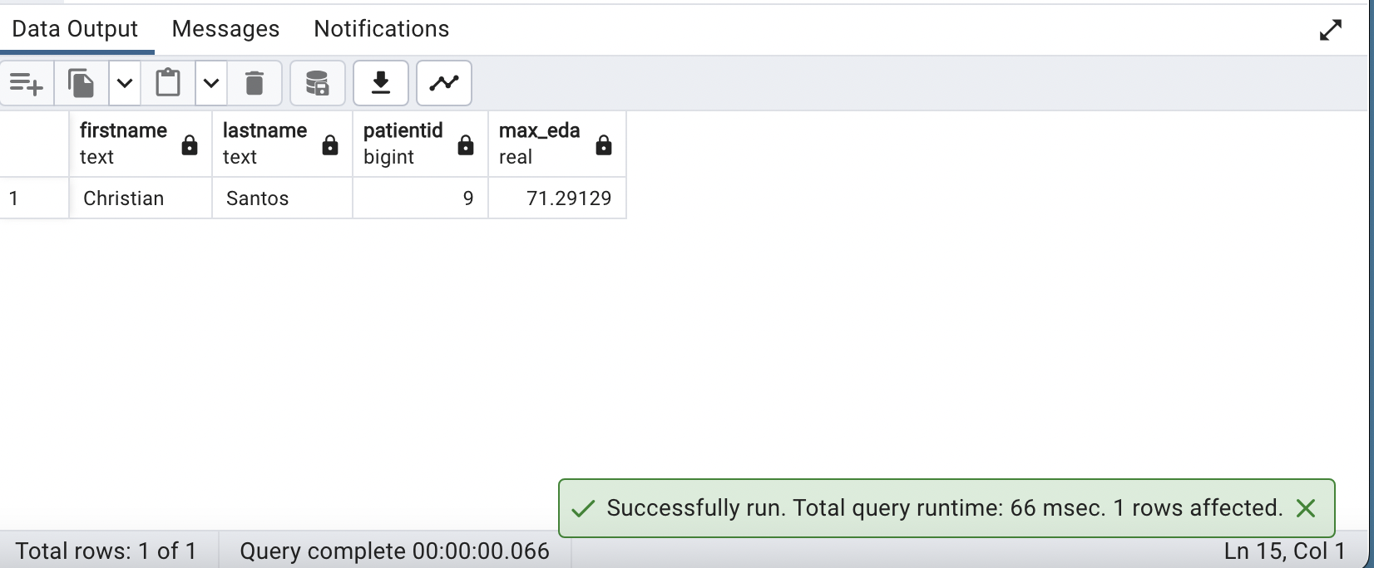

1. **Display details of the prediabetic patients.**

**QUERY:**

| ***-- Retrieve patient demographics for individuals with HbA1c levels between 5.7 and 6.4.***  **SELECT \***  **FROM demographics**  **WHERE hba1c >= 5.7 AND hba1c <= 6.4;** |
| --- |

**OUTPUT:**

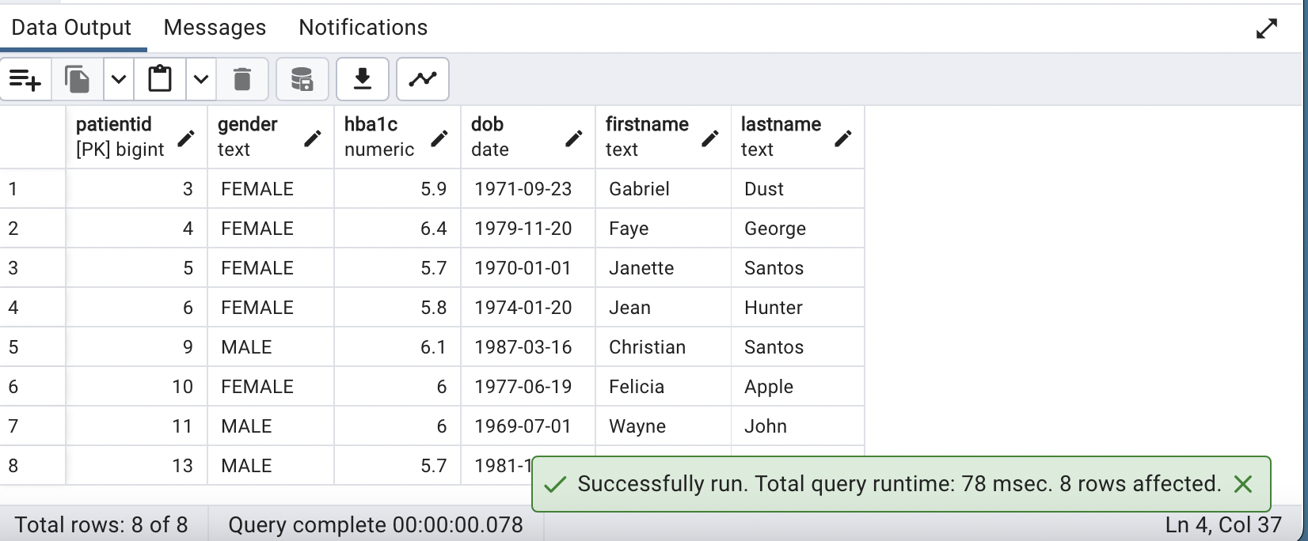

1. **List the patients that fall into the highest EDA category by name, gender and age**

**QUERY:**

| ***-- Retrieve patient demographics, age, gender, and maximum Electrodermal Activity (EDA)***  ***-- for individuals whose average maximum EDA is equal to or greater than 10.***  **SELECT**  **d.firstname,**  **d.lastname,**  **d.gender,**  **EXTRACT(YEAR FROM AGE(current_date, d.dob)) AS age,**  **mec.max_eda**  **FROM**  **demographics AS d**  **JOIN (**  **SELECT**  **e.patientid,**  **MAX(e.max_eda) AS max_eda**  **FROM**  **eda AS e**  **GROUP BY**  **e.patientid**  **HAVING**  **AVG(e.max_eda) >= 10 *-- Adjust this threshold if necessary***  **) AS mec**  **ON**  **d.patientid = mec.patientid**  **ORDER BY**  **mec.max_eda DESC;** |
| --- |

**OUTPUT:**

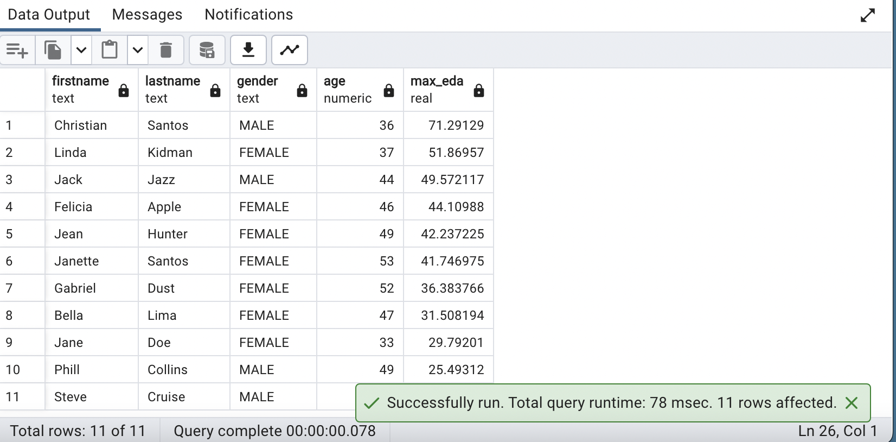

**Output: Here threshold is set to 10**

1. **How many patients have names starting with 'A'?**

**QUERY:**

| ***-- Count patients with first names starting with 'A' and group by first name.***  **SELECT COUNT(*) AS total_patients, firstname**  **FROM demographics**  **WHERE firstname LIKE 'A%'**  **GROUP BY firstname;** |
| --- |

**OUTPUT:**

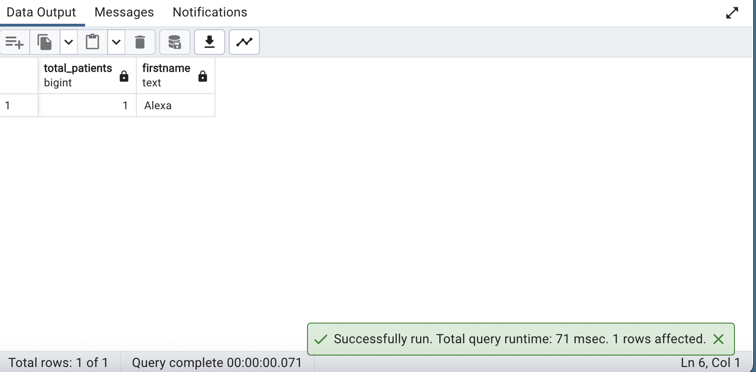

1. **Show the distribution of patients across age.**

**QUERY:**

| ***-- Count patients in different age groups and categorize them accordingly.***  **SELECT**  **CASE**  **WHEN age BETWEEN 0 AND 19 THEN '0-19'**  **WHEN age BETWEEN 20 AND 39 THEN '20-39'**  **WHEN age BETWEEN 40 AND 59 THEN '40-59'**  **WHEN age BETWEEN 60 AND 79 THEN '60-79'**  **ELSE '80+'**  **END AS age_group,**  **COUNT(*) AS patient_count**  **FROM (**  **SELECT**  **EXTRACT(YEAR FROM AGE(current_date, dob)) AS age**  **FROM demographics**  **WHERE dob IS NOT NULL *-- Exclude rows with NULL date of birth (dob)***  **) AS age_data**  **GROUP BY age_group**  **ORDER BY age_group;** |
| --- |

**OUTPUT:**

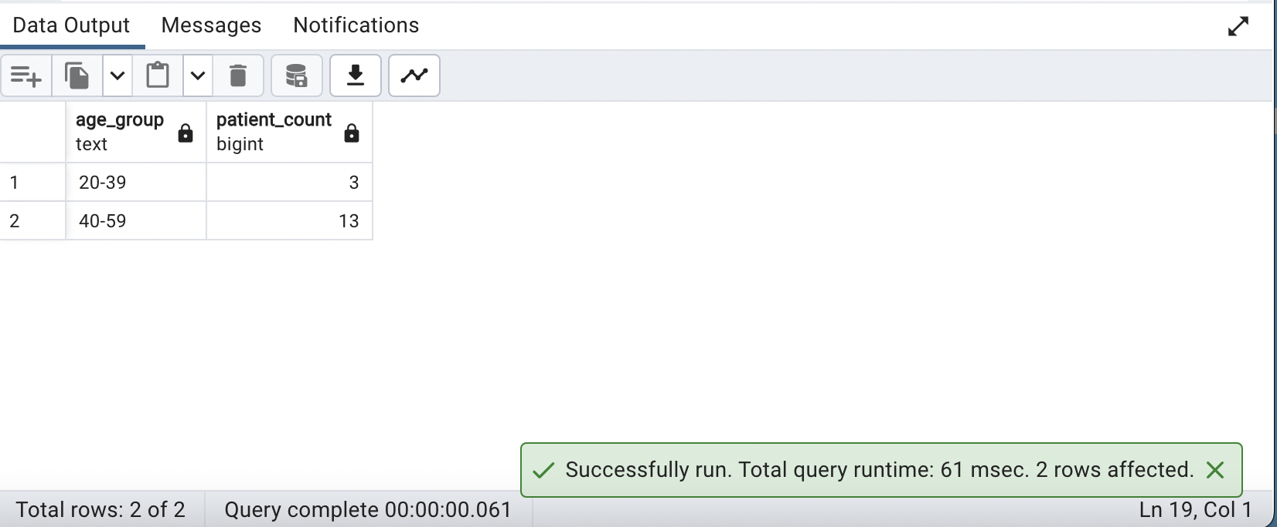

1. **Display the Date and Time in 2 separate columns for the patient who consumed only Egg**

**QUERY:**

| ***-- Retrieve the date and time of food entries for 'Egg' consumption.***  **SELECT patientid, datetime::DATE as Date, datetime::TIME as Time**  **FROM foodlog**  **WHERE logged_food = 'Egg';** |
| --- |

**OUTPUT:**

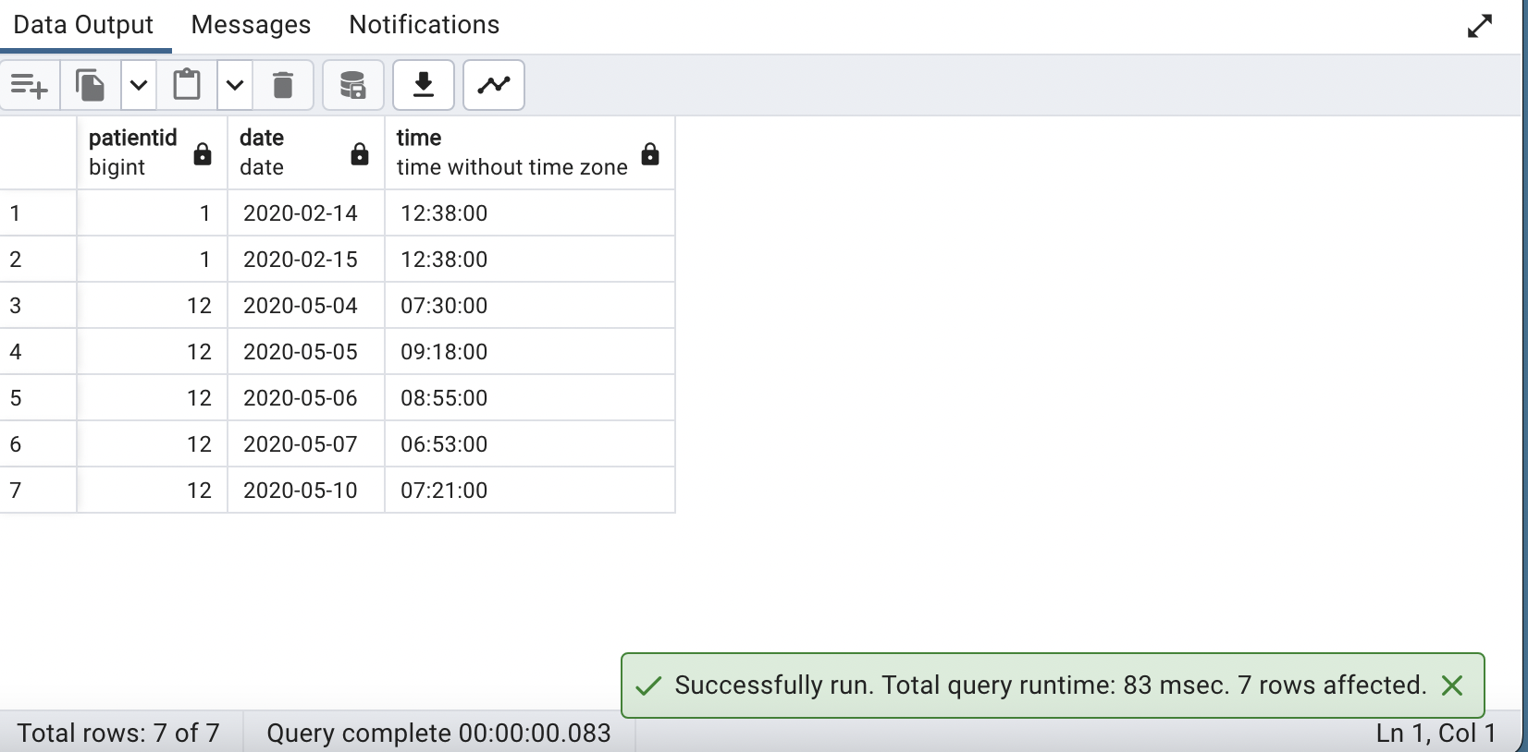

1. **Display list of patients along with the gender and hba1c for whom the glucose value is null.**

**QUERY:**

| ***-- Identify patients with missing glucose data.***  **SELECT DISTINCT d.patientid, d.gender, d.hba1c**  **FROM demographics d**  **JOIN dexcom dx ON dx.patientid = d.patientid**  **WHERE dx.glucose_value_mgdl IS NULL;** |
| --- |

**OUTPUT:**

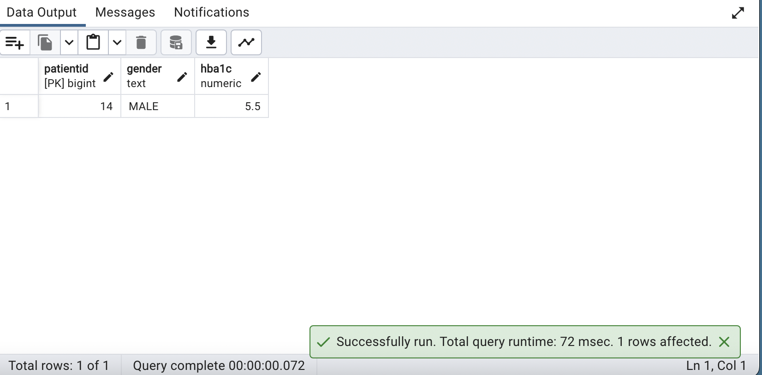

1. **Rank patients in descending order of Max blood glucose value per day**

**QUERY:**

| ***-- Rank patients based on their maximum glucose levels recorded per day.***  **WITH max_glucose_per_day AS (**  **SELECT**  **patientid,**  **datestamp,**  **MAX(glucose_value_mgdl) AS max_glucose**  **FROM dexcom**  **WHERE glucose_value_mgdl IS NOT NULL**  **GROUP BY patientid, datestamp**  **)**  **SELECT**  **patientid,**  **MAX(datestamp) AS datestamp,**  **MAX(max_glucose) AS max_glucose,**  **RANK() OVER (ORDER BY MAX(max_glucose) DESC) AS glucose_rank**  **FROM max_glucose_per_day**  **GROUP BY patientid**  **ORDER BY max_glucose DESC; *-- Sort max_glucose in descending order*** |
| --- |

**OUTPUT:**

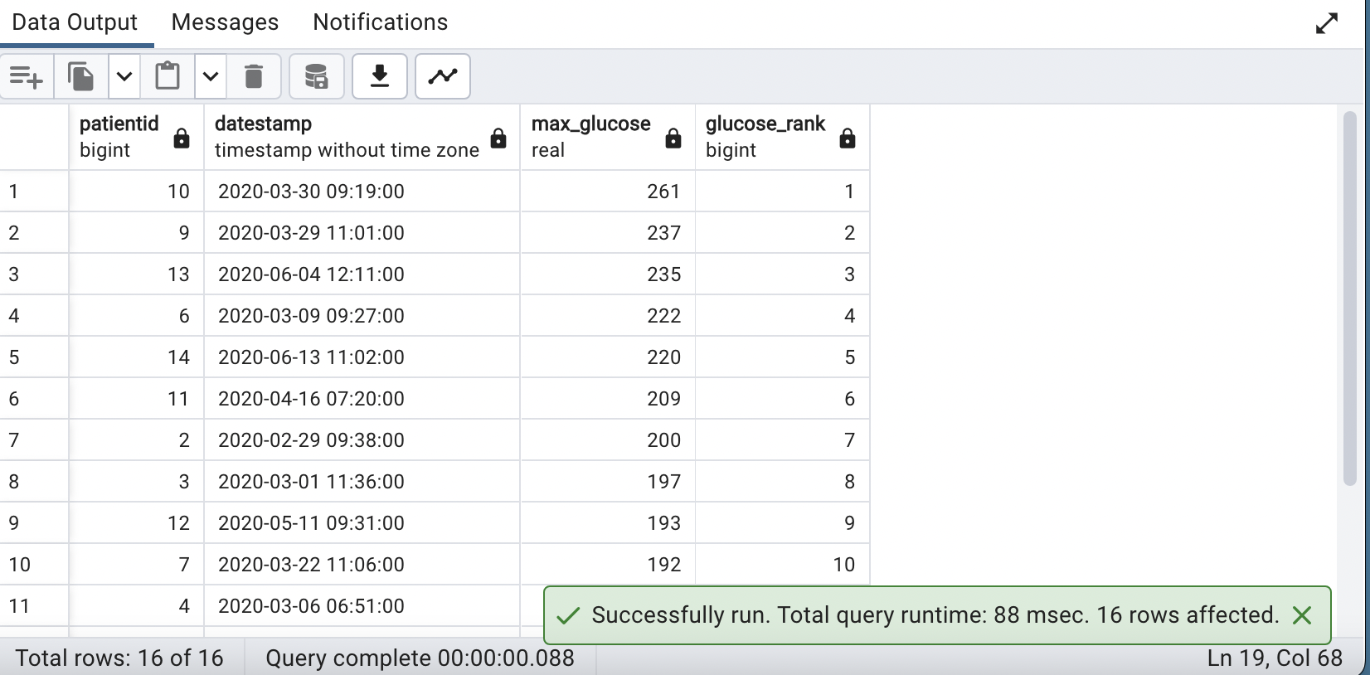

1. **Assuming the IBI per patient is for every 10 milliseconds, calculate Patient-wise HRV from RMSSD.**

**QUERY:**

| ***-- Calculate and round Heart Rate Variability (HRV) for each patient.***  **SELECT**  **ibi.patientid,**  **ROUND(((SUM(ibi.rmssd_ms)::numeric / COUNT(ibi.rmssd_ms)) * 600)::numeric, 2) AS hrv**  **FROM**  **ibi**  **GROUP BY**  **ibi.patientid**  **ORDER BY**  **ibi.patientid ASC;** |
| --- |

**OUTPUT:**

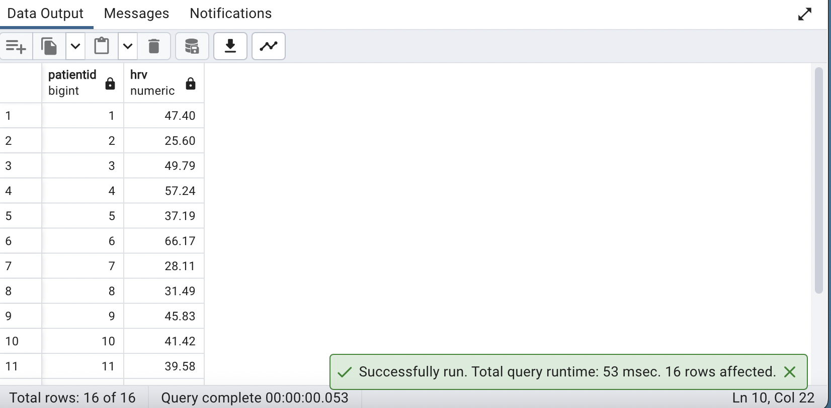

**17. What is the % of total daily calories consumed by patient 14 after 3pm Vs Before 3pm?**

**QUERY:**

| ***/*Calculates the percent of total daily calories Using Subqueries */***    **SELECT**  **DATE(datetime) AS log_date,**  **SUM(CASE WHEN EXTRACT(HOUR FROM datetime) >= 15 THEN calorie ELSE 0 END) AS calories_after_3pm,**  **SUM(CASE WHEN EXTRACT(HOUR FROM datetime) < 15 THEN calorie ELSE 0 END) AS calories_before_3pm,**  **SUM(calorie) AS total_calories,**  **ROUND((SUM(CASE WHEN EXTRACT(HOUR FROM datetime) >= 15 THEN calorie ELSE 0 END) / SUM(calorie)) * 100, 2) AS percentage_after_3pm,**  **ROUND((SUM(CASE WHEN EXTRACT(HOUR FROM datetime) < 15 THEN calorie ELSE 0 END) / SUM(calorie)) * 100, 2) AS percentage_before_3pm**  **FROM foodlog**  **WHERE patientid = 14**  **GROUP BY log_date**  **ORDER BY log_date;** |
| --- |

**OUTPUT:**

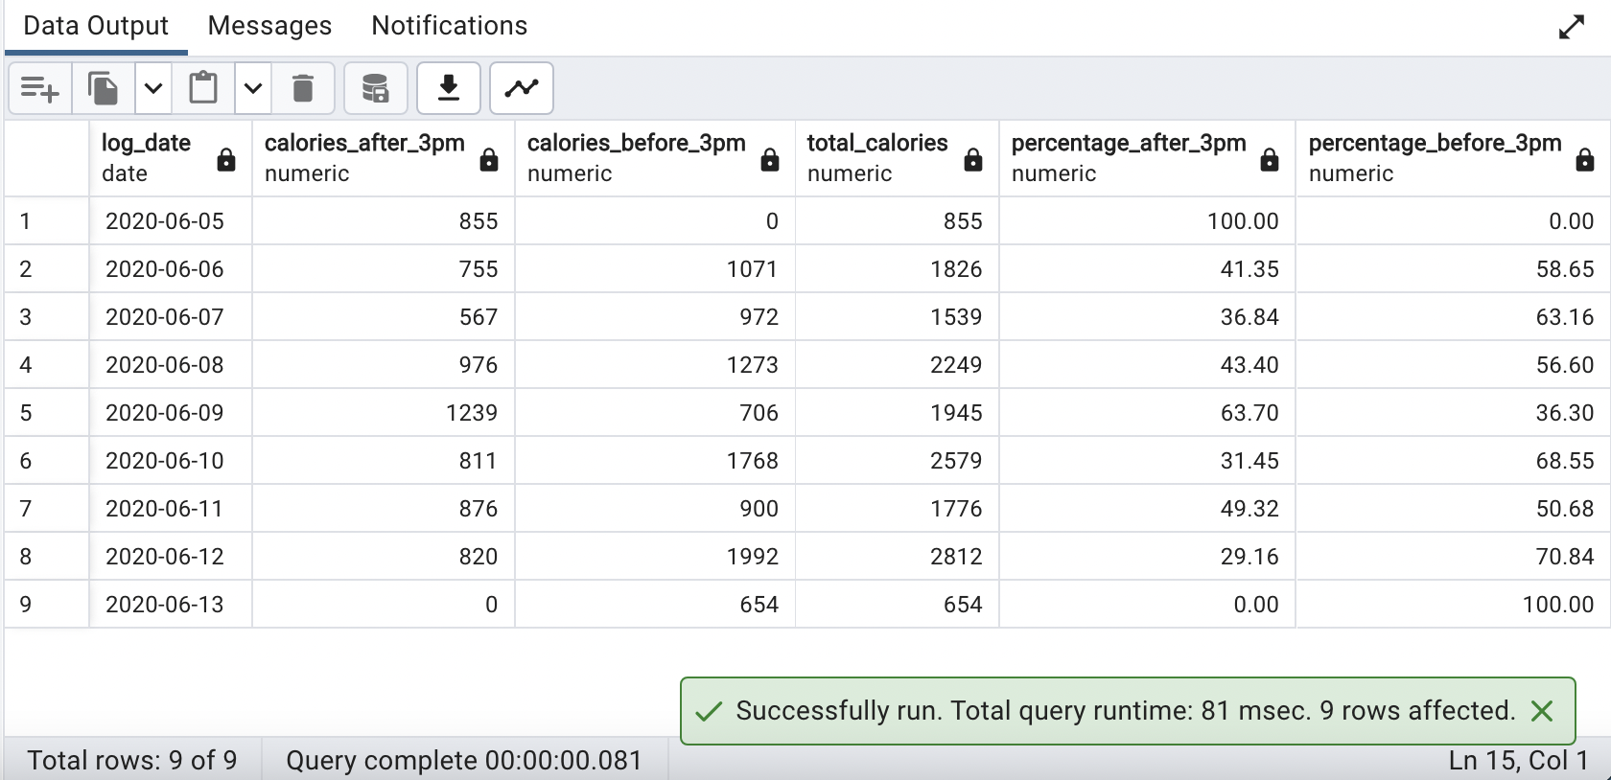

**18. Display 5 random patients with HbA1c less than 6.**

**QUERY:**

| ***/*This Query Randomly displays 5 patients info where hba1c < 6 */***  **SELECT patientid,hba1c FROM demographics**  **WHERE hba1c < 6**  **ORDER BY RANDOM()**  **LIMIT 5;** |
| --- |

**OUTPUT:**

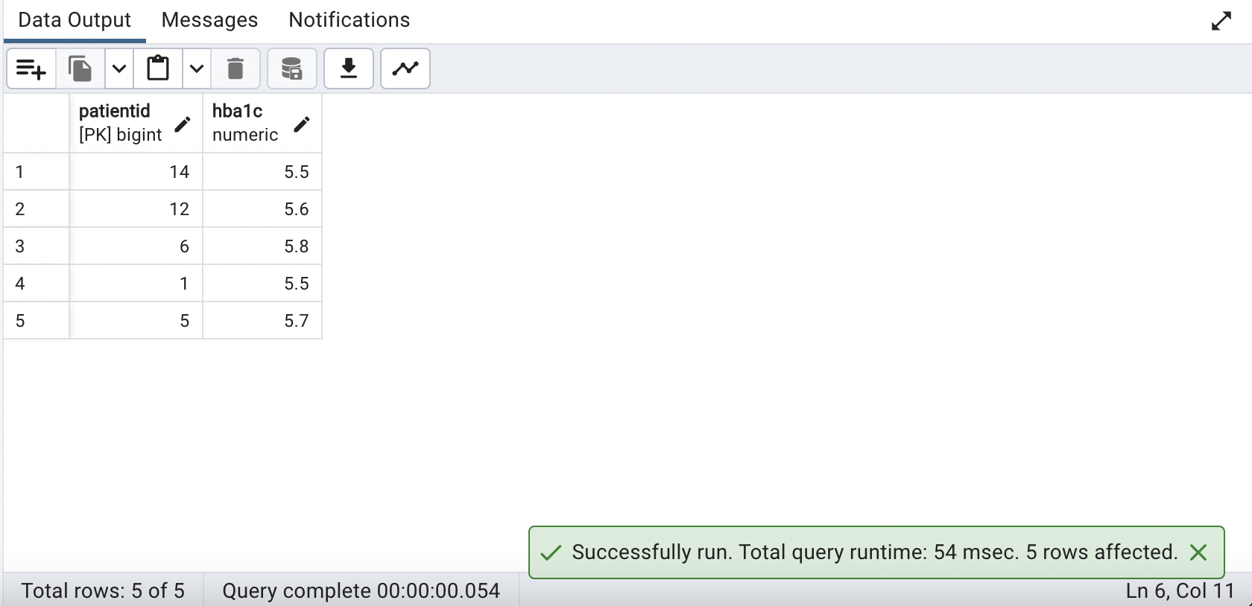

**19. Generate a random series of data using any column from any table as the base**

**QUERY:**

| ***/*Firstly Deleted records if already present Then inserted data using patientid from demographics table***  ***and generate_series function */***    **DELETE FROM demographics**  **WHERE patientid IN (SELECT patientid FROM demographics WHERE patientid in (17,18,19,20));**  **INSERT INTO demographics(patientid) VALUES (generate_series(17,20));**  **SELECT * FROM demographics WHERE patientid IN (17,18,19,20);** |
| --- |

**OUTPUT:**

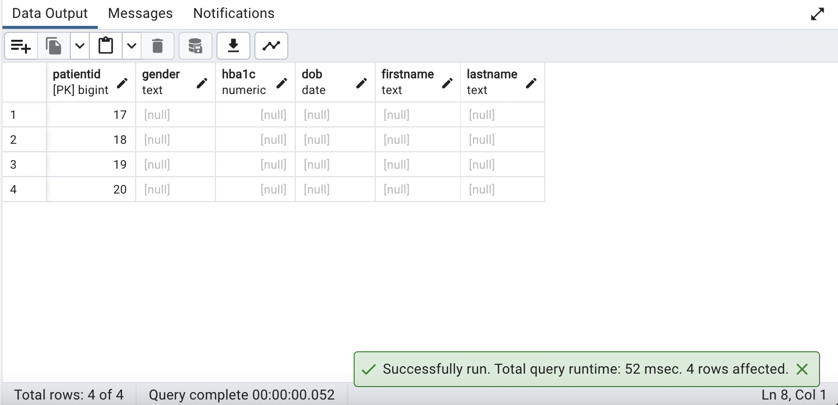

**20. Display the foods consumed by the youngest patient**

**QUERY:**

| ***/*Used sub-query to extract the youngest age of patient from demographics table*/***    **SELECT DISTINCT demographics.patientid,foodlog.logged_food**  **FROM foodlog JOIN demographics**  **ON demographics.patientid = foodlog.patientid**  **WHERE foodlog.patientid = (SELECT demographics.patientid FROM demographics**  **ORDER BY EXTRACT('YEAR' FROM AGE(CURRENT_DATE,dob))**  **LIMIT 1);** |
| --- |

**OUTPUT:**

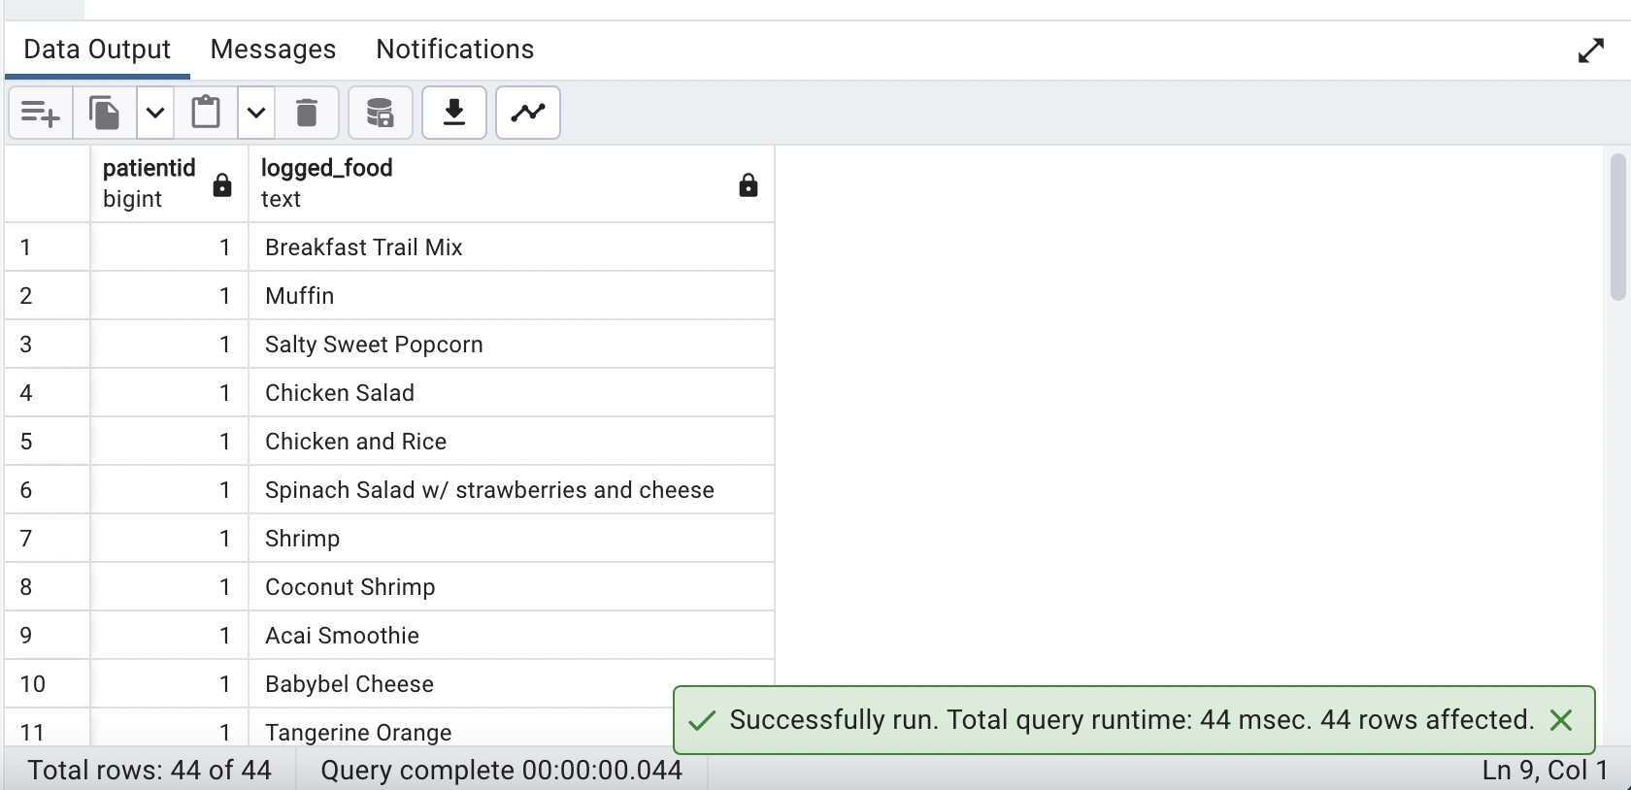

1. **Identify the patients that has letter 'h' in their first name and print the last letter of their first name.**

**QUERY:**

| ***/*Identified the required patients using like and RIGHT function*/***    **SELECT patientid,firstname,RIGHT(firstname,1) AS LastLetterOfFirstname**  **FROM demographics**  **WHERE firstname LIKE 'h%'**  **OR firstname LIKE '%h'**  **OR firstname LIKE '%h%';** |
| --- |

**OUTPUT:**

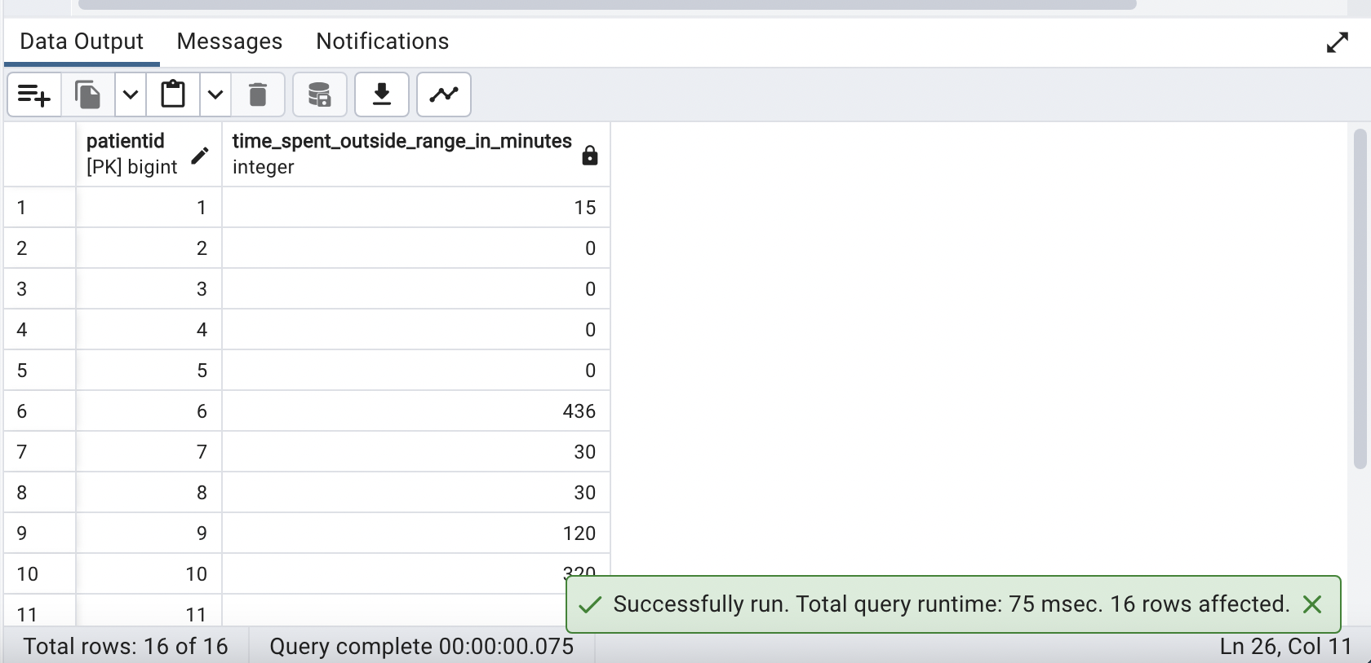

**22. Calculate the time spent by each patient outside the recommended blood glucose range**

**QUERY:**

| **WITH glucose_duration AS (**  **SELECT**  **demographics.patientid,**  **dexcom.datestamp,**  **dexcom.glucose_value_mgdl,**  **CASE**  **WHEN dexcom.glucose_value_mgdl < 55 OR dexcom.glucose_value_mgdl > 200 THEN**  **EXTRACT(EPOCH FROM (**  **LEAD(dexcom.datestamp, 1, dexcom.datestamp) OVER (PARTITION BY dexcom.patientid ORDER BY dexcom.datestamp)**  **- dexcom.datestamp)**  **)**  **ELSE**  **0**  **END AS duration_outside_range_in_secs**  **FROM**  **demographics**  **JOIN**  **dexcom ON demographics.patientid = dexcom.patientid**  **)**  **SELECT**  **patientid,**  **CAST(SUM(duration_outside_range_in_secs) / 60.0 AS integer) AS time_spent_outside_range_in_minutes**  **FROM**  **glucose_duration**  **GROUP BY**  **patientid;** |
| --- |

**OUTPUT:**



**23. Show the time in minutes recorded by the Dexcom for every patient**

**QUERY:**

| **SELECT DATE(datestamp),patientid,**  **SUM(FLOOR(EXTRACT(EPOCH FROM datestamp::timestamp::time)/60)) AS TimeInMinutes**  **FROM dexcom**  **GROUP BY patientid,DATE(datestamp)**  **ORDER BY patientid,DATE(datestamp);** |
| --- |

**OUTPUT:**

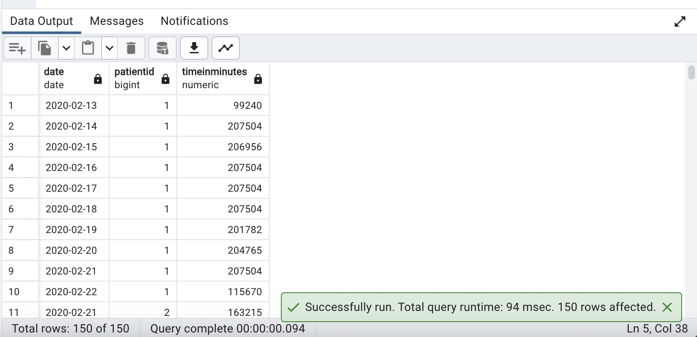

**24. List all the food eaten by patient Phill Collins**

**QUERY:**

| **SELECT DISTINCT foodlog.logged_food FROM foodlog**  **JOIN demographics**  **ON demographics.patientid = foodlog.patientid**  **WHERE demographics.firstname = 'Phill' AND demographics.lastname = 'Collins';** |
| --- |

**OUTPUT:**

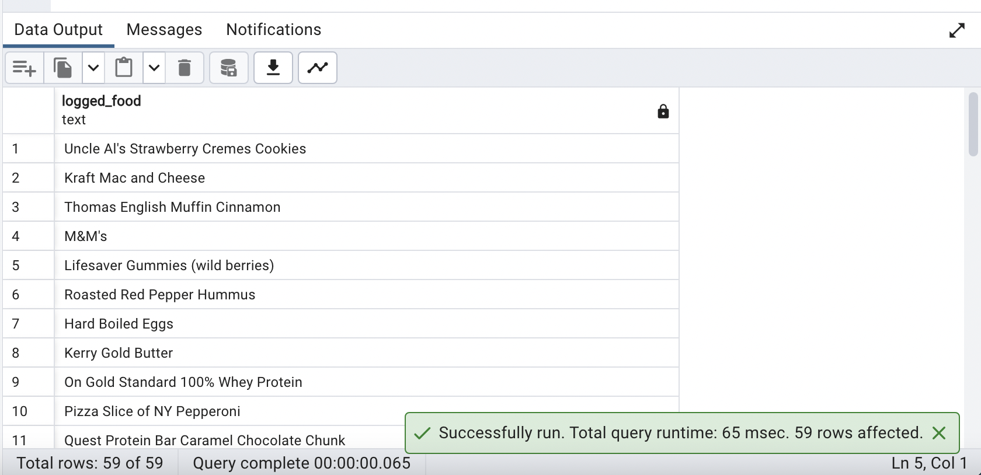

**25. Create a stored procedure to delete the min_EDA column in the table EDA**

**QUERY:**

| **/*Created a dummy column and copied the values of min_EDA to dummy before deleting it.*/**  **/*ALTER TABLE eda ADD COLUMN dummy real default 0;**  **UPDATE eda**  **SET dummy = min_EDA; */**    **CREATE OR REPLACE PROCEDURE DELmin_EDA()**  **language plpgsql**  **AS $$**  **BEGIN**  **ALTER TABLE eda DROP COLUMN min_EDA;**  **END**  **$$;**    **CALL DELmin_EDA(); -- Call the procedure**  **SELECT eda.min_eda FROM eda; --To check if the column min_eda got deleted** |
| --- |

**OUTPUT:**

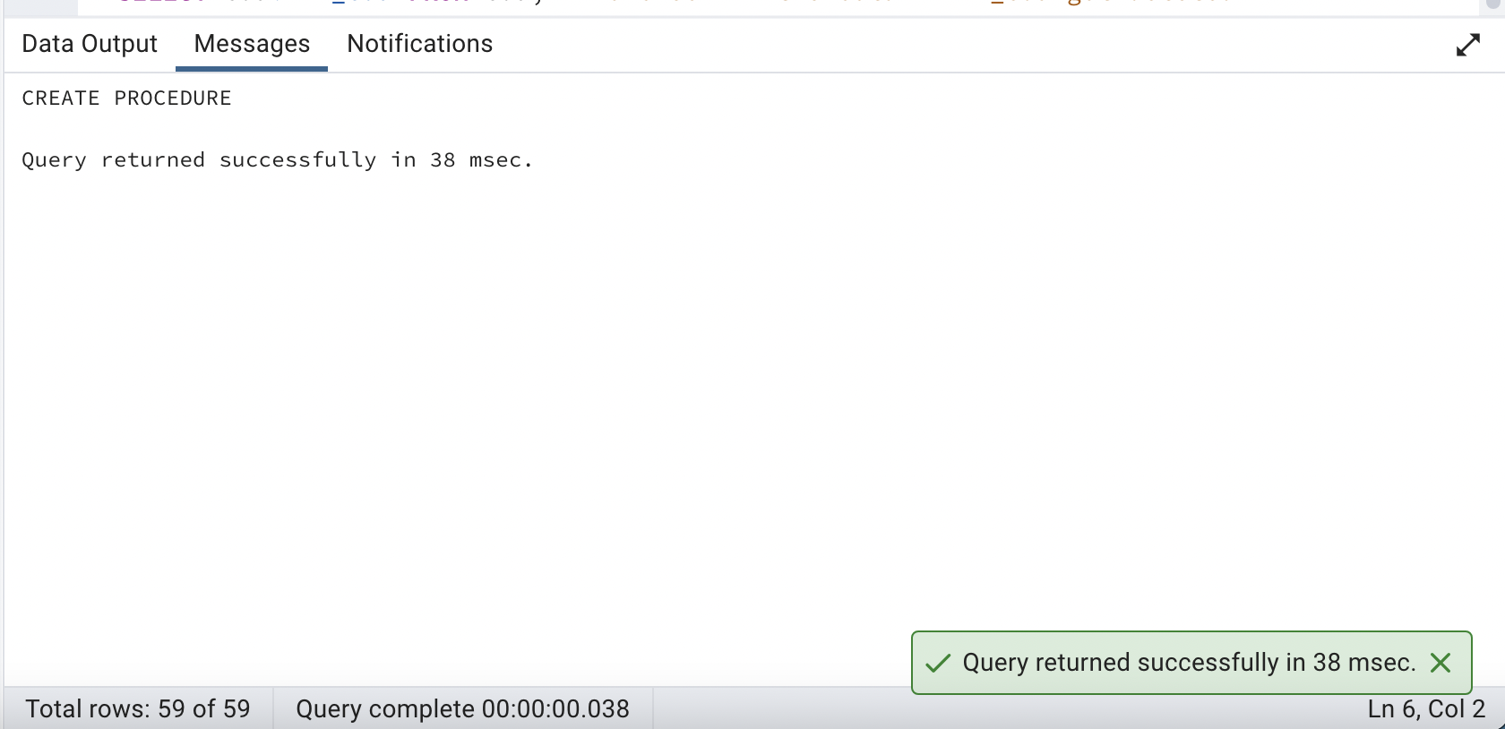

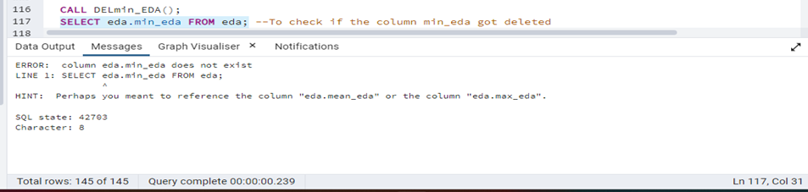

**26. When is the most common time of day for people to consume spinach?**

**QUERY:**

| ***/*SELECT datetime,patientid FROM foodlog WHERE logged_food= 'Spinach'***  ***Spinach is consumed three times during afternoon(12:45 - 14:00)*/***    **SELECT**  **CASE**  **WHEN EXTRACT(HOUR FROM datetime) >= 9 AND EXTRACT(HOUR FROM datetime) < 12 THEN 'Morning'**  **WHEN EXTRACT(HOUR FROM datetime) >= 12 AND EXTRACT(HOUR FROM datetime) < 15 THEN 'Afternoon'**  **WHEN EXTRACT(HOUR FROM datetime) >= 15 AND EXTRACT(HOUR FROM datetime) < 18 THEN 'Evening'**  **WHEN EXTRACT(HOUR FROM datetime) >= 18 AND EXTRACT(HOUR FROM datetime) < 21 THEN 'NIGHT'**  **ELSE 'LATENIGHT'**  **END AS consumption_time,**  **COUNT(*) AS total_consumption**  **FROM**  **foodlog**  **WHERE logged_food = 'Spinach'**  **GROUP BY**  **consumption_time**  **ORDER BY**  **total_consumption DESC**  **LIMIT 1;** |
| --- |

**OUTPUT:**

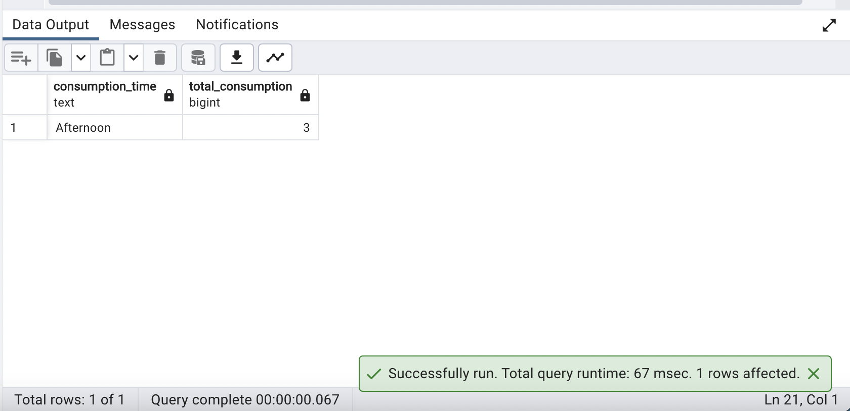

**27. Classify each patient based on their HRV range as high, low or normal**

**QUERY:**

| **WITH CTE_hrv AS(**  **SELECT DISTINCT(patientid),AVG(rmssd_ms)*600 AS hrv**  **FROM ibi**  **GROUP BY patientid**  **)**  **SELECT CTE_hrv.patientid,**  **(**  **CASE**  **WHEN CTE_hrv.hrv < 20 THEN 'HIGH'**  **WHEN CTE_hrv.hrv > 20 AND CTE_hrv.hrv < 200 THEN 'NORMAL'**  **ELSE 'LOW'**  **END**  **) HRVRangeStatus**  **FROM CTE_hrv;** |
| --- |

**OUTPUT:**

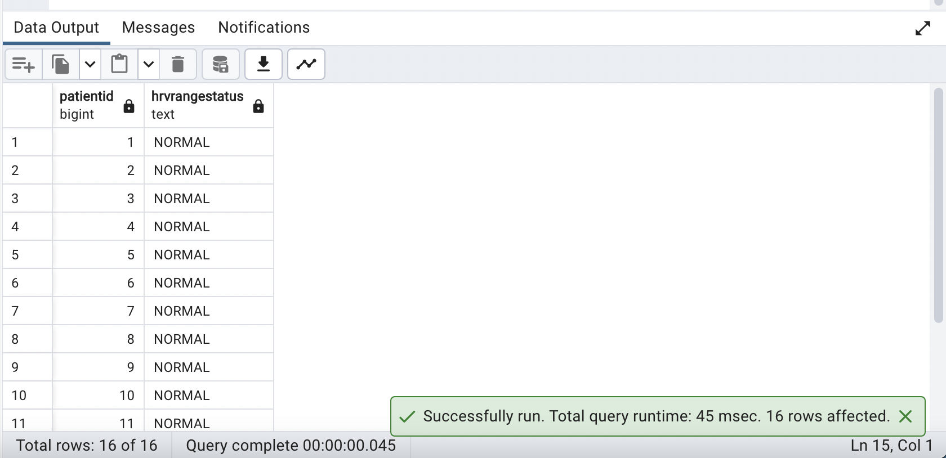

**28. List full name of all patients with 'an' in either their first or last names**

**QUERY:**

| ***/*Combined first and last name te get full name of patients and used Like to get the result*/***    **SELECT firstname||' '||lastname AS fullname**  **FROM demographics**  **WHERE firstname LIKE '%an' OR firstname LIKE 'an%' OR firstname LIKE '%an%'**  **OR lastname LIKE '%an' OR lastname LIKE 'an%' OR lastname LIKE '%an%';** |
| --- |

**OUTPUT:**

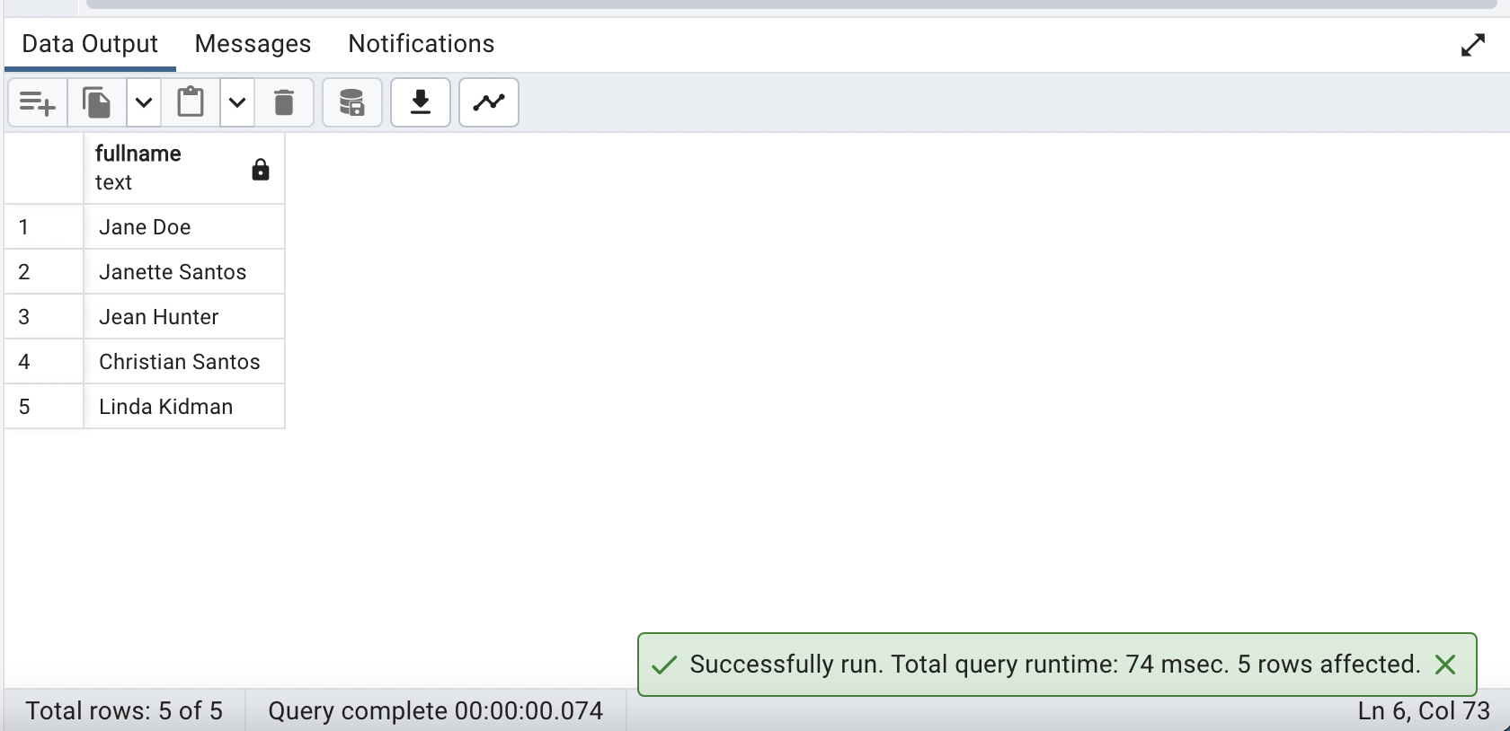

**29. Display a pie chart of gender vs average HbA1c**

**QUERY:**

| **SELECT gender,AVG(hba1c) FROM demographics**  **GROUP BY gender;** |
| --- |

**OUTPUT:**

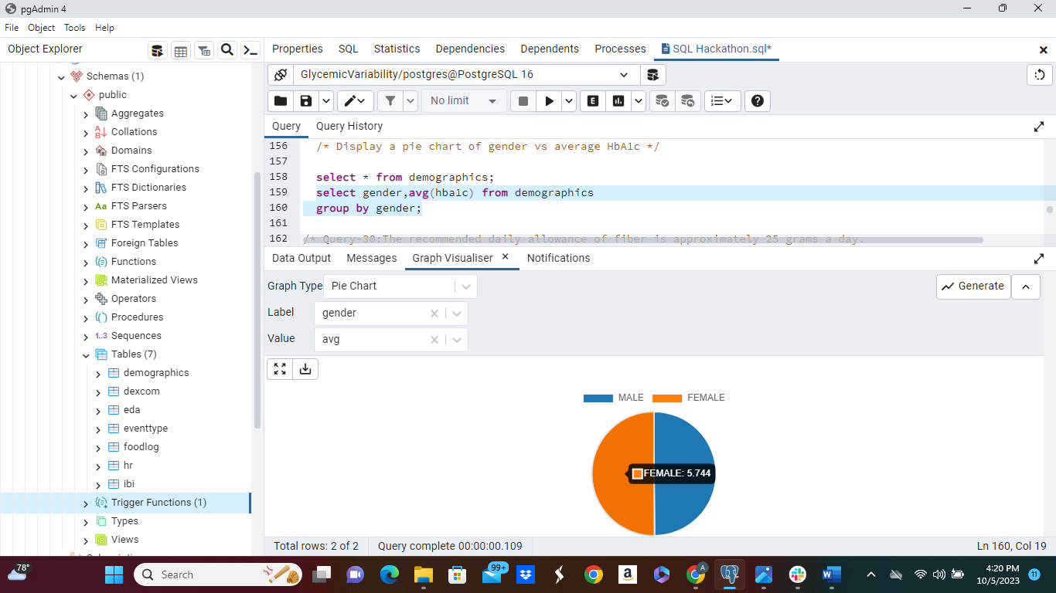

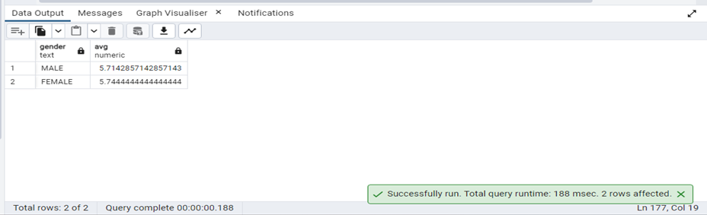

**30. The recommended daily allowance of fiber is approximately 25 grams a day. What % of this does every patient get on average?**

**QUERY:**

| ***/*Calculated percent using avg() function */***  **SELECT foodlog.patientid,**  **FLOOR(AVG(foodlog.dietary_fiber)*100 / 25) AS PercentOfFiber**  **FROM foodlog**  **GROUP BY foodlog.patientid**  **ORDER BY foodlog.patientid;** |
| --- |

**OUTPUT:**

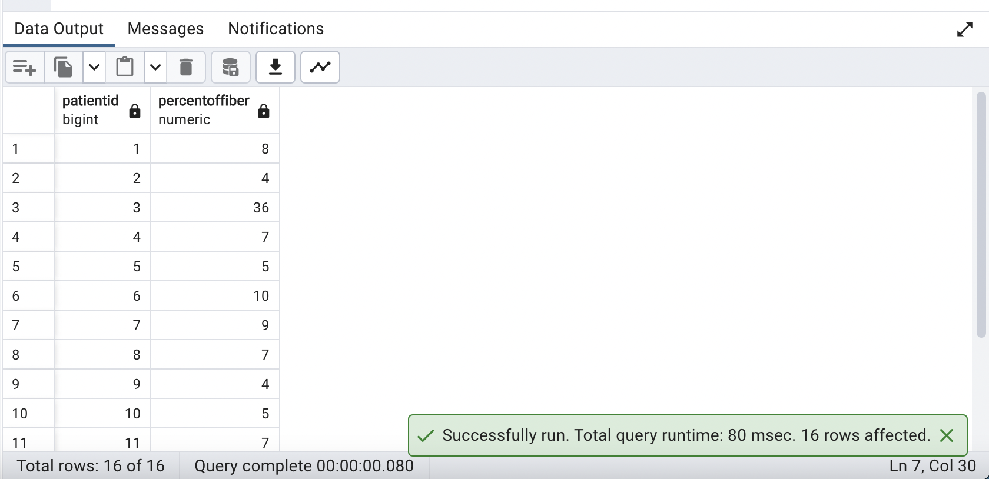

**31. What is the relationship between EDA and Mean HR?**

**QUERY:**

| ***/*Based on the result there is weak correlation between EDA and Mean HR */***    **SELECT CORR(eda.mean_eda,hr.mean_hr) AS Correlation**  **FROM eda JOIN hr**  **ON eda.patientid = hr.patientid;** |
| --- |

**OUTPUT:**

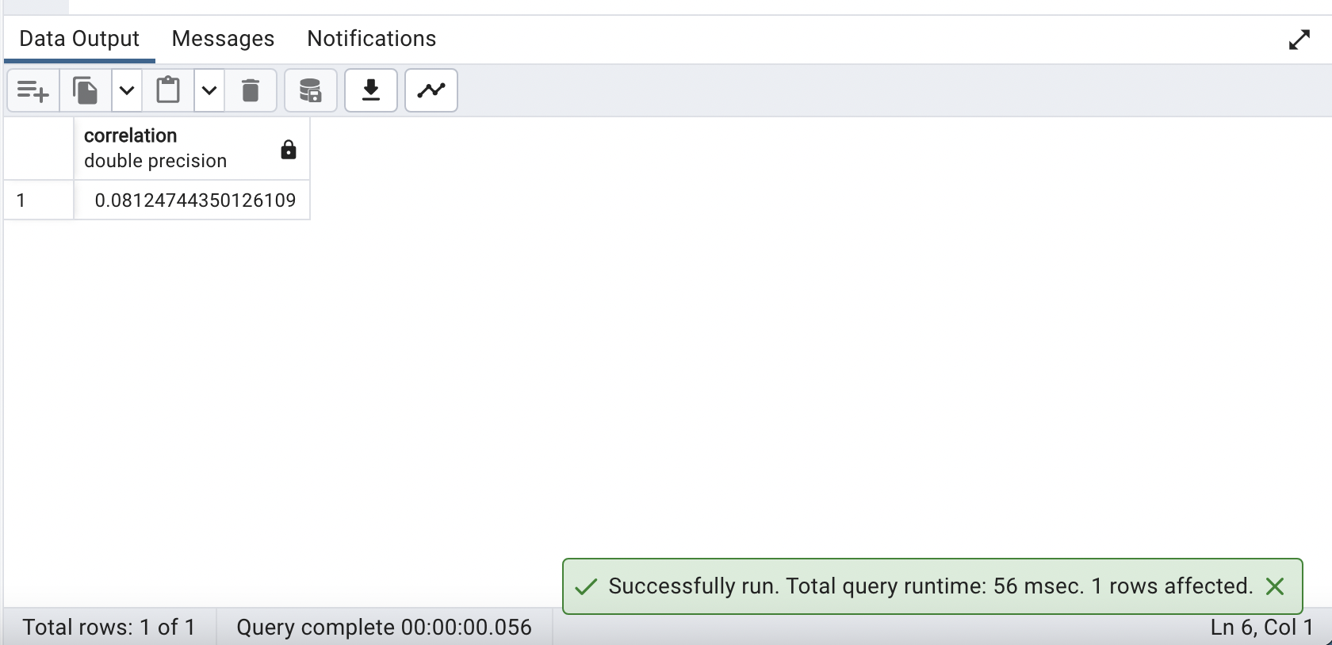

**32. Show the patient that spent the maximum time out of blood glucose range**

**QUERY:**

| **SELECT DISTINCT(patientid),COUNT(glucose_value_mgdl) AS MaxTimeOutOfGlucoseRange**  **FROM dexcom**  **WHERE glucose_value_mgdl < 55 OR glucose_value_mgdl > 200**  **GROUP BY patientid**  **ORDER BY COUNT(glucose_value_mgdl) DESC**  **LIMIT 1;** |
| --- |

**OUTPUT:**

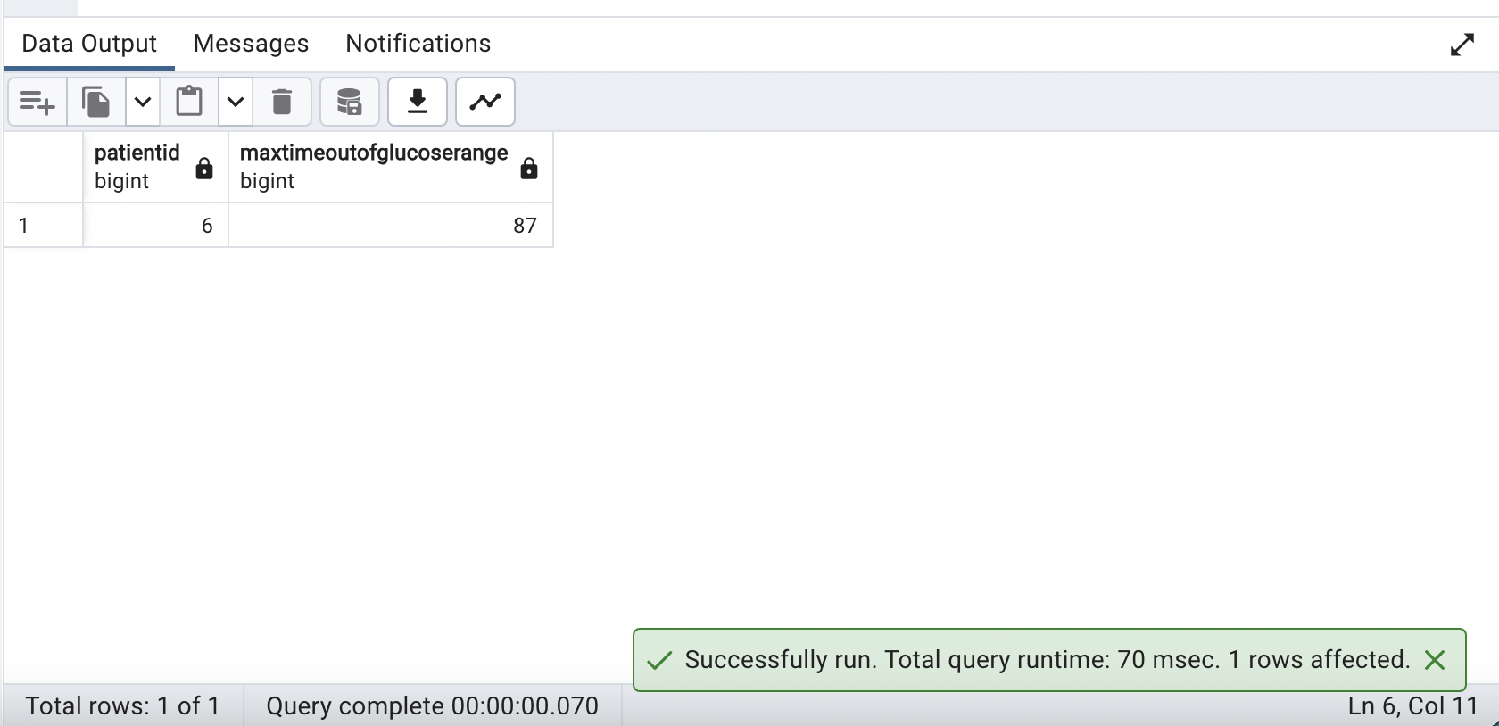

1. **Create a User Defined function that returns min glucose value and patient ID for any date entered.**

**QUERY:**

| ***-- It takes the target_date as input and returns a table with patient_id and min_glucose columns.***  **CREATE OR REPLACE FUNCTION GetMinGlucoseForDate(target_date DATE)**  **RETURNS TABLE (patient_id BIGINT, min_glucose REAL)**  **AS $$**  **BEGIN**  ***-- Query the dexcom table to find the minimum glucose value for each patient on the target date.***  **RETURN QUERY (**  **SELECT patientid, MIN(glucose_value_mgdl) AS min_glucose_value**  **FROM dexcom**  **WHERE DATE(datestamp) = target_date**  **GROUP BY patientid**  **);**  **END;**  **$$ LANGUAGE plpgsql;**  ***-- Call the function with a specific date to retrieve the minimum glucose values for that date.***  **SELECT * FROM GetMinGlucoseForDate('2020-02-13');** |
| --- |

**OUTPUT:**

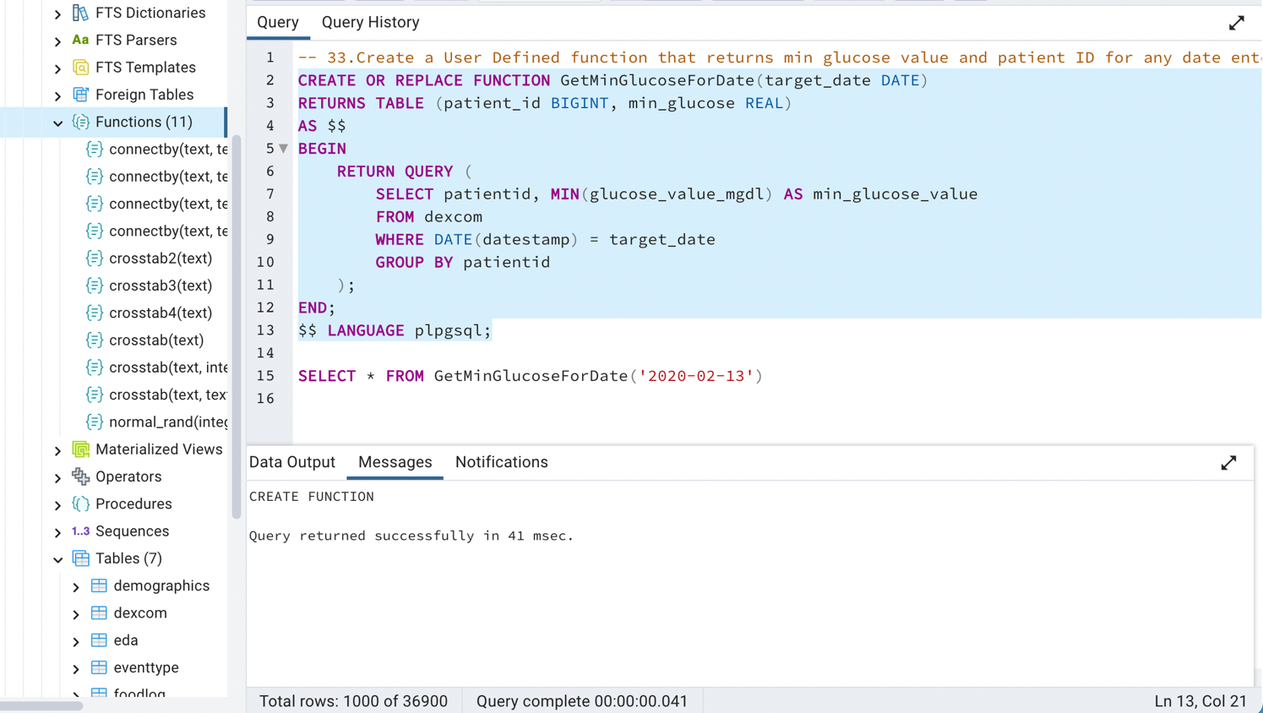

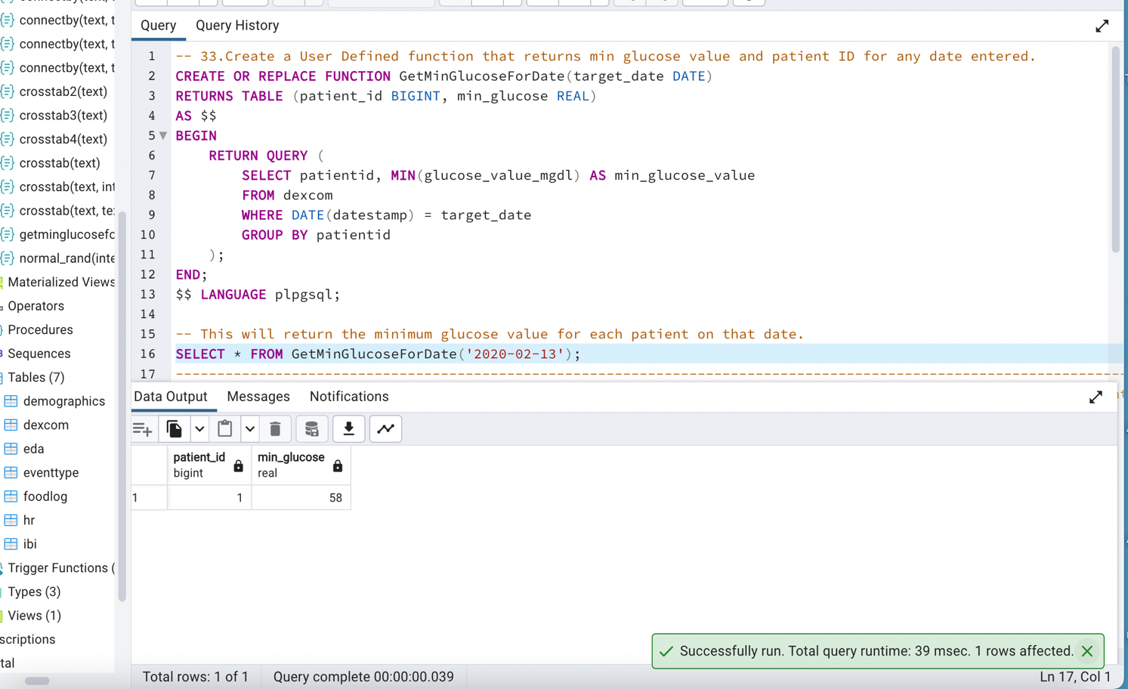

1. **Write a query to find the day of highest mean HR value for each patient and display it along with the patient id.**

**QUERY:**

| ***-- Calculate the mean HR for each patient on each highest_mean_date***  **WITH MeanHeartRates AS (**  **SELECT**  **patientid,**  **datestamp AS highest_mean_date,**  **mean_hr**  **FROM**  **hr**  **),**  ***-- Rank the mean HR values in descending order for each patient***  **RankHighestMean AS (**  **SELECT**  **patientid,**  **highest_mean_date,**  **mean_hr,**  **RANK() OVER (PARTITION BY patientid ORDER BY mean_hr DESC) AS rank**  **FROM**  **MeanHeartRates**  **)**  ***-- Select the rows where the rank is 1 (highest mean HR) for each patient***  **SELECT**  **patientid,**  **highest_mean_date AS day_of_highest_mean_hr,**  **mean_hr AS highest_mean_hr**  **FROM**  **RankHighestMean**  **WHERE**  **rank = 1;** |
| --- |

**OUTPUT:**

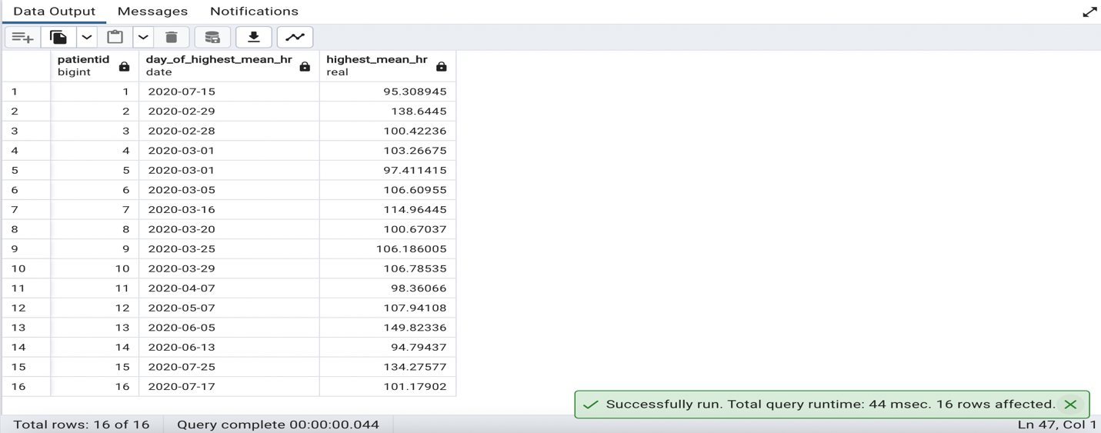

1. **Create view to store Patient ID, Date, Avg Glucose value and Patient Day to every patient, ranging from 1-11 based on every patients minimum date and maximum date (eg: Day1,Day2 for each patient)**

**QUERY:**

| ***-- Create or replace a view named PatientGlucoseView***  **CREATE OR REPLACE VIEW PatientGlucoseView AS**  **WITH PatientDateRanges AS (**  ***-- Step 1: Calculate the minimum and maximum dates for each patient***  **SELECT**  **patientid,**  **MIN(DATE_TRUNC('day', datestamp)) AS min_date,**  **MAX(DATE_TRUNC('day', datestamp)) AS max_date**  **FROM**  **dexcom**  **GROUP BY**  **patientid**  **)**  **SELECT**  **d.patientid AS patient_id,**  **d.datestamp AS date,**  **CONCAT('Day',**  **FLOOR(EXTRACT(EPOCH FROM (d.datestamp - pdr.min_date)) / (60*60*24)) + 1**  **) AS patient_day,*-- Calculate the patient's day based on the date***  **AVG(d.glucose_value_mgdl) AS avg_glucose_value*-- Calculate the average glucose value***  **FROM**  **dexcom d**  **JOIN**  **PatientDateRanges pdr ON d.patientid = pdr.patientid**  ***-- Step 2: Filter date within 11 days of the minimum date***  **WHERE**  **d.datestamp BETWEEN pdr.min_date AND (pdr.min_date + INTERVAL '10 days')**  **GROUP BY**  **d.patientid, d.datestamp, pdr.min_date;**  **SELECT * FROM PatientGlucoseView ORDER BY patient_id, date;** |
| --- |

**OUTPUT:**

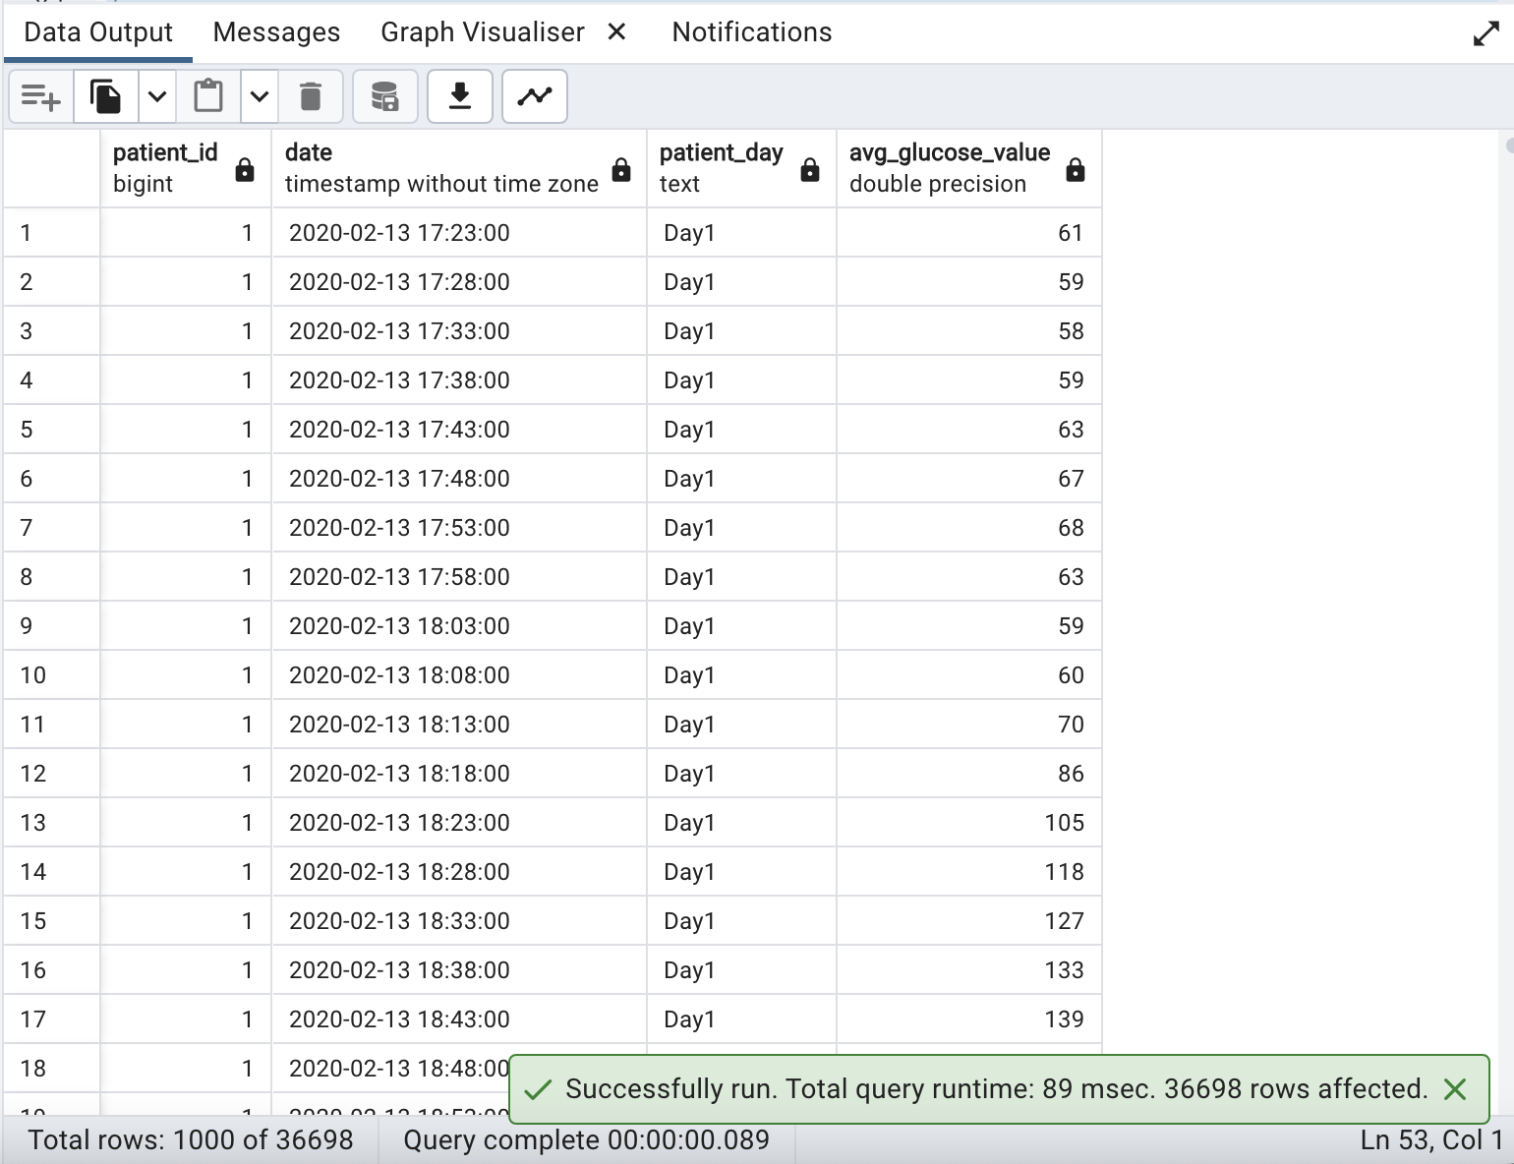

1. **Using width bucket functions, group patients into 4 HRV categories**

**QUERY:**

| ***-- Create a view to categorize patients based on HRV***  **CREATE OR REPLACE VIEW HRV_Categories AS**  **SELECT DISTINCT**  **patientid,**  **ROUND(AVG(rmssd_ms * 600)) AS hrv_value,**  **width_bucket(AVG(rmssd_ms * 600), MIN(AVG(rmssd_ms * 600)) OVER (), MAX(AVG(rmssd_ms * 600)) OVER (), 3) AS hrv_category**  **FROM**  **ibi**  **GROUP BY**  **patientid**  **ORDER BY**  **patientid;**  **SELECT * FROM HRV_Categories** |
| --- |

**OUTPUT:**

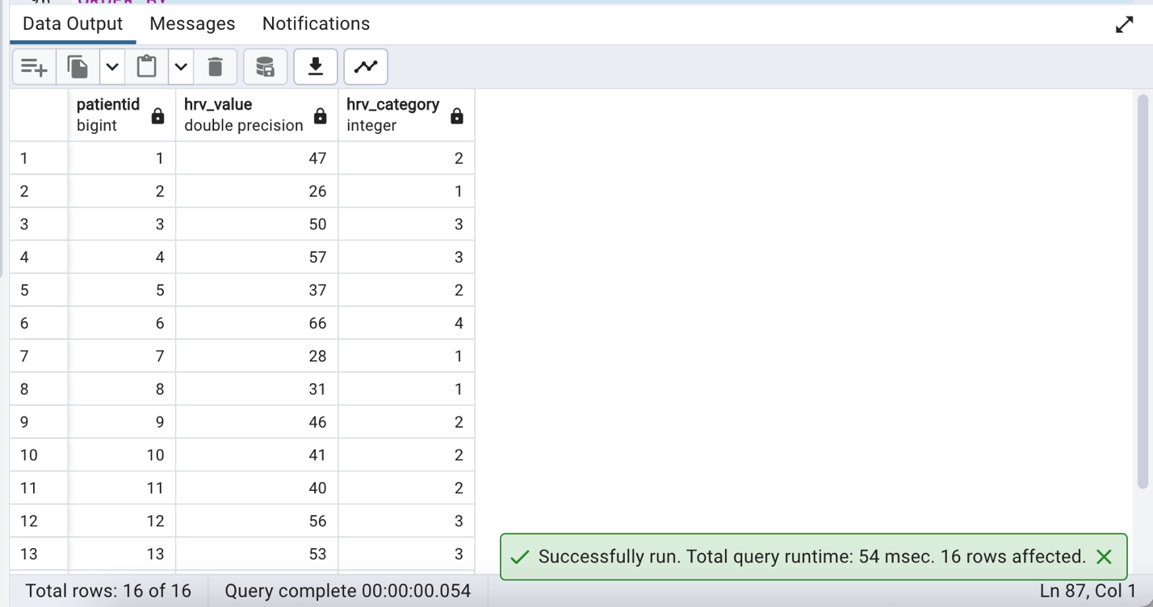

1. **Is there a correlation between High EDA and HRV. If so, display this data by querying the relevant tables?**

**QUERY:**

| ***-- This CTE selects distinct patient IDs who have a maximum EDA value greater than 2.0***  **WITH HighEDA AS (**  **SELECT DISTINCT e.patientid**  **FROM eda e**  **WHERE e.max_eda > 2.0**  **)**  ***-- Select and calculate HRV, EDA, and their correlation for patients in HighEDA***  **SELECT**  **AVG(i.rmssd_ms * 600) AS HRV, *-- Calculate the average HRV for patients in HighEDA***  **AVG(e.max_eda) AS EDA, *-- Calculate the average maximum EDA for patients in HighEDA***  **CORR(i.rmssd_ms * 600, e.max_eda) AS Correlation *-- Calculate the correlation between HRV and EDA***  **FROM ibi i**  **JOIN eda e ON i.patientid = e.patientid**  **WHERE i.patientid IN (SELECT * FROM HighEDA);** |
| --- |

**OUTPUT:**

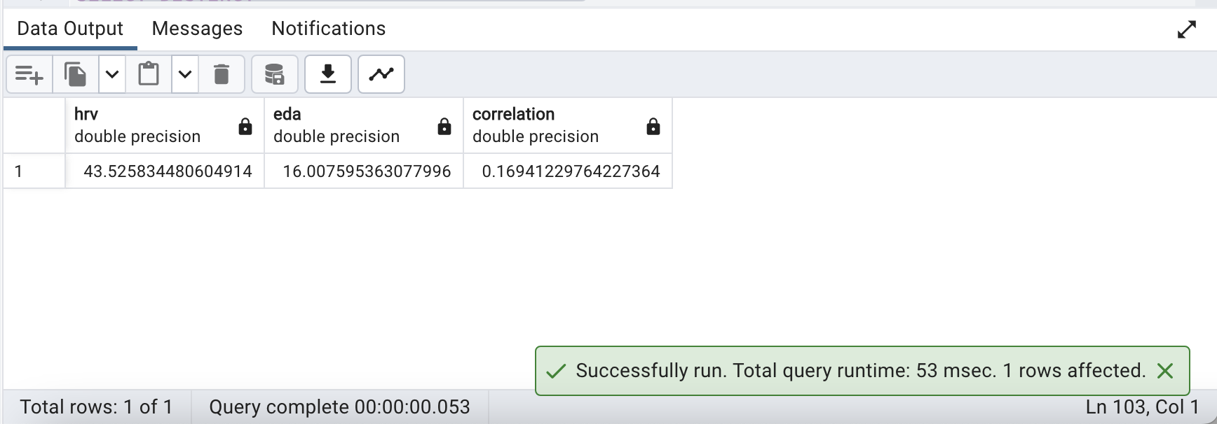

1. **List hypoglycemic patients by age and gender**

**QUERY:**

| ***-- Select distinct patient names, ages, and genders of patients with hypoglycemia (glucose_value_mgdl < 70).***  **SELECT DISTINCT**  **CONCAT(dg.firstname, ' ', dg.lastname) AS hypoglycemic_patient_name, *-- Concatenate first and last names for patient name.***  **DATE_PART('year', AGE(current_date, dg.dob)) AS age, *-- Calculate the age based on date of birth (dob).***  **dg.gender *-- Gender information.***  **FROM**  **demographics dg**  **JOIN**  **dexcom d ON dg.patientid = d.patientid *-- Join demographics and dexcom tables on patientid.***  **WHERE**  **d.glucose_value_mgdl < 70; *-- Filter for patients with glucose values less than 70 mg/dL (hypoglycemia).*** |
| --- |

**OUTPUT:**

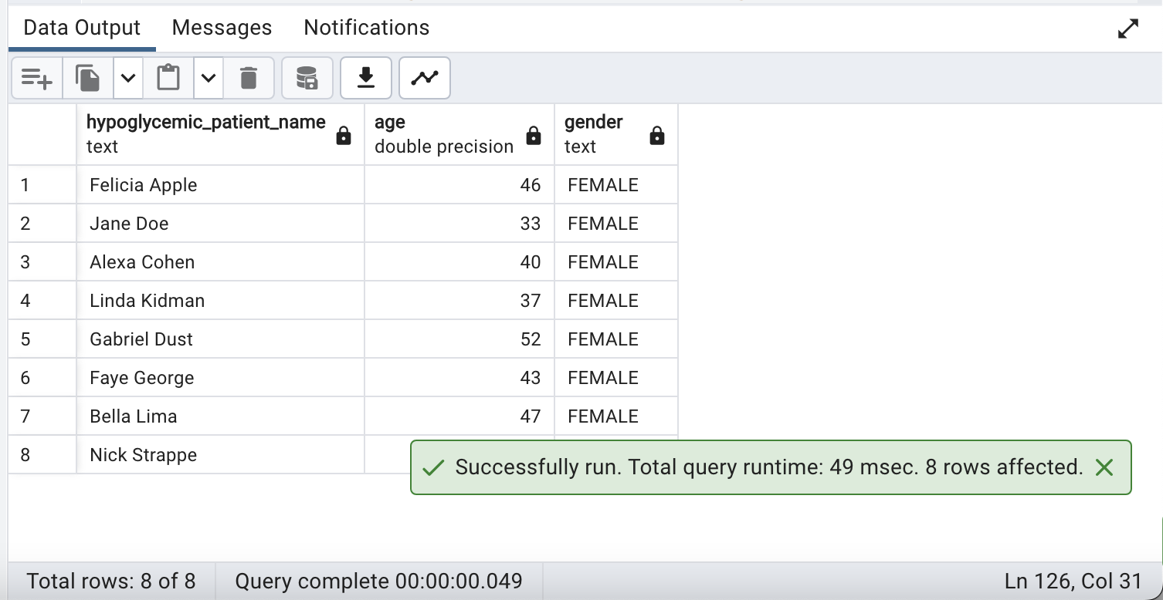

1. **Write a query using recursive view(use the given dataset only)**

**QUERY:**

| **CREATE OR REPLACE RECURSIVE VIEW PatientGlucoseHistory(patientid,**  **glucose_value_mgdl,**  **datestamp) AS**  **WITH RECURSIVE GlucoseHistory AS (**  ***-- Anchor query: Select initial data from dexcom***  **SELECT**  **d.patientid,**  **d.glucose_value_mgdl,**  **d.datestamp**  **FROM**  **dexcom d**  **UNION ALL**  ***-- Recursive query: Join with demographics based on patientid***  **SELECT**  **d.patientid,**  **dglc.glucose_value_mgdl,**  **d.datestamp**  **FROM**  **dexcom d**  **INNER JOIN**  **GlucoseHistory dglc ON d.patientid = dglc.patientid**  **)**  ***-- Select data from the CTE joined with demographics***  **SELECT**  **dh.patientid,**  **dh.glucose_value_mgdl,**  **dh.datestamp,**  **dm.firstname,**  **dm.lastname,**  **dm.hba1c,**  **dm.dob,**  **dm.gender**  **FROM**  **GlucoseHistory dh**  **INNER JOIN**  **demographics dm ON dh.patientid = dm.patientid;** |
| --- |

**PROBLEM FACED FOR THE RECURSIVE QUERY:**

* Creating a recursive view typically involves hierarchical data structures or recursive relationships between tables. Since the provided tables don't seem to have a natural hierarchical or recursive structure, it may not be appropriate to create a recursive view for them. Recursive views are commonly used when we have parent-child relationships or tree-like structures within a single table.
* In this case if we try to create recursive structure the execution time is too long. There could be several reasons for it. Instead, we could simply create regular view.

**OUTPUT:**

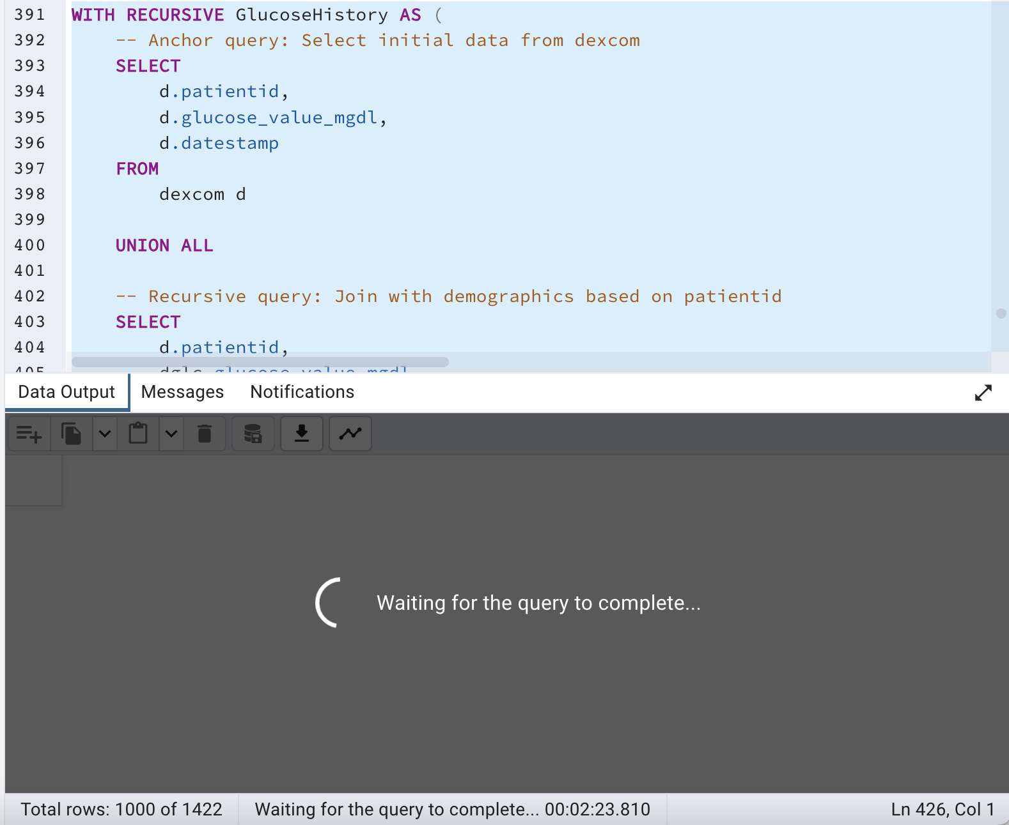

1. **Create a stored procedure that adds a column to table IBI. The column should just be the date part extracted from IBI.Date**

**QUERY:**

| ***-- Create a function (stored procedure)***  **CREATE OR REPLACE FUNCTION AddDatePartColumnToIBI()**  **RETURNS VOID AS $$**  **BEGIN**  ***-- Check if the new column already exists***  **IF NOT EXISTS (**  **SELECT column_name**  **FROM information_schema.columns**  **WHERE table_name = 'ibi' AND column_name = 'DatePart'**  **) THEN**  ***-- Add the new column 'DatePart' as DATE data type***  **EXECUTE 'ALTER TABLE ibi ADD COLUMN DatePart DATE';**  ***-- Update the 'DatePart' column with the date part extracted from the 'datestamp' column***  **EXECUTE 'UPDATE ibi SET DatePart = DATE(datestamp)';**  ***-- Display a message indicating that the column has been added***  **RAISE NOTICE 'DatePart column added to ibi table.';**  **ELSE**  ***-- If the column already exists, do nothing and display a message indicating that***  **RAISE NOTICE 'DatePart column already exists in ibi table. No action taken.';**  **END IF;**  **END;**  **$$ LANGUAGE plpgsql;**  **SELECT AddDatePartColumnToIBI();**  **SELECT DATESTAMP,DATEPART FROM IBI** |
| --- |

**OUTPUT:**

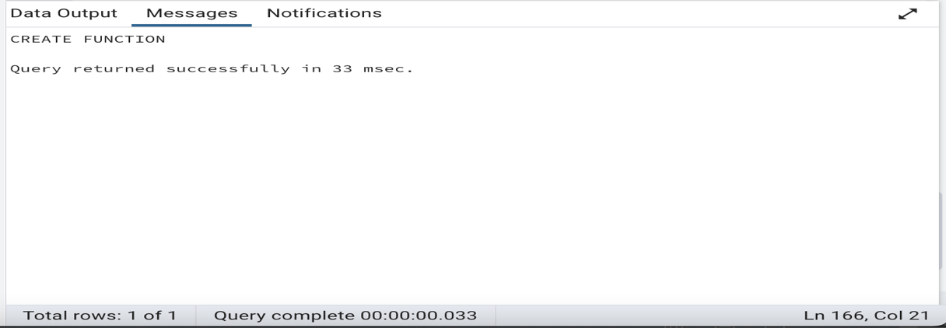

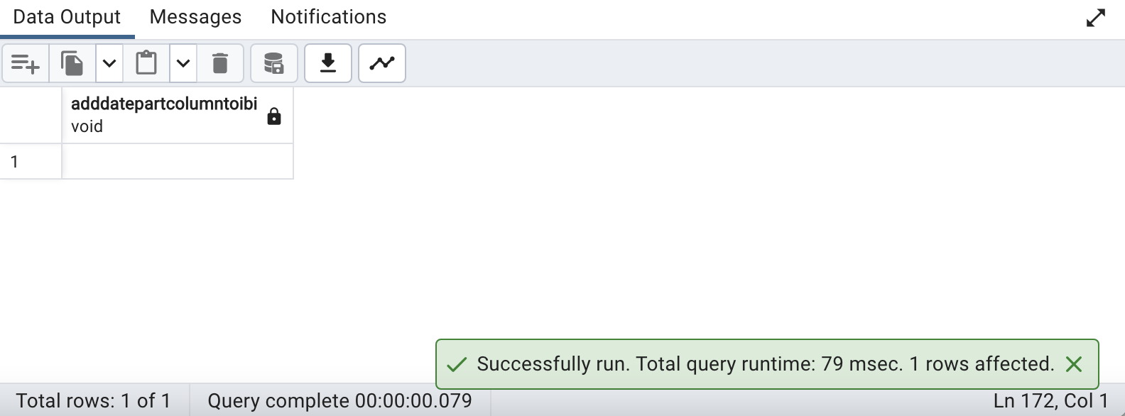

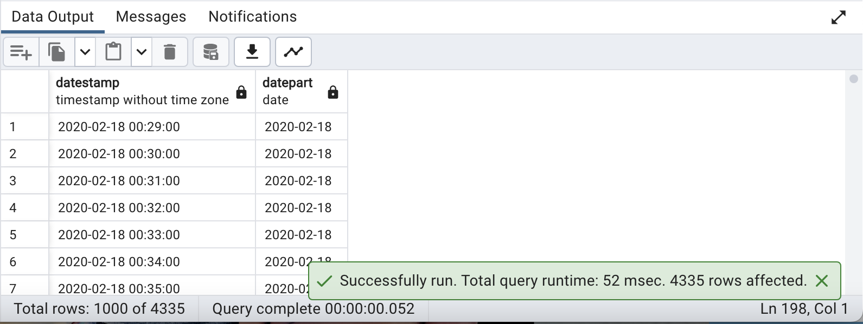

1. **Fetch the list of Patient ID's whose sugar consumption exceeded 30 grams on a meal from FoodLog table.**

**QUERY:**

| **SELECT DISTINCT patientid**  **FROM FoodLog**  **WHERE Sugar > 30**  **ORDER BY patientid;** |
| --- |

**OUTPUT:**

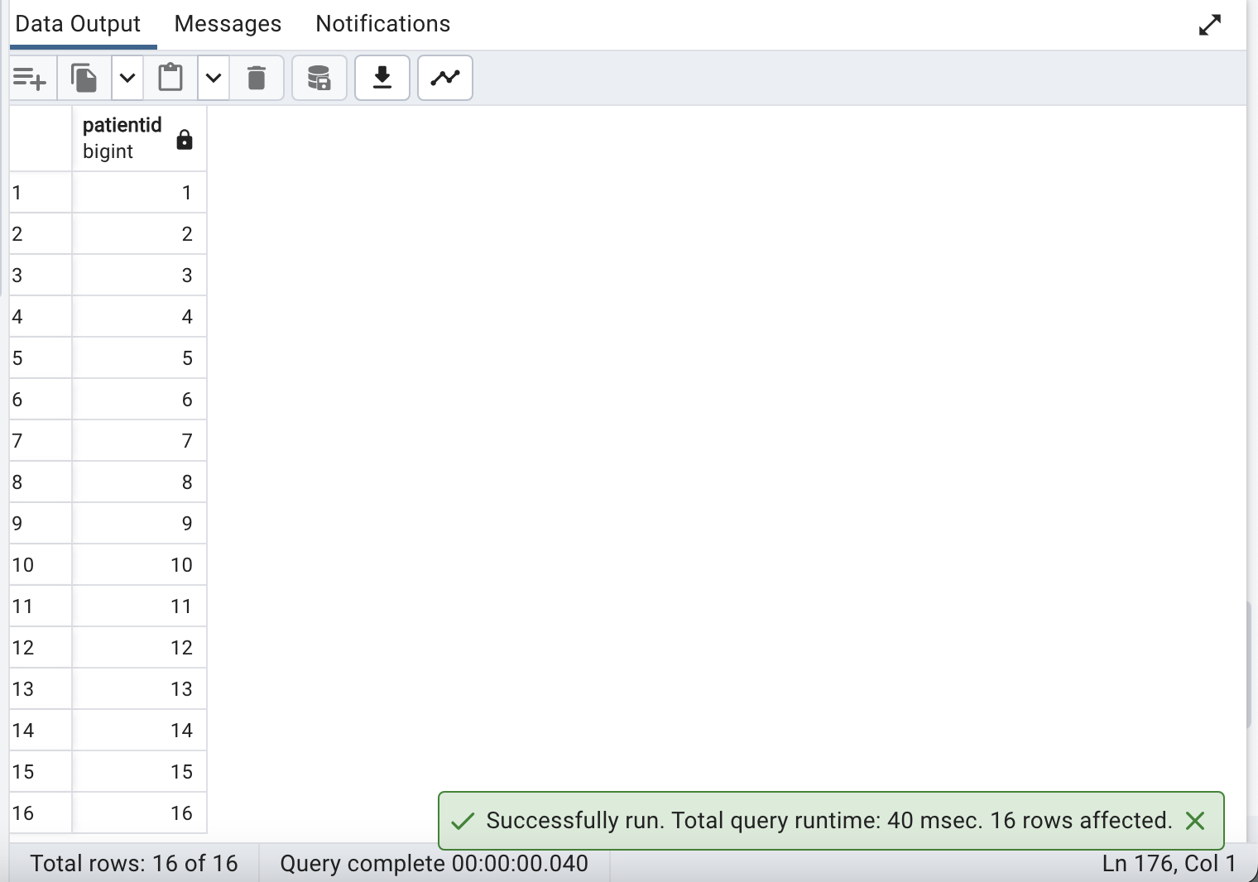

1. **How many patients are celebrating their birthday this month?**

**QUERY:**

| ***-- Count the number of records in the demographics table where the date of birth matches the current month and day.***  **SELECT COUNT(*) *-- Count the number of matching records.***  **FROM demographics *-- From the demographics table.***  **WHERE**  **EXTRACT(MONTH FROM dob) = EXTRACT(MONTH FROM CURRENT_DATE) *-- Match the month of birth with the current month.***  **AND EXTRACT(DAY FROM dob) = EXTRACT(DAY FROM CURRENT_DATE); *-- Match the day of birth with the current day.*** |
| --- |

**OUTPUT:**

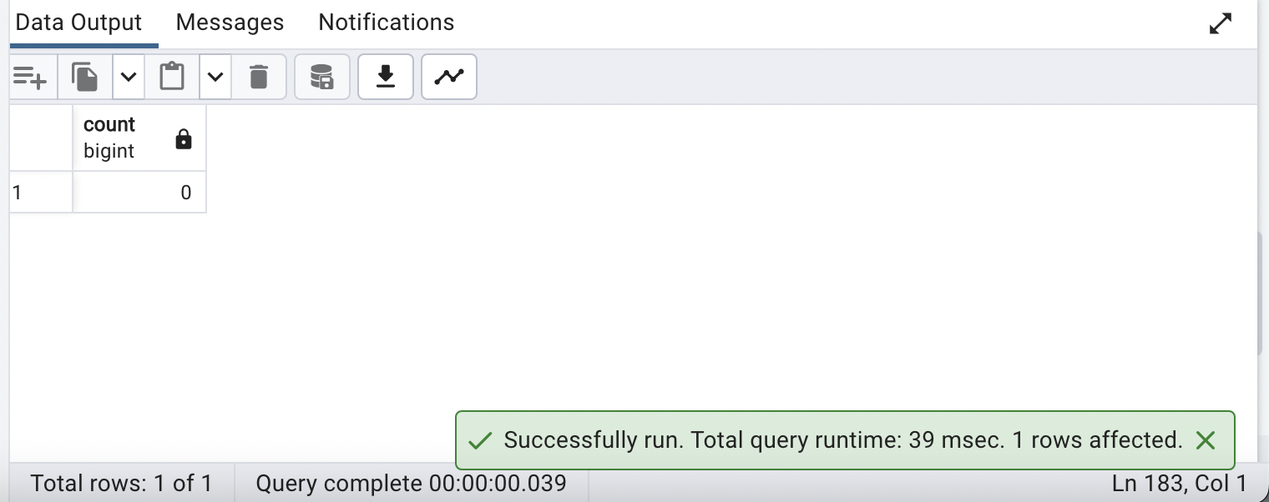

1. **How many different types of events were recorded in the Dexcom tables? Display counts against each Event type**

**QUERY:**

| ***-- Count and list the event types along with the count of events for each type.***  **SELECT**  **et.event_type, *-- Select the event type.***  **COUNT(*) AS event_count *-- Count the number of events and give it an alias 'event_count'.***  **FROM**  **eventtype et *-- From the eventtype table, which likely contains event types.***  **JOIN**  **dexcom d ON et.id = d.eventid *-- Join with the dexcom table based on event IDs.***  **GROUP BY**  **et.event_type *-- Group the results by event type.***  **ORDER BY**  **event_count DESC; *-- Order the results by event count in descending order.*** |
| --- |

**OUTPUT:**

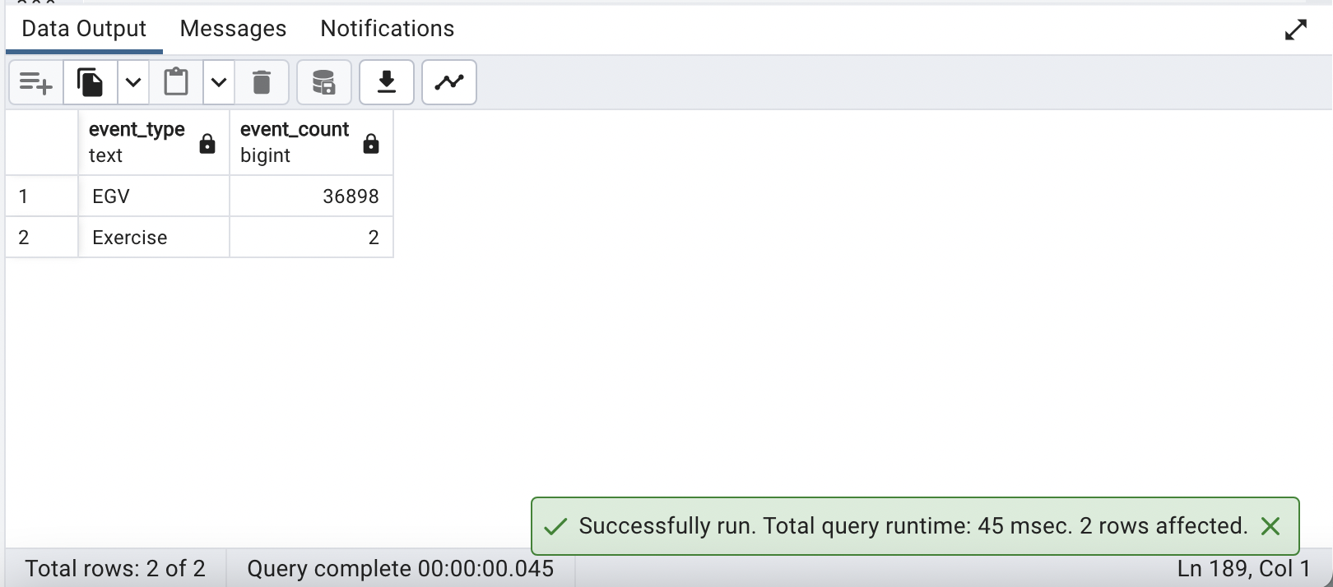

1. **How many prediabetic/diabetic patients also had a high level of stress?**

**QUERY:**

| ***-- Create a Common Table Expression (CTE) to classify patients based on HbA1c levels and determine their stress levels.***  **WITH PatientStatus AS (**  **SELECT**  **d.patientid,**  **CASE**  **WHEN d.hba1c >= 5.7 AND d.hba1c < 6.5 THEN 'Prediabetic' *-- Prediabetic Patients***  **WHEN d.hba1c >= 6.5 THEN 'Diabetic' *-- Diabetic patients***  **ELSE 'Normal'**  **END AS diabetes_status,**  **CASE**  **WHEN**  **MAX(e.mean_eda) > 40**  **OR**  **MAX(h.mean_hr) > 100**  **OR**  **AVG(i.rmssd_ms) * 600 < 20**  **THEN 'High Stress'**  **ELSE 'Normal Stress'**  **END AS stress_level**  **FROM demographics d**  **JOIN eda e ON d.patientid = e.patientid**  **JOIN hr h ON d.patientid = h.patientid**  **JOIN ibi i ON d.patientid = i.patientid**  **GROUP BY**  **d.patientid, d.hba1c**  **)**  ***-- Query to count patients in different diabetes status categories and total stress levels.***  **SELECT**  **COUNT(*) FILTER (WHERE diabetes_status = 'Prediabetic') AS prediabetic_count,**  **COUNT(*) FILTER (WHERE diabetes_status = 'Diabetic') AS diabetic_count,**  **COUNT(*) FILTER (WHERE diabetes_status IN ('Prediabetic', 'Diabetic')) AS total_count**  **FROM**  **PatientStatus;** |
| --- |

**OUTPUT:**

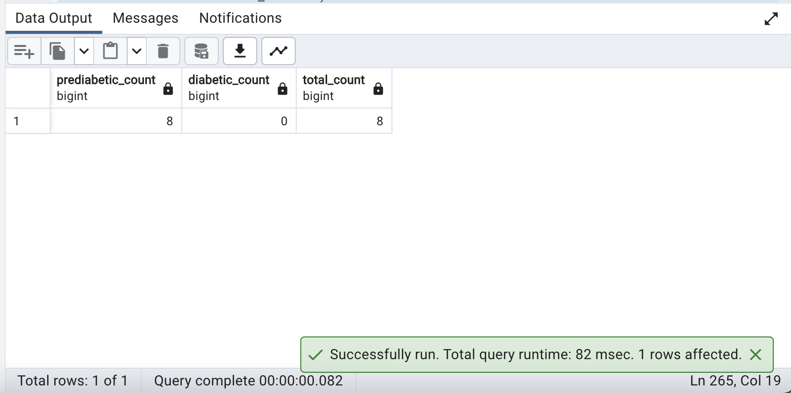

1. **List the food that coincided with the time of highest blood sugar for every patient**

**QUERY:**

| ***-- Create a Common Table Expression (CTE) to find the maximum blood sugar level for each patient.***  **WITH MaxBloodSugar AS (**  ***-- Subquery to find the maximum blood sugar level for each patient***  **SELECT**  **d.patientid,**  **MAX(dc.glucose_value_mgdl) AS max_glucose**  **FROM**  **demographics d**  **JOIN**  **dexcom dc ON d.patientid = dc.patientid**  **GROUP BY**  **d.patientid**  **)**  ***-- Query to list the food that coincided with the time of the highest blood sugar for every patient.***  **SELECT**  **d.patientid,**  **dc.datestamp AS high_blood_sugar_time,**  **fl.logged_food AS food_entry**  **FROM**  **MaxBloodSugar m**  **JOIN**  **dexcom dc ON m.patientid = dc.patientid**  **AND**  **m.max_glucose = dc.glucose_value_mgdl**  **JOIN**  **demographics d**  **ON**  **m.patientid = d.patientid**  **JOIN**  **foodlog fl**  **ON**  **m.patientid = fl.patientid**  **AND dc.datestamp = fl.datetime**  **ORDER BY**  **m.patientid, dc.datestamp;** |
| --- |

**OUTPUT:**

**UNDERSTANDING/EXPLANATION:**

There are no food entries at the exact time of a patient's high blood sugar level, that why the query isn't returning any results.

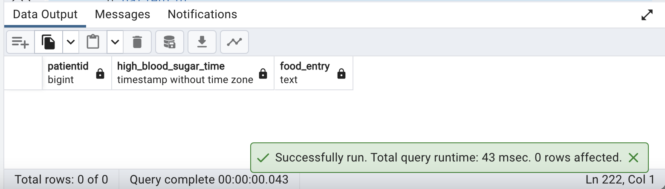

1. **How many patients have first names with length >7 letters?**

**QUERY:**

| ***-- Count the number of patients whose first names are longer than 7 characters.***  **SELECT COUNT(*) AS patient_count *-- Count and give an alias 'patient_count' to the result.***  **FROM demographics *-- From the demographics table.***  **WHERE LENGTH(firstname) > 7; *-- Filter for records where the length of the first name is greater than 7 characters.*** |
| --- |

**OUTPUT:**

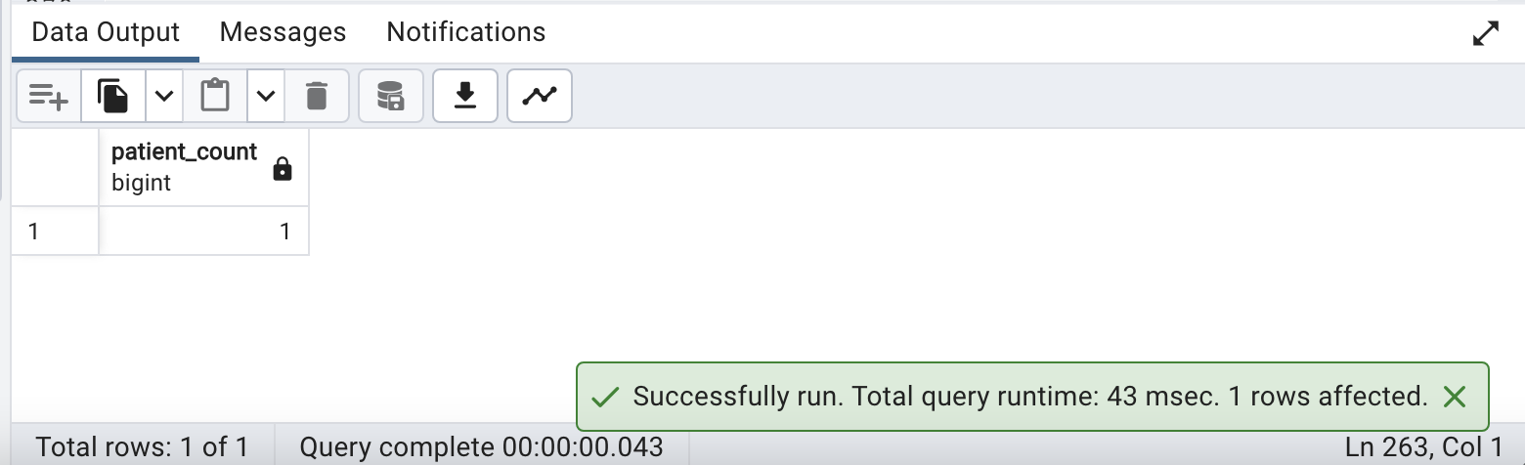

1. **List all foods logged that end with 'se'. Ensure that the output is in Title Case**

**QUERY:**

| ***-- Select distinct food items ending with 'se,' convert them to title case, and order them alphabetically.***  **SELECT DISTINCT**  **INITCAP(logged_food) AS logged_food_in_title_case *-- Convert the logged_food column to title case.***  **FROM**  **foodlog *-- From the foodlog table.***  **WHERE**  **logged_food LIKE '%se' *-- Filter for food items that end with 'se.'***  **ORDER BY**  **logged_food_in_title_case; *-- Order the results in ascending order of the title-cased food names.*** |
| --- |

**OUTPUT:**

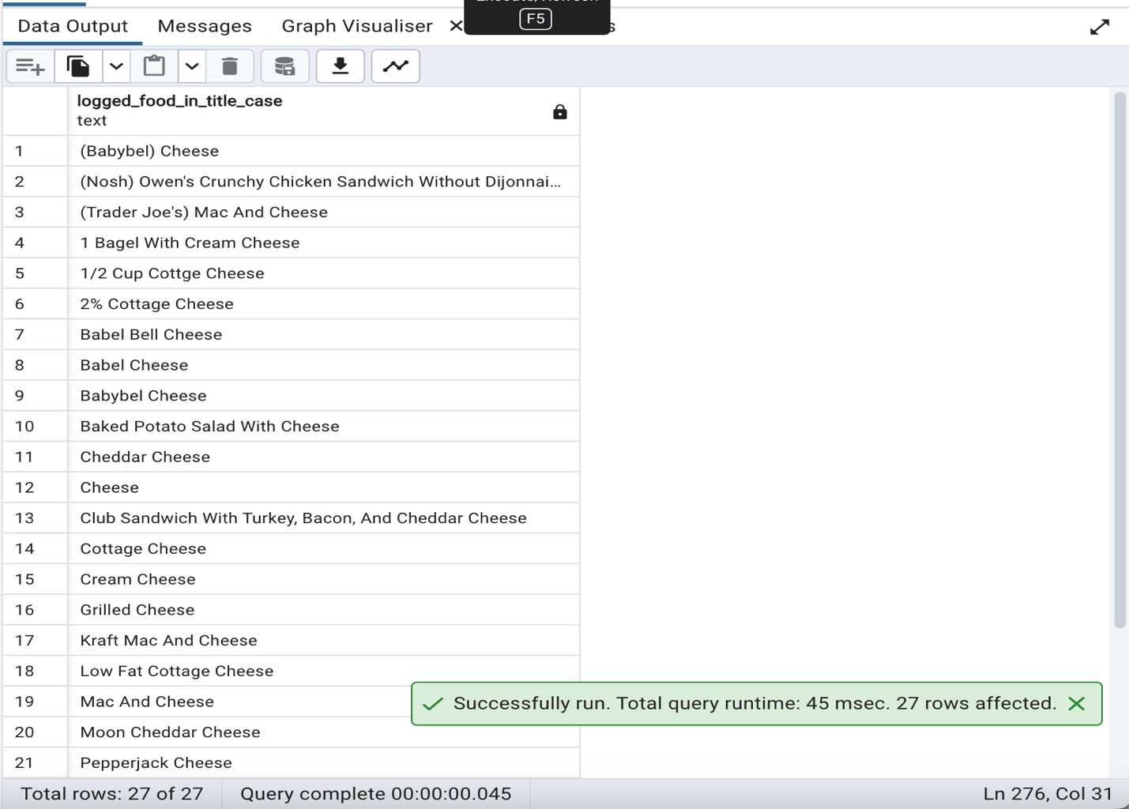

1. **List the patients who had a birthday the same week as their glucose or IBI readings**

**QUERY:**

| ***-- Select distinct patient information for patients with data in dexcom or ibi tables based on week-by-week comparison.***  **SELECT DISTINCT**  **dg.patientid,**  **dg.firstname,**  **dg.lastname,**  **dg.dob**  **FROM demographics dg**  **LEFT JOIN dexcom d *-- Left join with the dexcom table***  **ON dg.patientid = d.patientid**  **AND DATE_PART('week', dg.dob) = DATE_PART('week', d.datestamp)**  **LEFT JOIN ibi i *-- Left join with the ibi table***  **ON dg.patientid = i.patientid**  **AND DATE_PART('week', dg.dob) = DATE_PART('week', i.datestamp)**  **WHERE d.patientid IS NOT NULL OR i.patientid IS NOT NULL; *-- Filter for patients with data in either dexcom or ibi tables.*** |
| --- |

**OUTPUT:**

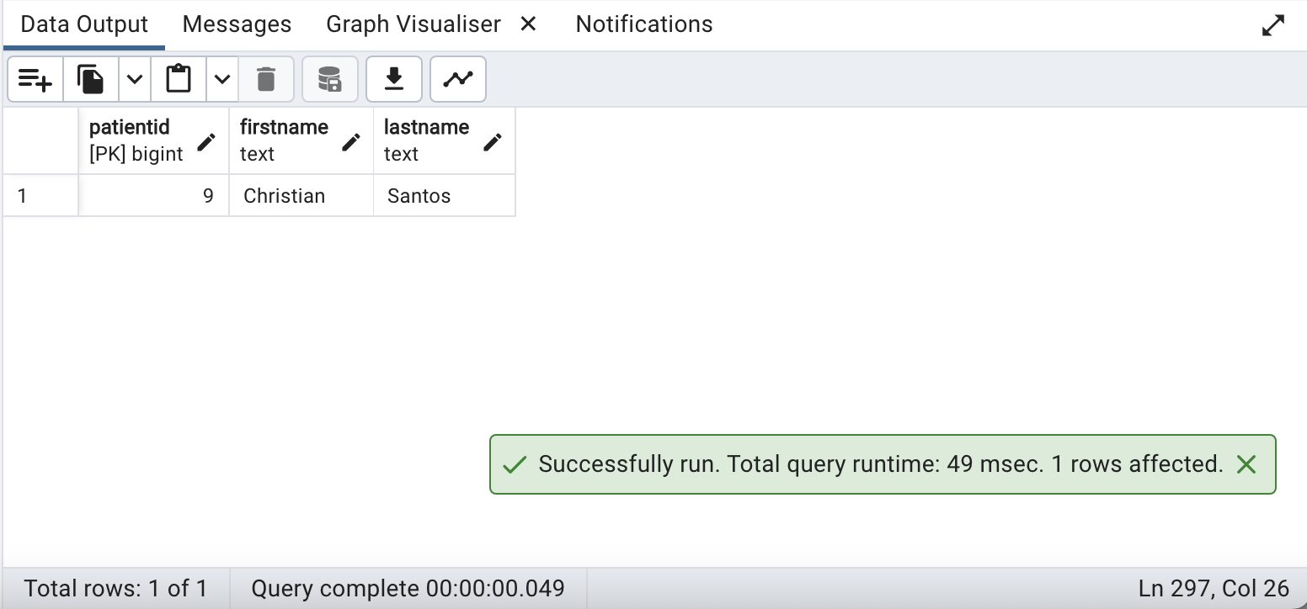

1. **Assuming breakfast is between 8 am and 11 am. How many patients ate a meal with bananas in it?**

**QUERY:**

| **SELECT count(distinct patientid) FROM foodlog**  **WHERE EXTRACT(HOUR FROM datetime) BETWEEN 8 AND 11**  **AND logged_food like '%Banana%';** |
| --- |

**OUTPUT:**

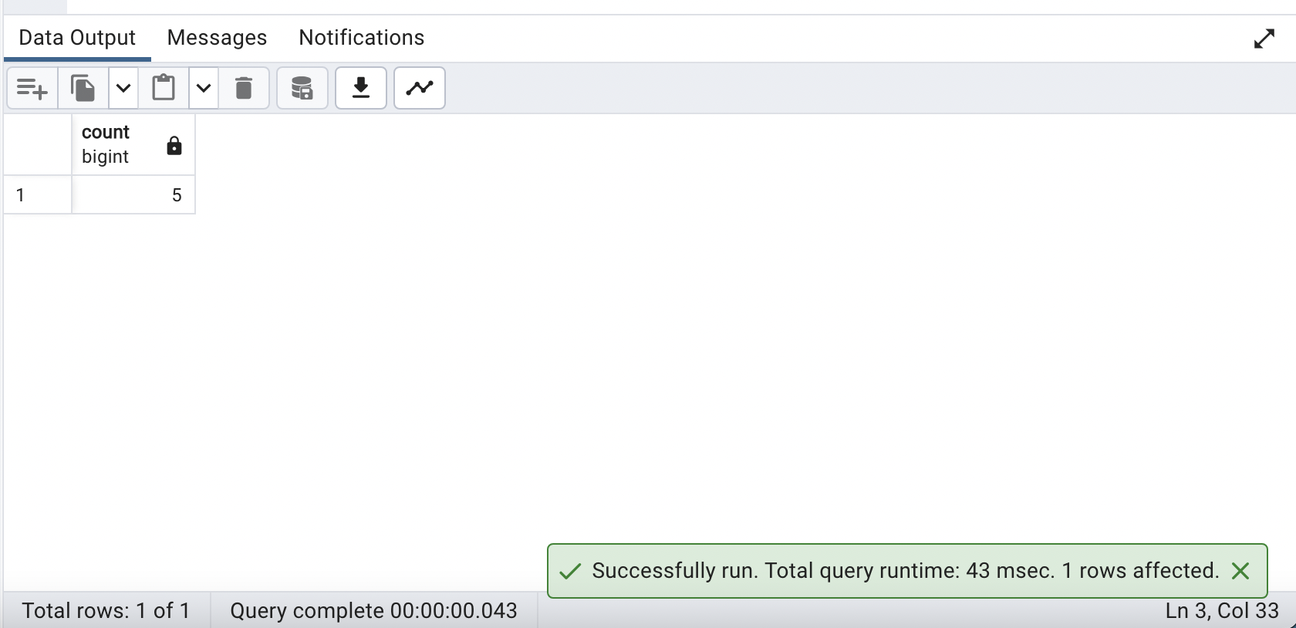

1. **Create a User defined function that returns the age of any patient based on input**

**QUERY:**

| ***-- Create or replace a PostgreSQL function named AgeOfPatient that takes a patientIdno as input***  **CREATE OR REPLACE FUNCTION AgeOfPatient(patientIdno bigint)**  **RETURNS TABLE (age interval)**  **AS $$**  **BEGIN**  ***-- Use RETURN QUERY to return the result of the SELECT statement***  **RETURN QUERY (**  ***-- Select the age of the patient based on their date of birth (dob)***  **SELECT AGE(CURRENT_DATE, dob)**  **FROM demographics**  **WHERE patientid = patientIdno**  **);**  **END;**  **$$ LANGUAGE plpgsql; *-- Define the language for the function***  **SELECT * FROM AgeOfPatient(1);** |
| --- |

**OUTPUT:**

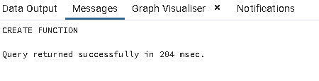

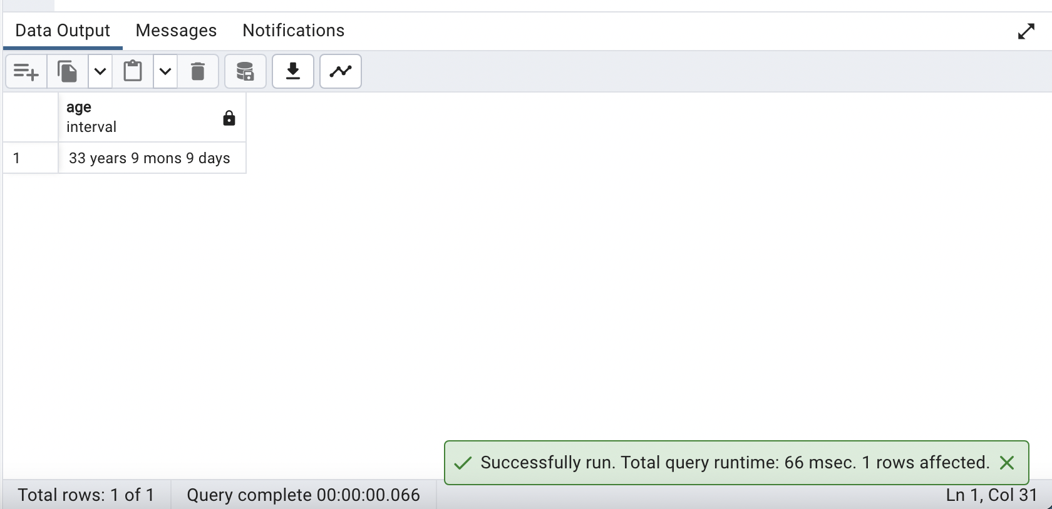

1. **Based on Number of hyper and hypoglycemic incidents per patient, which patient has the least control over their blood sugar?**

**QUERY:**

| ***-- Select the patient with the most readings below 70 or above 125 mg/dL.***  **SELECT**  **patientid**  **FROM**  **dexcom**  **WHERE**  **glucose_value_mgdl < 70 *-- Filter for glucose values below 70 mg/dL***  **OR glucose_value_mgdl >= 126 *-- or glucose values above or equal to 126 mg/dL***  **GROUP BY**  **patientid**  **ORDER BY**  **COUNT(1) DESC *-- Order the groups in descending order of count***  **LIMIT 1; *-- Limit the result to the top (most frequent) patient*** |
| --- |

**OUTPUT:**

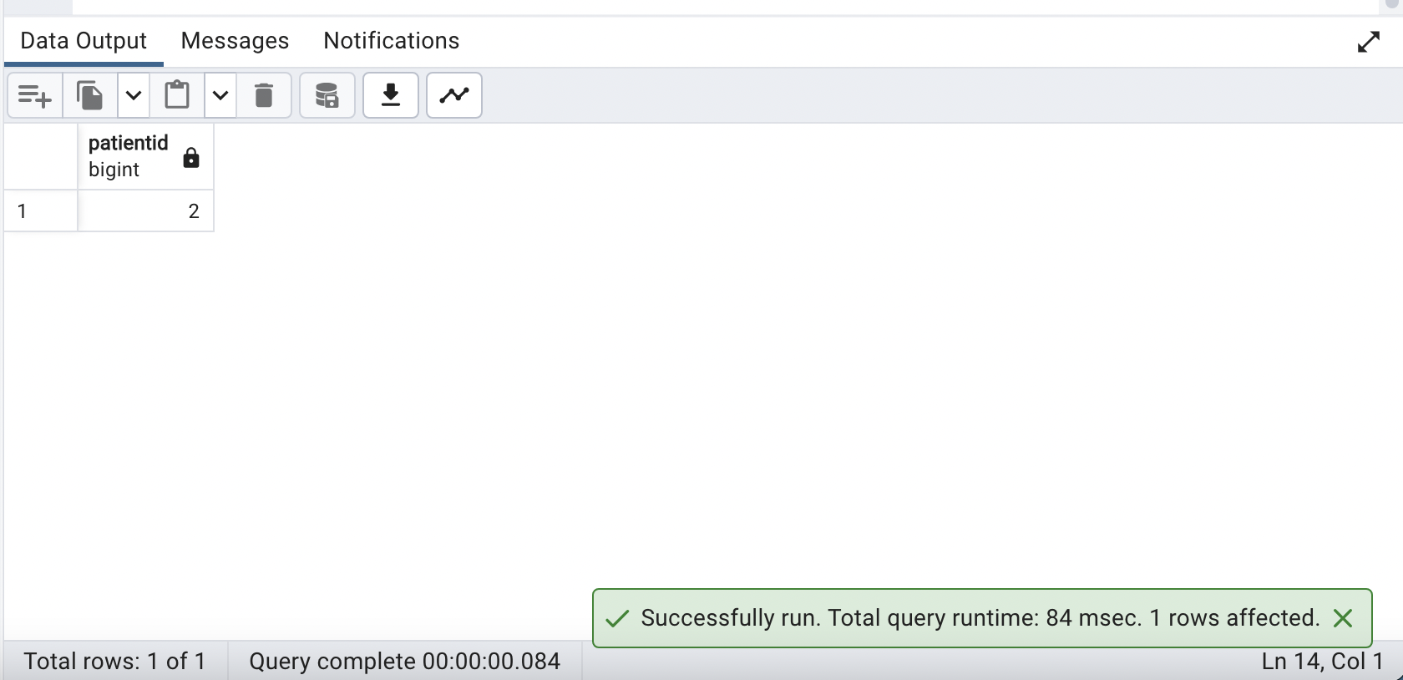

1. **Display patients details with event details and minimum heart rate**

**QUERY:**

| ***-- Select distinct patient information along with event type and minimum heart rate.***  **SELECT DISTINCT**  **d.patientid,**  **d.gender,**  **d.hba1c,**  **d.dob,**  **e.event_type,**  **(**  **SELECT MIN(min_hr) *-- Subquery to find the minimum heart rate for the patient***  **FROM hr**  **WHERE patientid = d.patientid**  **) AS min_heart_rate**  **FROM**  **demographics d**  **JOIN**  **dexcom dx *-- Join with the dexcom table based on patient ID***  **ON**  **d.patientid = dx.patientid**  **JOIN**  **eventtype e*-- Join with the eventtype table based on event ID***  **ON**  **dx.eventid = e.id**  **ORDER BY**  **d.patientid;*-- Order the results by patient ID*** |
| --- |

**OUTPUT:**

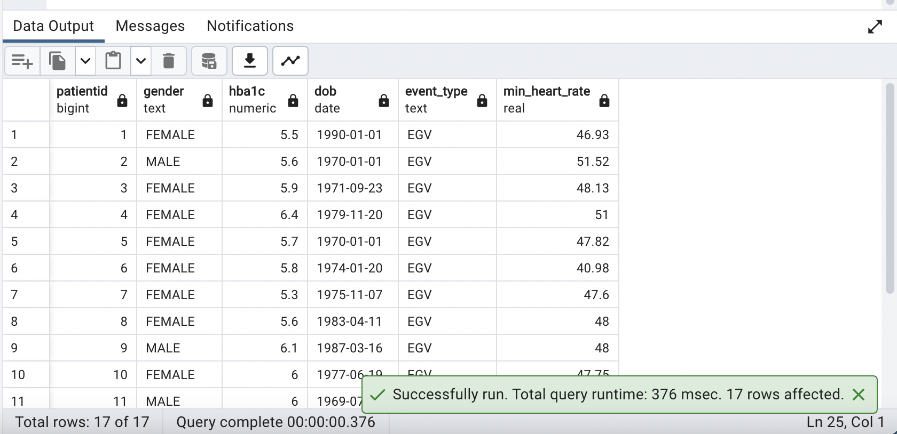

1. **Display a list of patients whose daily max_eda lies between 40 and 50.**

**QUERY:**

| ***SELECT DISTINCT patientid***  ***FROM (***  ***SELECT patientid, max_eda***  ***FROM eda***  ***WHERE max_eda BETWEEN 40 AND 50***  ***) AS filtered_eda;*** |
| --- |

**OUTPUT:**

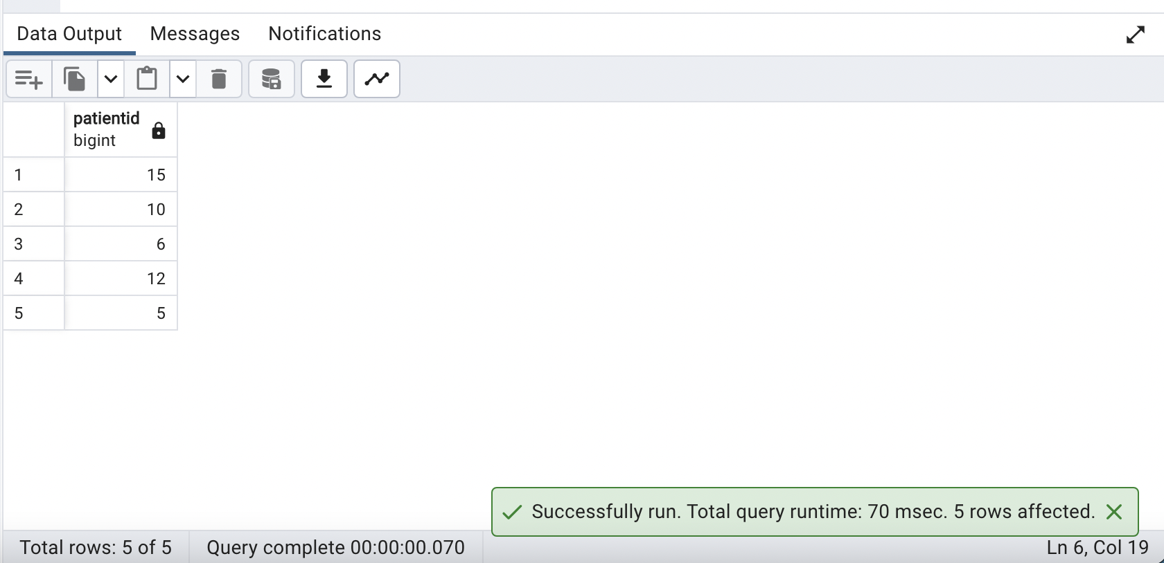

1. **Count the number of hyper and hypoglycemic incidents per patient**

**QUERY:**

| ***-- Retrieve the count of hypo and hyperglycemic incidents for each patient and perform a full join on patientid.***  **SELECT**  **second.patientid,**  **first.hypo_incidents,**  **second.hyper_incidents**  **FROM**  **(**  ***-- Subquery to count hypo incidents for each patient***  **SELECT**  **patientid,**  **COUNT(glucose_value_mgdl) as hypo_incidents *-- Count of glucose values below 70 mg/dL***  **FROM**  **dexcom**  **WHERE**  **glucose_value_mgdl < 70*-- Filter for hypo incidents***  **GROUP BY**  **patientid**  **) first**  **FULL JOIN**  **(**  ***-- Subquery to count hyper incidents for each patient***  **SELECT**  **patientid,**  **COUNT(glucose_value_mgdl) as hyper_incidents *-- Count of glucose values greater than or equal to 126 mg/dL***  **FROM**  **dexcom**  **WHERE**  **glucose_value_mgdl >= 126 *-- Filter for hyper incidents***  **GROUP BY**  **patientid**  **) second**  **ON**  **first.patientid = second.patientid**  **ORDER BY**  **patientid; *-- Order the results by patient identifier*** |
| --- |

**OUTPUT:**

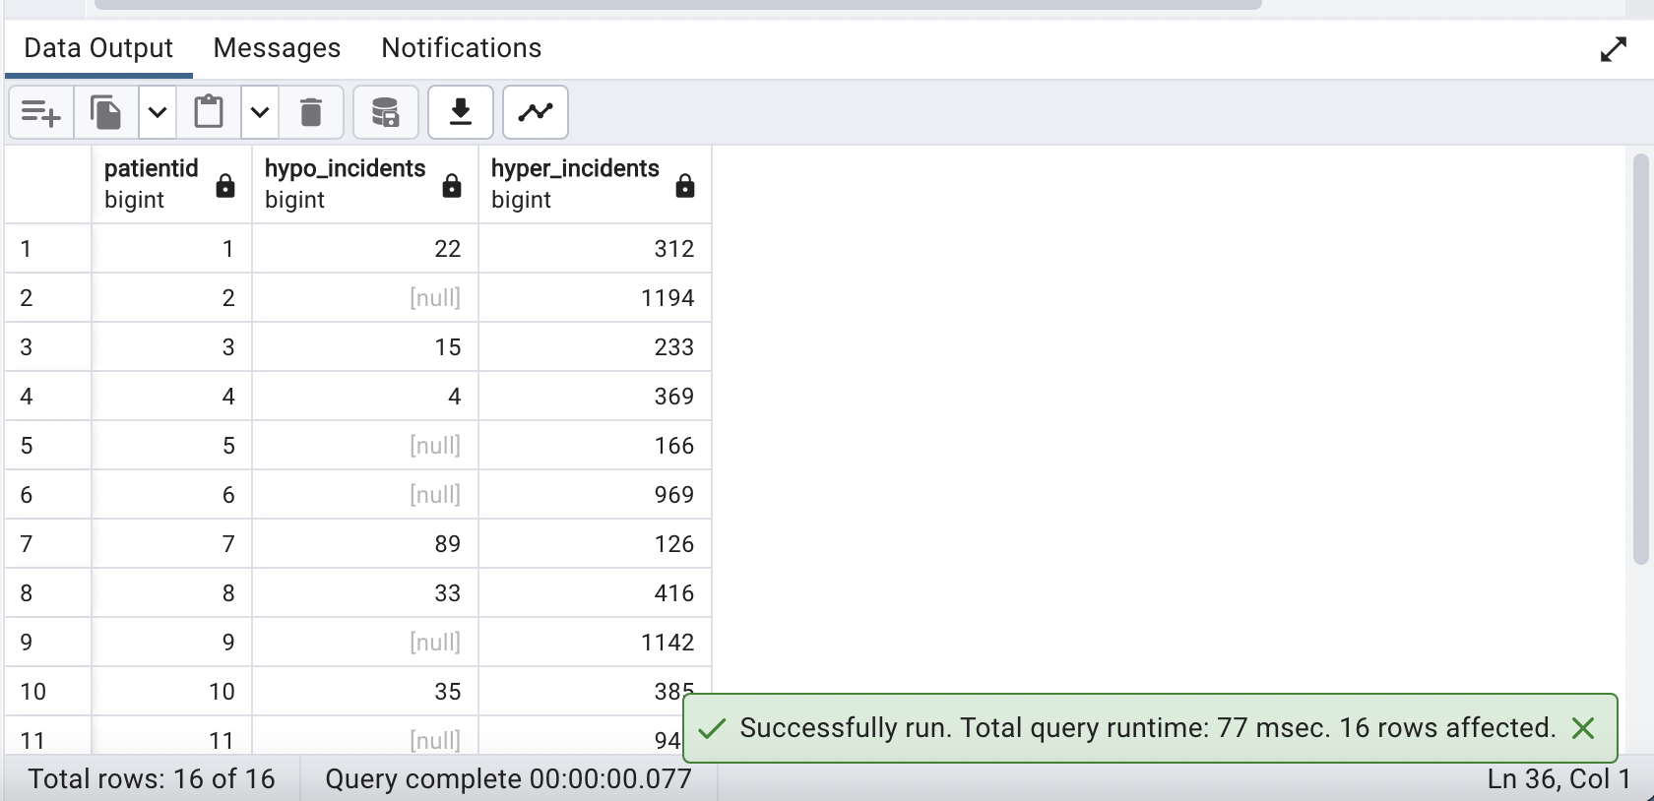

1. **What is the variance from mean for all patients for the table IBI?**

**QUERY:**

| ***-- Calculate the variance of mean interbeat intervals (IBI) for each patient.***  **SELECT**  **patientid,**  **VARIANCE(mean_ibi_ms) AS Variance *-- Calculate and alias the variance of mean IBI***  **FROM**  **ibi**  **GROUP BY**  **patientid;** |
| --- |

**OUTPUT:**

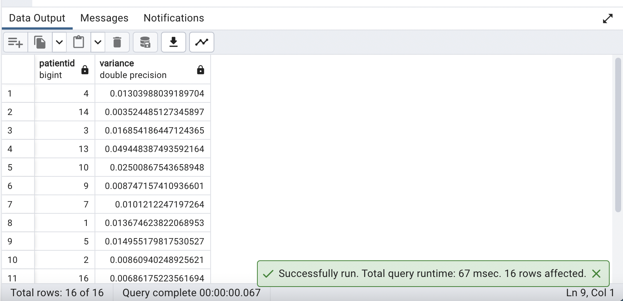

1. **Create a view that combines all relevant patient demographics and lab markers into one. Call this view ‘Patient_Overview’.**

**QUERY:**

| ***-- Create or replace a view named Patient_Overview***  **CREATE OR REPLACE VIEW Patient_Overview AS**  ***-- Select distinct patient information and calculate average mean heart rate***  **SELECT DISTINCT d.patientid,d.firstname ||' '|| d.lastname AS patient_name, d.gender, d.hba1c**  **,AVG(h.mean_hr)**  **FROM demographics d**  **JOIN hr h**  **ON d.patientid = h.patientid**  **GROUP BY d.patientid**  **ORDER BY d.patientid;**  **SELECT * FROM Patient_Overview;** |
| --- |

**OUTPUT:**

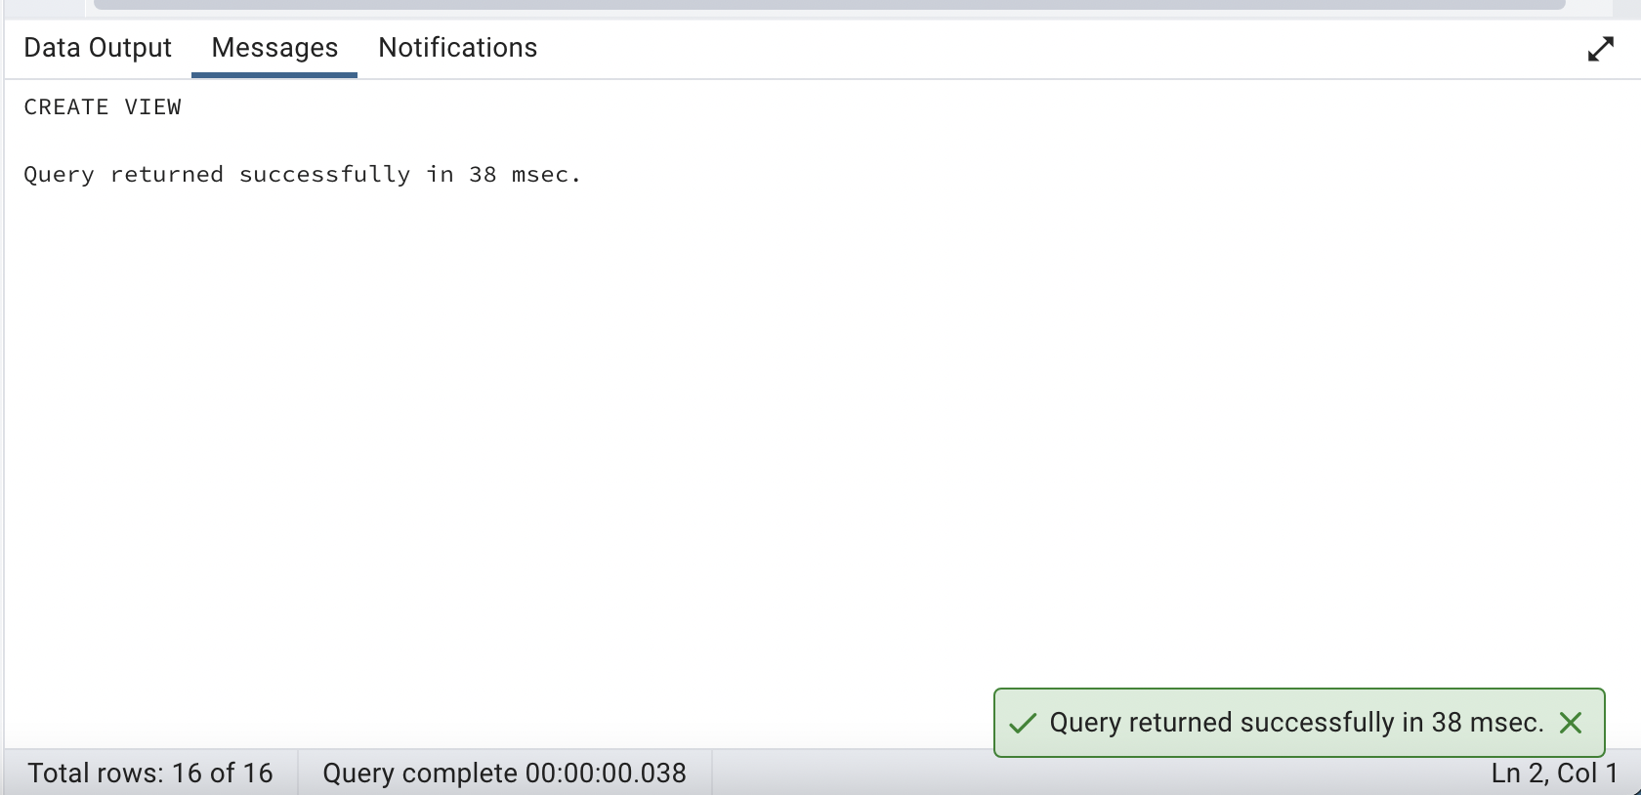

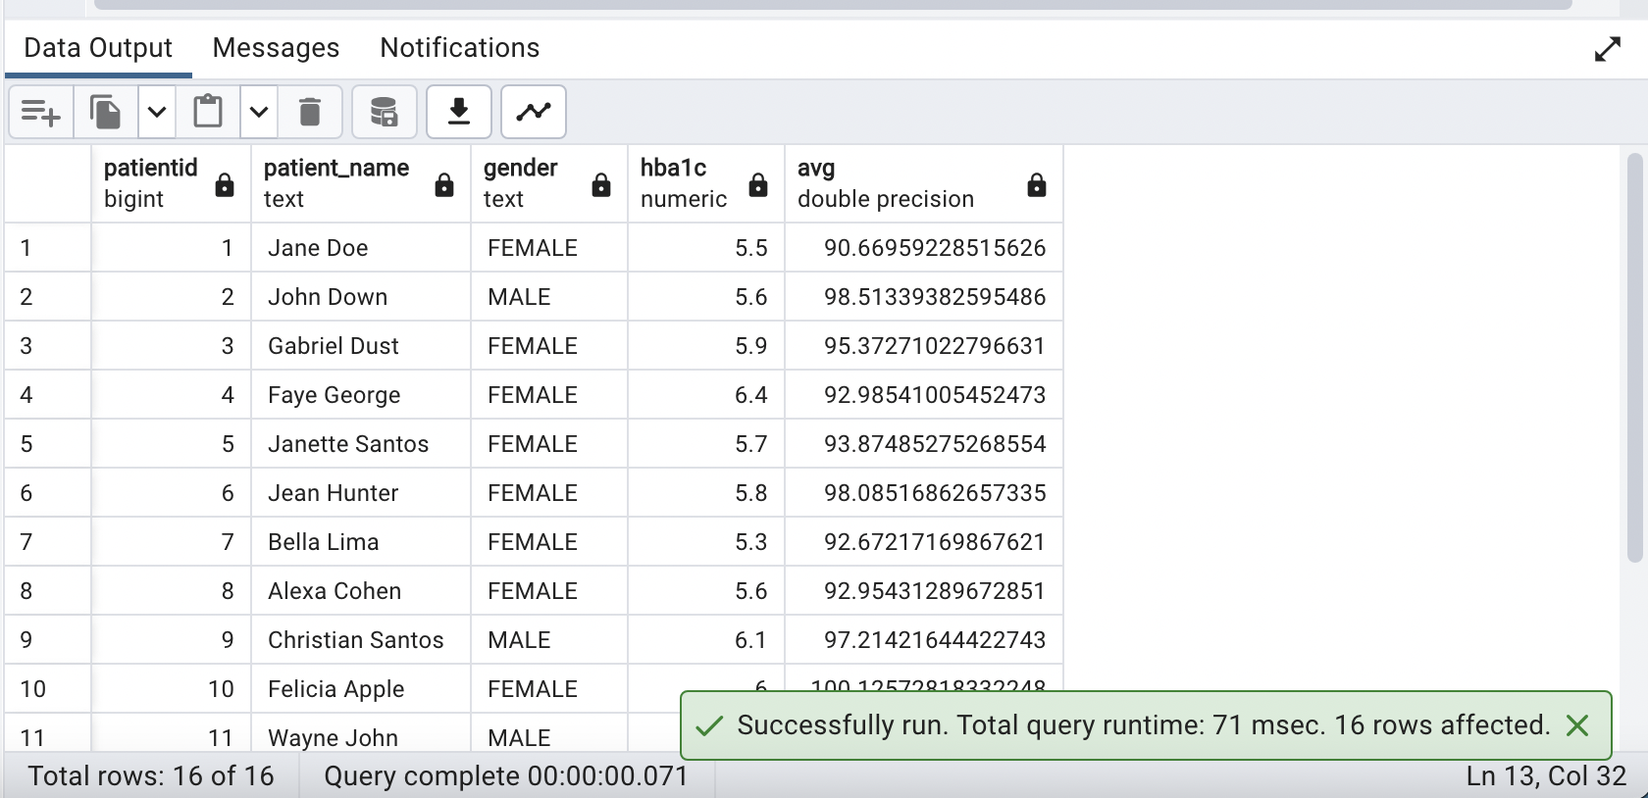

1. **Create a table that stores an array of biomarkers: Min(Glucose Value), Avg(Mean_HR), Max(Max_EDA) for every patient.**

**QUERY:**

| ***-- Create a table named Array_of_biometrics***  **CREATE TABLE Array_of_biometrics AS**  ***-- Select and aggregate patient biometric data as a numeric array***  **SELECT**  **CAST(d.patientid AS int) AS pid, *-- Cast patientid as an integer***  **CAST(**  **'{' || MIN(glucose_value_mgdl) || ',' || AVG(mean_hr) || ',' || MAX(max_eda) || '}'**  **AS numeric[]**  **) AS biomarkers *-- Create a numeric array containing aggregated biometric values***  **FROM**  **demographics d**  **INNER JOIN**  **eda e ON d.patientid = e.patientid**  **INNER JOIN**  **hr h ON d.patientid = h.patientid**  **INNER JOIN**  **dexcom dx ON d.patientid = dx.patientid**  **GROUP BY**  **d.patientid**  **ORDER BY**  **d.patientid;**  **SELECT * FROM Array_of_biometrics** |
| --- |

**OUTPUT:**

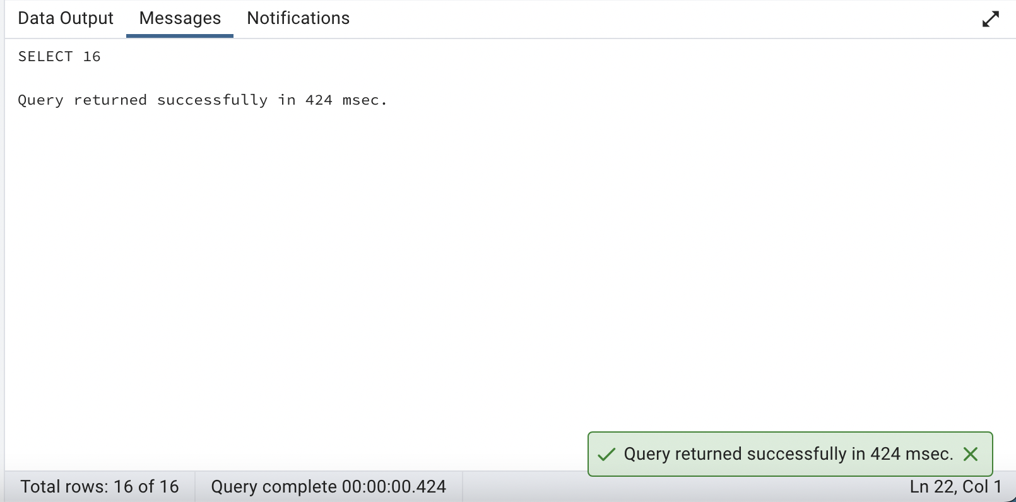

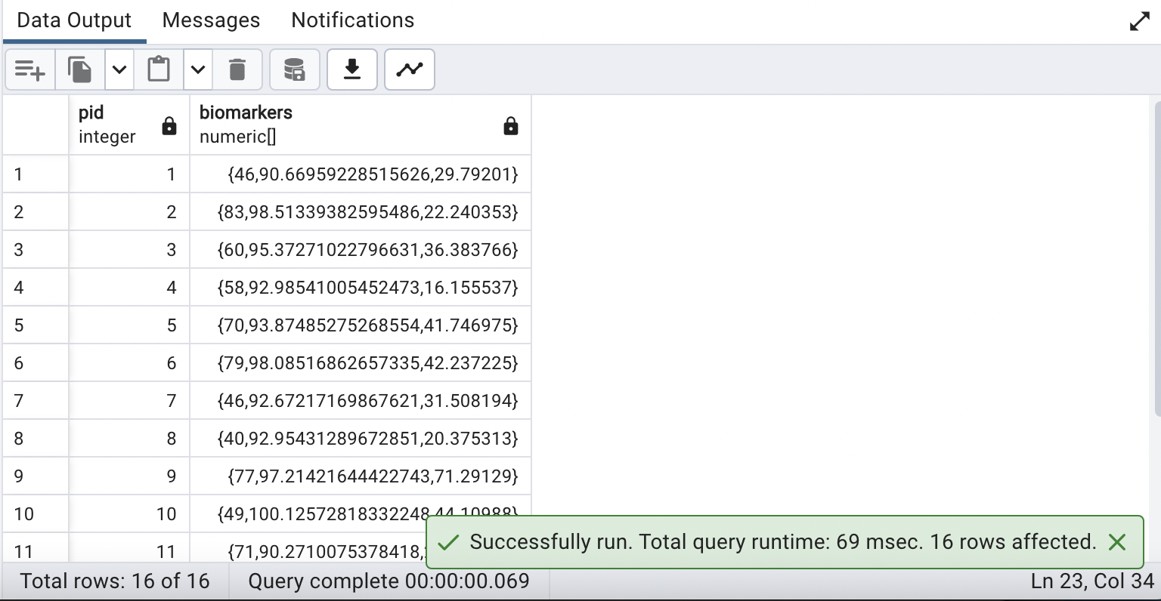

1. **Assuming lunch is between 12pm and 2pm. Calculate the total number of calories consumed by each patient for lunch on "2020-02-24"**

**QUERY:**

| ***-- Select patient IDs and the sum of calories consumed during a specific time range on a specific date.***  **SELECT**  **patientid,**  **SUM(calorie)**  **FROM**  **foodlog**  **WHERE**  **EXTRACT(HOUR FROM datetime) BETWEEN 12 AND 14 *-- Filter for records between 12:00 PM and 2:00 PM***  **AND DATE(datetime) = '2020-02-24' *-- Filter for records on the specific date '2020-02-24'***  **GROUP BY**  **patientid; *-- Group the results by patient identifier*** |
| --- |

**OUTPUT:**

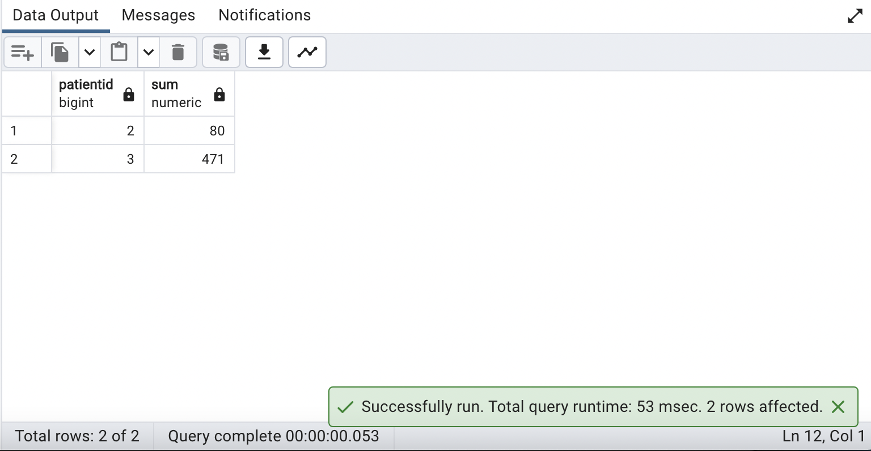

1. **What is the total length of time recorded for each patient(in hours) in the Dexcom table?**

**QUERY:**

| ***-- Calculate the total hours between the maximum and minimum datestamps for each patient***  **SELECT**  **patientid,**  **ROUND(EXTRACT(EPOCH FROM (MAX(datestamp) - MIN(datestamp))) / 3600) AS total_hours *-- Calculate total hours and round***  **FROM**  **dexcom**  **GROUP BY**  **patientid**  **ORDER BY**  **patientid;** |
| --- |

**OUTPUT:**

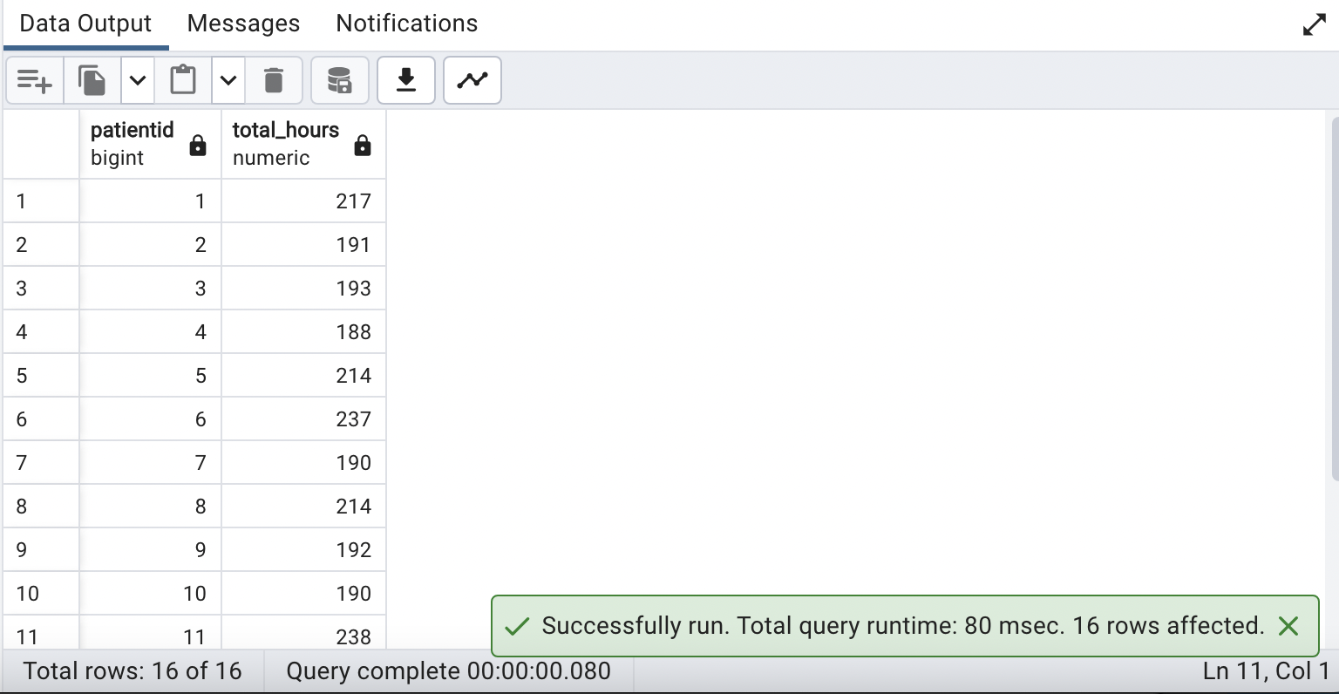

1. **Display the first, last name, patient age and max glucose reading in one string for every patient**

**QUERY:**

| ***-- Select patient information and the maximum glucose value as a concatenated string.***  **SELECT**  **d.patientid,**  **d.firstname || ', ' || d.lastname *-- Concatenate first name and last name***  **|| ', ' || AGE(CURRENT_DATE, d.dob)*-- Concatenate age calculated from date of birth***  **|| ', ' || MAX(dx.glucose_value_mgdl) AS oneString*-- Concatenate maximum glucose value***  **FROM**  **demographics d *-- Data is sourced from the demographics table (aliased as 'd')***  **JOIN**  **dexcom dx ON d.patientid = dx.patientid *-- Join with dexcom table based on patient ID***  **GROUP BY**  **d.patientid;*-- Group the results by patient identifier*** |
| --- |

**OUTPUT:**

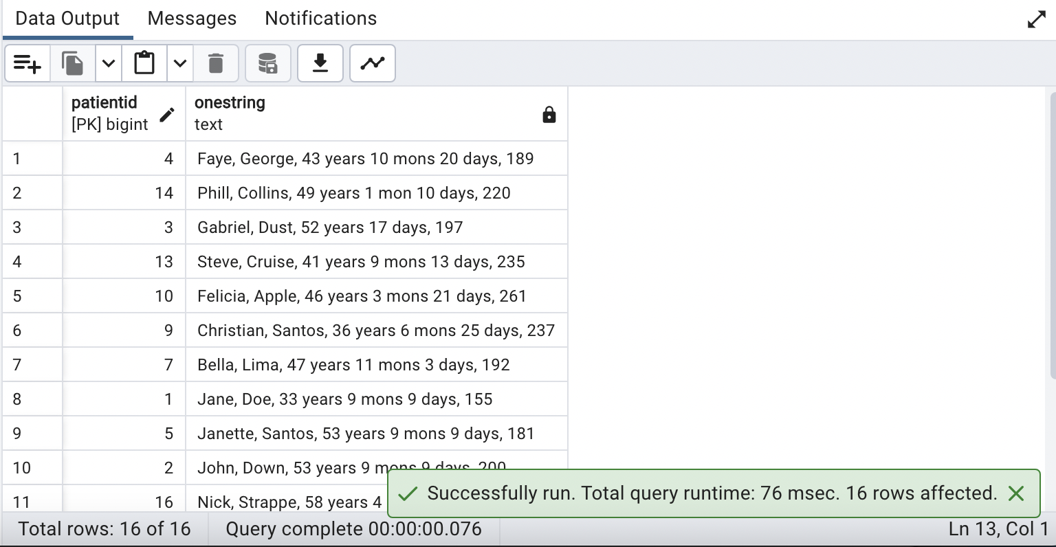

1. **What is the average age of all patients in the database?**

**QUERY:**

| ***-- Calculate the average age of patients***  **SELECT AVG(age) *-- Calculate the average of the calculated ages***  **FROM**  **(SELECT**  **patientid,**  **AGE(CURRENT_DATE, dob) AS age*-- Calculate the age based on the date of birth***  **FROM**  **demographics**  **GROUP BY**  **patientid) a;** |
| --- |

**OUTPUT:**

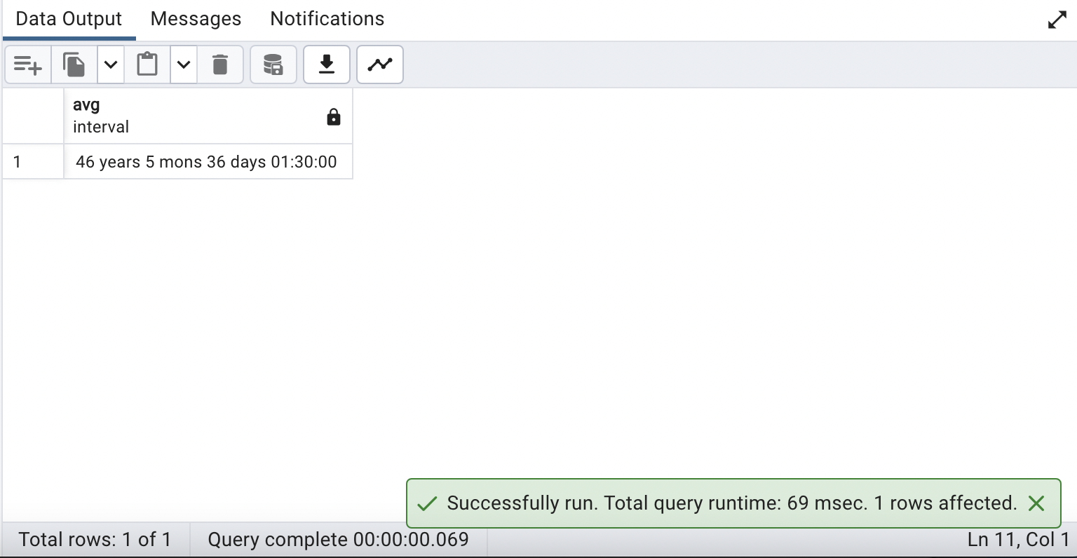

1. **Display All female patients with age less than 50**

**QUERY:**

| ***-- Select patient information for female patients under the age of 50***  **SELECT**  **patientid,**  **gender,**  **AGE(CURRENT_DATE, dob) AS age**  **FROM**  **demographics**  **WHERE**  **gender = 'FEMALE' *-- Filter for female patients***  **AND EXTRACT(YEAR FROM AGE(CURRENT_DATE, dob)) < 50 *-- Filter for patients under the age of 50***  **ORDER BY**  **patientid;** |
| --- |

**OUTPUT:**

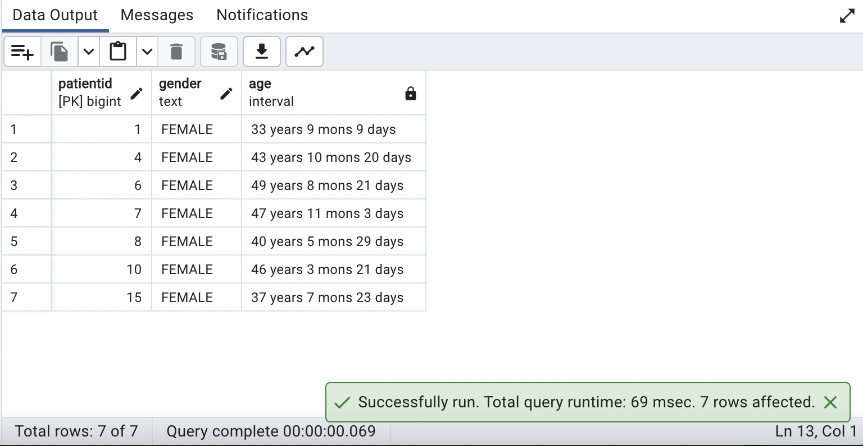

1. **Display count of Event ID, Event Subtype and the first letter of the event subtype. Display all events**

**QUERY:**

| ***-- Retrieve data from the eventtype table, count occurrences, and order by id***  **SELECT id,event_subtype,LEFT(event_subtype,1),count(1) as CNT**  **FROM eventtype**  **GROUP BY id,event_subtype,LEFT(event_subtype,1)**  **order by id;** |
| --- |

**OUTPUT:**

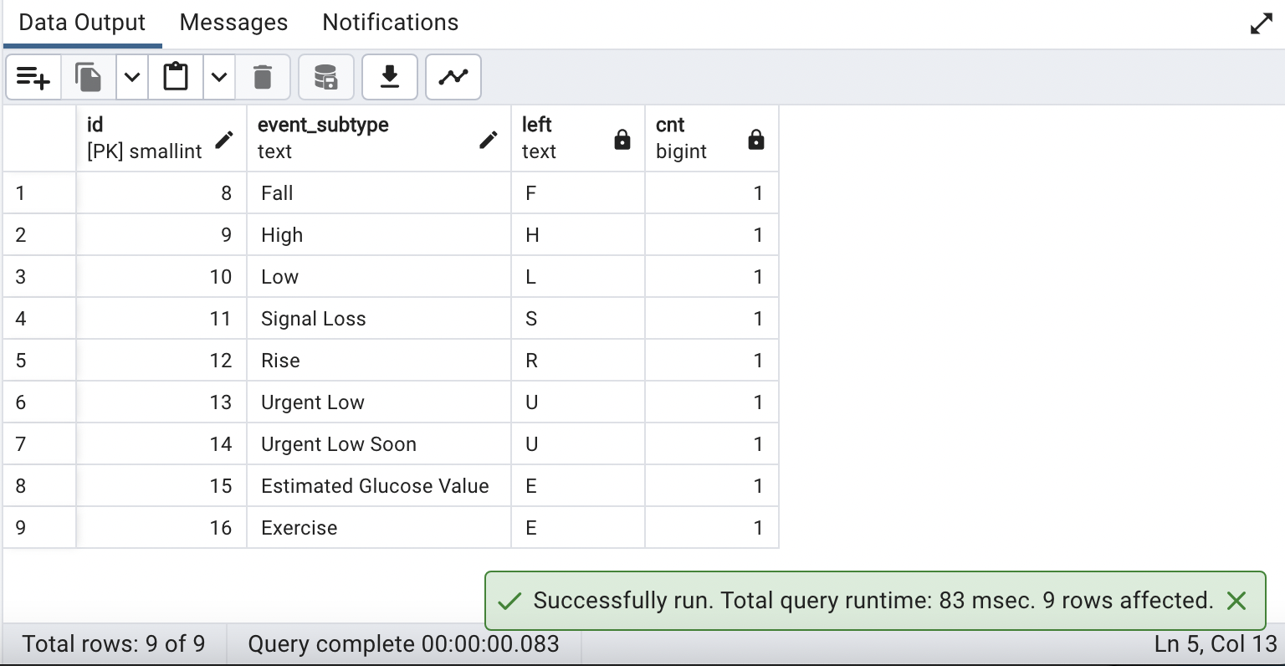

1. **List the foods consumed by the patient(s) whose eventype is "Estimated Glucose Value".**

**QUERY:**

| **SELECT DISTINCT f.logged_food FROM dexcom d**  **JOIN eventtype e**  **ON d.eventid = e.id**  **JOIN foodlog f**  **ON d.patientid = f.patientid**  **WHERE e.event_subtype='Estimated Glucose Value'** |
| --- |

**OUTPUT:**

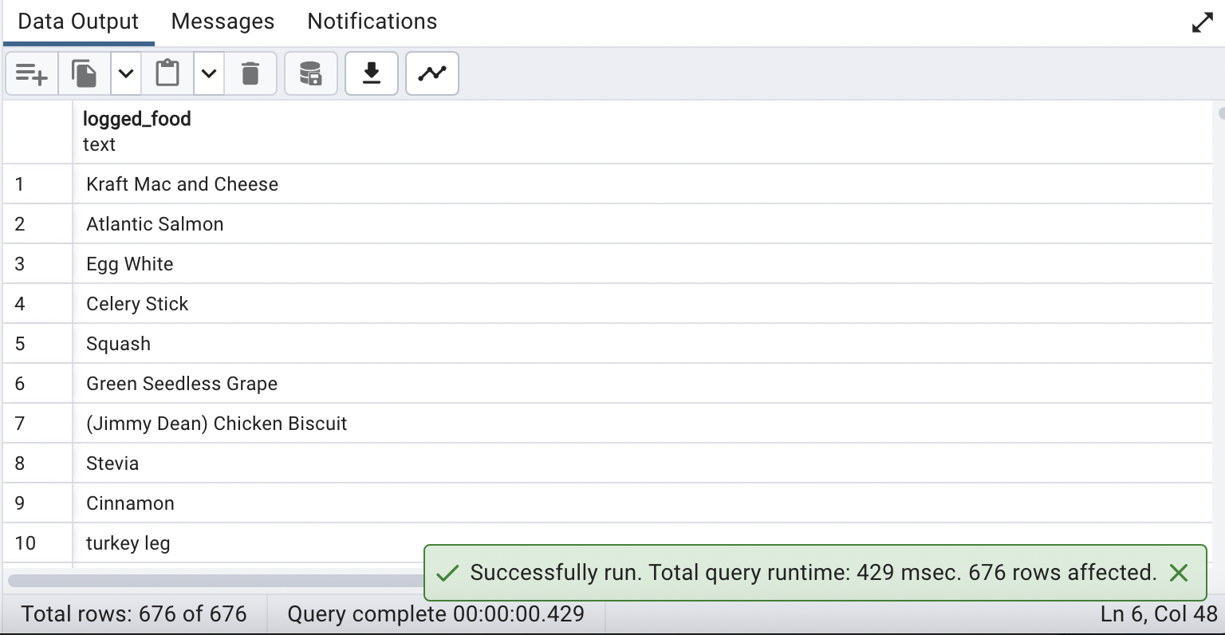

1. **Rank the patients' health based on HRV and Control of blood sugar(AKA min time spent out of range)**

**QUERY:**

| ***--Step 1 :Create a 'hrv' field to table 'ibi' to store Heat Rate Variability***  ***--Add 'hrv' field to table 'ibi'***  **ALTER TABLE ibi**  **ADD COLUMN hrv numeric;**  **UPDATE ibi**  **SET hrv = (SELECT AVG(rmssd_ms) * 600**  **FROM ibi AS sub**  **WHERE sub.patientid = ibi.patientid);**  ***--Step 2 : Create Table named 'hrv_bloodSugar' with HRV and Blood sugar data***  **CREATE TABLE hrv_bloodSugar AS**  **SELECT**  **d.patientid,**  **ROUND(AVG(dc.glucose_value_mgdl)) AS Glucose_Value,**  **ROUND(AVG(ibi.hrv)) AS HRV**  **FROM**  **demographics d**  **JOIN**  **dexcom dc ON d.patientid = dc.patientid**  **JOIN**  **ibi ON d.patientid = ibi.patientid**  **GROUP BY d.patientid**  **ORDER BY d.patientid;**  ***--Step 3 : Query to Rank patients health based on HRV and control of bloodsugar***    **WITH hrv_ranks AS (**  **SELECT**  **patientid,**  **RANK() OVER (ORDER BY hrv DESC) AS hrv_rank**  **FROM**  **hrv_bloodsugar**  **),**  **bs_ranks AS (**  **SELECT**  **patientid,**  **RANK() OVER (ORDER BY glucose_value ASC) AS bloodsugar_rank**  **FROM**  **hrv_bloodsugar**  **)**  **SELECT**  **hrvbs.patientid,**  **hrvbs.HRV AS HRV_Value,**  **hrvbs.Glucose_Value,**  **hrv.hrv_rank AS hrv_rank,**  **bs.bloodsugar_rank bloodsugar_rank**  **FROM**  **hrv_bloodsugar hrvbs**  **LEFT JOIN**  **hrv_ranks hrv ON hrvbs.patientid = hrv.patientid**  **LEFT JOIN**  **bs_ranks bs ON hrvbs.patientid = bs.patientid;** |
| --- |

**OUTPUT:**

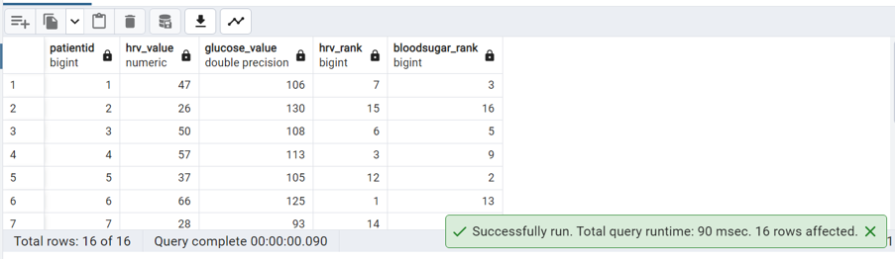

**66. Create a trigger on the foodlog table that warns a person about any food logged that has more than 20 grams of sugar. The user should not be stopped from inserting the row. Only a warning is needed**

**QUERY:**

| **CREATE FUNCTION check_sugar_limit() *--Create trigger function***  **RETURNS TRIGGER AS $$**  **BEGIN**  **IF NEW.sugar > 20 THEN**  ***-- Raise a warning***  **RAISE WARNING 'The food item inserted has more than 20 grams of sugar.';**  **END IF;**  **RETURN NEW;**  **END;**  **$$ LANGUAGE plpgsql;**  ***--Drop Function***  **DROP FUNCTION check_sugar_limit();**  ***--CREATE TRIGGER statement***    **CREATE TRIGGER sugar_limit_trigger**  **AFTER INSERT ON foodlog**  **FOR EACH ROW**  **EXECUTE FUNCTION check_sugar_limit();**  ***--Drop a Trigger***  **DROP TRIGGER sugar_limit_trigger ON foodlog;**  ***--Trying to Insert a record on foodlog table with sugar greater than 20 grams.***  **INSERT INTO foodlog(**  **datetime, logged_food, calorie, total_carb, dietary_fiber, sugar, protein, total_fat, patientid)**  **VALUES ('2020-02-13 18:30:00', 'Juice', 413, 56, 2.3, 55, 12, 3,4);**  ***--The record will be inserted with a warning message "The food item inserted has more than 20 grams of sugar"*** |
| --- |

**OUTPUT:**

**Trigger Created :**

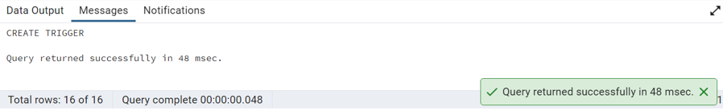

**Trying to Insert a record on foodlog table with sugar greater than 20 grams:**

**(Item inserted with a warning message)**

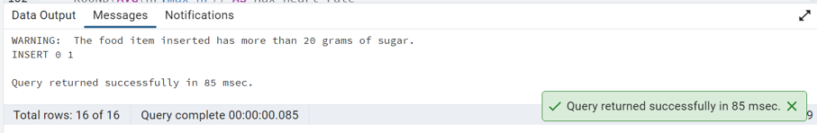

**67. Display all the patients with high heart rate and prediabetic**

**QUERY:**

| **SELECT**  **d.patientid,**  **d.firstname,**  **d.lastname,**  **d.gender,**  **ROUND(AVG(hr.max_hr)) AS Max_heart_rate**  **FROM**  **demographics d**  **JOIN**  **hr ON d.patientid = hr.patientid**  **GROUP BY d.patientid**  **HAVING**  **d.hba1c>=5.7 AND d.hba1c<=6.4 *---- filtering out Prediabetic patients***  **ORDER BY Max_heart_rate DESC;** |
| --- |

**OUTPUT:**

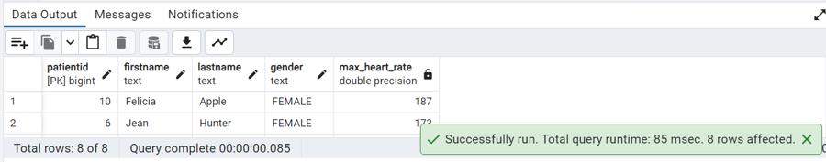

**68. Display patients information who have tachycardia HR and a glucose value greater than 200.**

**QUERY:**

| **SELECT**  **dc.patientid,**  **ROUND(AVG(hr.mean_hr)) AS Tachycardia_HR,**  **ROUND(MAX(dc.glucose_value_mgdl)) AS Glucose_Value**  **FROM**  **dexcom dc**  **JOIN**  **hr ON dc.patientid = hr.patientid**  **GROUP BY dc.patientid**  **HAVING**  **AVG(hr.mean_hr) > 100 AND MAX(dc.glucose_value_mgdl) > 200;** |
| --- |

**OUTPUT:**

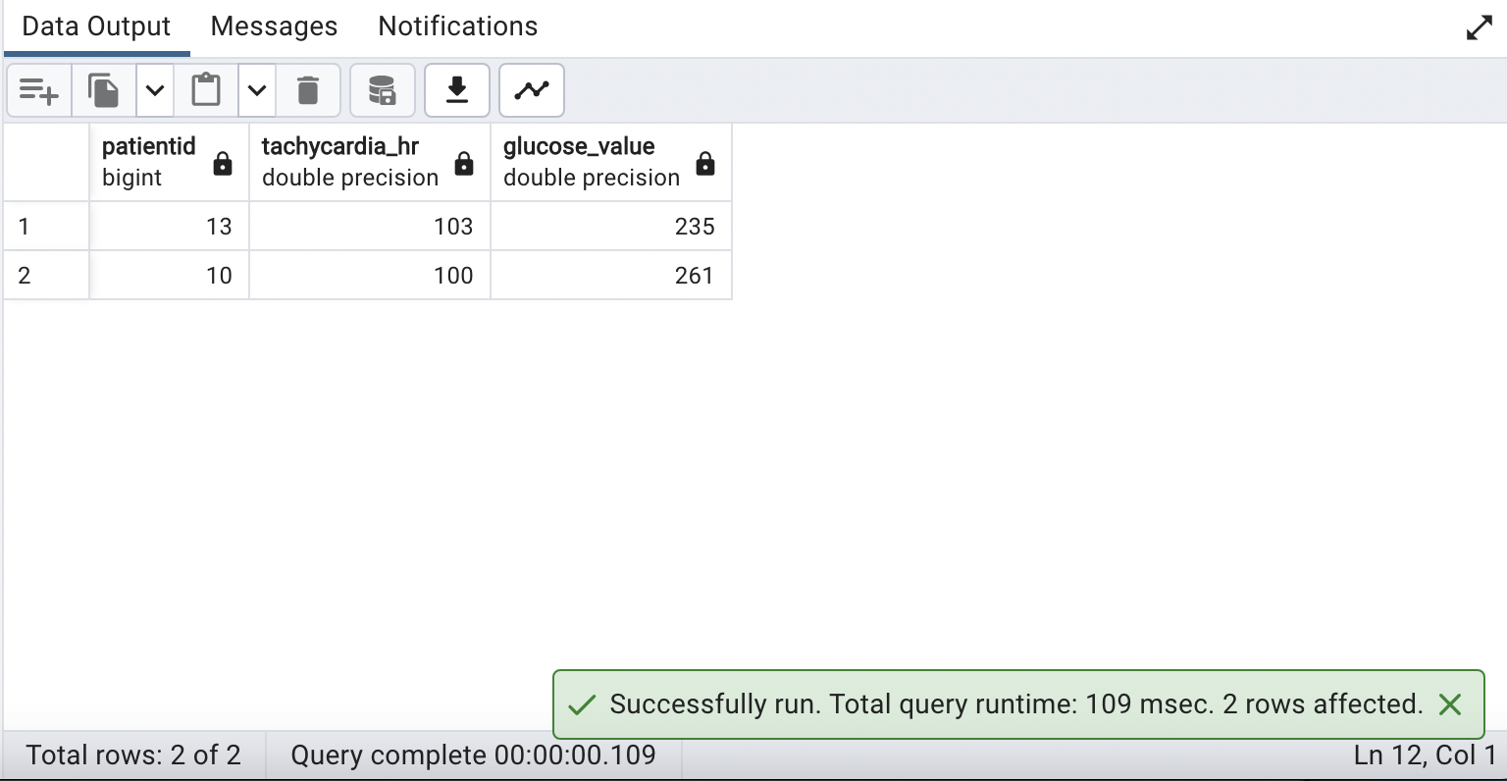

**69. Calculate the number of hypoglycemic incident per patient per day where glucose drops under 55**

**QUERY:**

| ***--use a common table expression (CTE) named hypoglycemic_incidents to count the number of hypoglycemic incidents (glucose drops under 55) per patient per day.***  **WITH hypoglycemic_incidents AS (**  **SELECT**  **patientid,**  **DATE_TRUNC('day', datestamp) AS incident_day,**  **COUNT(*) AS incident_count**  **FROM**  **dexcom as dc**  **WHERE**  **glucose_value_mgdl < 55**  **GROUP BY**  **patientid, incident_day**  **)**  **SELECT**  **patientid,**  **incident_day,**  **incident_count**  **FROM**  **hypoglycemic_incidents**  **ORDER BY**  **patientid, incident_day;** |
| --- |

**OUTPUT:**

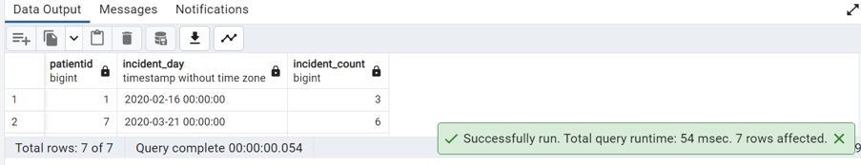

**70. List the day wise calories intake for each patient.**

**QUERY:**

| **SELECT**  **patientid,**  **DATE_TRUNC('day', datetime) AS date,**  **SUM(calorie) AS Total_calories_consumed *--Sum function to calulate total calories per day for each patient***  **FROM**  **foodlog**  **GROUP BY**  **patientid,DATE_TRUNC('day', datetime)**  **ORDER BY**  **patientid,date;** |
| --- |

**OUTPUT:**

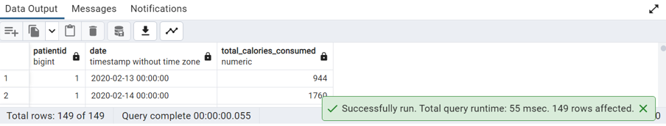

**71. Display the demographic details for the patient that had the maximum time below recommended blood glucose range**

**QUERY:**

| **WITH below_range_times AS (**  **SELECT**  **dc.patientid,**  **SUM(CASE WHEN dc.glucose_value_mgdl < 55 THEN 1 ELSE 0 END) AS time_below_range**  **FROM**  **dexcom dc**  **GROUP BY**  **dc.patientid**  **ORDER BY**  **dc.patientid**  **)**  **SELECT**  **d.patientid,**  **d.firstname,**  **d.lastname,**  **d.gender,**  **MAX(brt.time_below_range) AS max_time_in_below_range**  **FROM**  **below_range_times brt**  **JOIN**  **demographics d ON brt.patientid = d.patientid**  **GROUP BY d.patientid**  **ORDER BY max_time_in_below_range DESC**  **limit 1;** |
| --- |

**OUTPUT:**

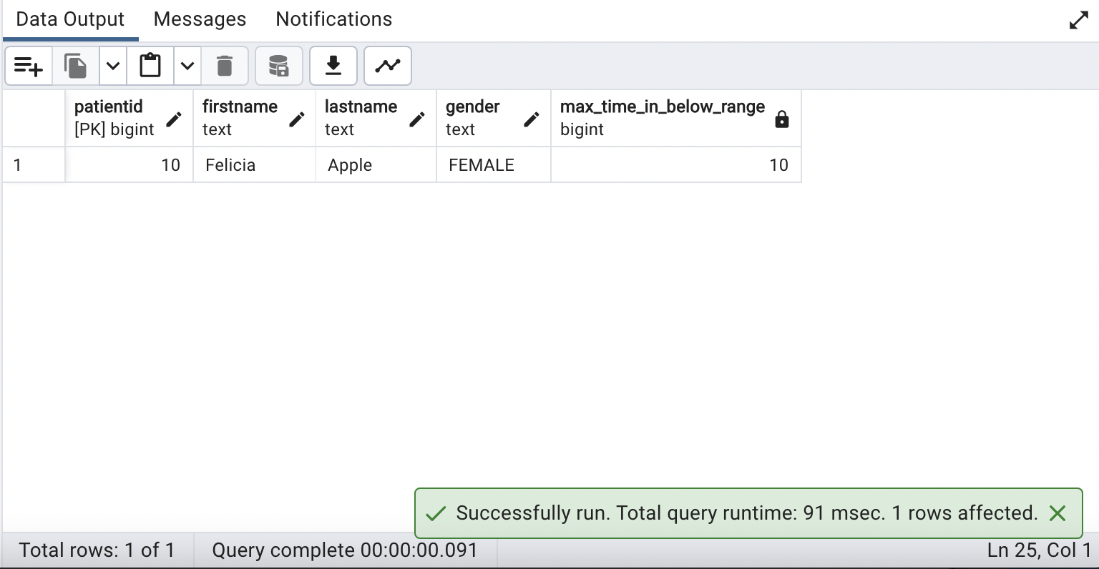

**72. How many patients have a minimum HR below the medically recommended level(ie, below 60)?**

**QUERY:**

| **SELECT COUNT(DISTINCT hr.patientid) AS patients_below_minimum_hr**  **FROM hr**  **JOIN**  **(**  **SELECT**  **patientid,**  **MAX(min_hr) AS min_heart_rate *--Considering the highest value of each patient mininum heart rate***  **FROM**  **hr**  **GROUP BY**  **patientid**  **) AS mhr ON hr.patientid = mhr.patientid**  **WHERE**  **min_heart_rate < 60;** |
| --- |

**OUTPUT:**

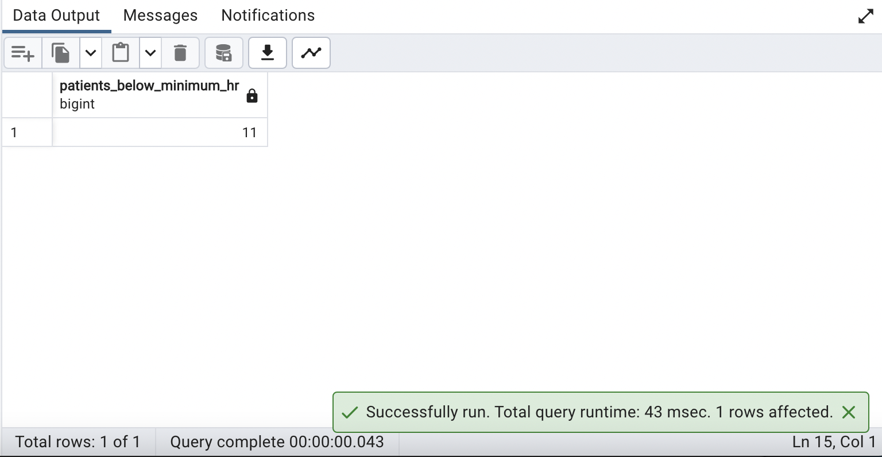

**73. Create a trigger to raise notice and prevent the deletion of a record from ‘Patient_Overview’.**

**QUERY:**

| ***--Create a function to handle the DELETE operation on the view:***  **CREATE FUNCTION prevent_delete_from_patient_overview()**  **RETURNS TRIGGER AS $$**  **BEGIN**  **RAISE NOTICE 'Deletion from Patient_Overview view is not allowed';**  **RETURN NULL;**  **END;**  **$$ LANGUAGE plpgsql;**  ***--Drop Function***  **DROP FUNCTION prevent_delete_from_patient_overview();**  ***--Create a trigger to call the function for DELETE operations on the view:***  **CREATE TRIGGER prevent_delete_trigger**  **INSTEAD OF DELETE ON Patient_Overview**  **FOR EACH ROW**  **EXECUTE FUNCTION prevent_delete_from_patient_overview();**  ***--This approach uses an INSTEAD OF DELETE trigger to call a function that raises a notice and returns NULL, effectively preventing the deletion from the view.***  ***--Drop a Trigger***  **DROP TRIGGER prevent_delete_trigger ON Patient_Overview;**  ***--Trying to delete a record from the view 'Patient_Overview'***  **DELETE FROM Patient_Overview**  **WHERE patientid=1;** |
| --- |

**OUTPUT:**

**Created Trigger:**

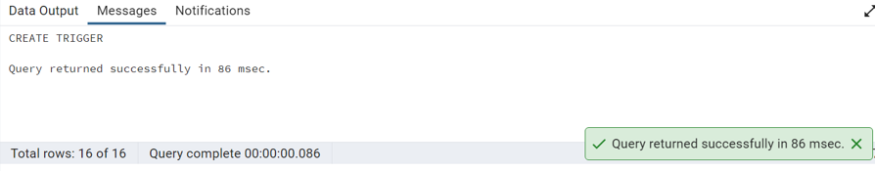

**Message When trigger executed (Deletion not allowed from ‘Patient_Overview) :**

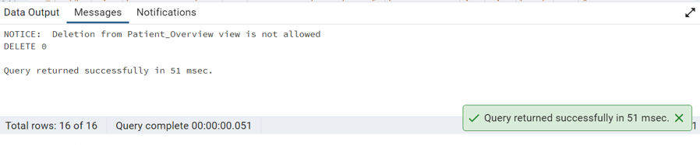

**74. What is the average heart rate, age and gender of the every patient in the dataset?**

**QUERY:**

| **SELECT**  **d.patientid,**  **ROUND(AVG(hr.mean_hr)) AS average_heart_rate,**  **EXTRACT(YEAR FROM AGE(NOW(), d.dob)) AS age,**  **d.gender**  **FROM**  **demographics d**  **JOIN**  **hr ON d.patientid = hr.patientid**  **GROUP BY**  **d.patientid**  **ORDER BY**  **d.patientid;** |
| --- |

**OUTPUT:**

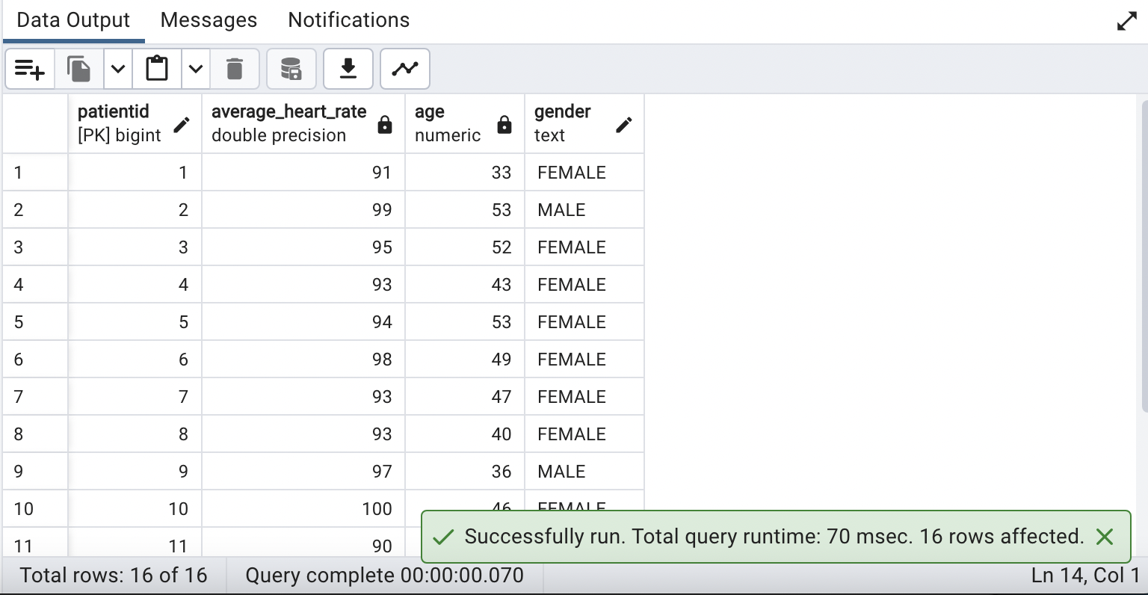

**75. What is the daily total calories consumed by every patient?**

**QUERY:**

| **SELECT**  **patientid,**  **DATE_TRUNC('day', datetime) AS date,**  **SUM(calorie) AS Total_calories_consumed *--Sum function to calculate total calories per day for each patient***  **FROM**  **foodlog**  **GROUP BY**  **patientid,DATE_TRUNC('day', datetime)**  **ORDER BY**  **patientid,date;** |
| --- |

**OUTPUT:**

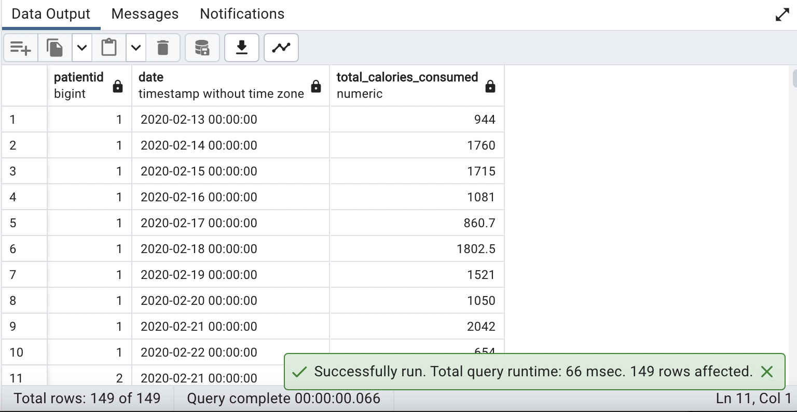

**76. Write a query to classify max EDA into 5 categories and display the number of patients in each category.**

**QUERY:**

| **SELECT**  **CASE**  **WHEN max_eda BETWEEN 0 AND 0.2 THEN 'VERY LOW'**  **WHEN max_eda BETWEEN 0.2 AND 0.4 THEN 'LOW'**  **WHEN max_eda BETWEEN 0.4 AND 0.6 THEN 'MEDIUM'**  **WHEN max_eda BETWEEN 0.6 AND 0.8 THEN 'HIGH'**  **ELSE 'VERY HIGH'**  **END AS max_eda_category,**  **COUNT(patientid) AS number_of_patients**  **FROM**  **eda**  **GROUP BY**  **max_eda_category;** |
| --- |

**OUTPUT:**

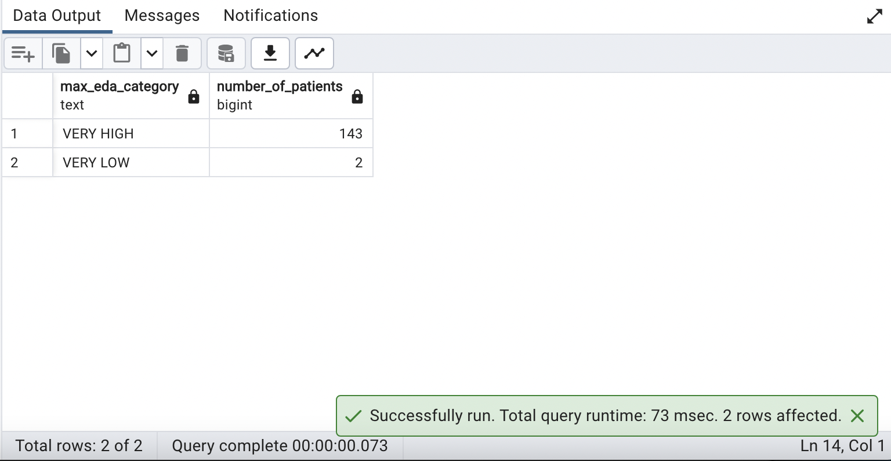

**77. List the daily max HR for patient with event type Exercise.**

**QUERY:**

| **SELECT**  **hr.patientid,**  **MAX(hr.max_hr) AS max_heart_rate, *--MAX function to retrieve the maximum heart rate***  **DATE_TRUNC('day', hr.datestamp) AS date**  **FROM hr**  **JOIN**  **dexcom dc ON hr.patientid=dc.patientid**  **WHERE**  **dc.eventid = 16 *--eventid is 16 for event type Excercise***  **GROUP BY**  **hr.patientid, DATE_TRUNC('day', hr.datestamp)**  **ORDER BY**  **hr.patientid, DATE_TRUNC('day', hr.datestamp);** |
| --- |

**OUTPUT:**

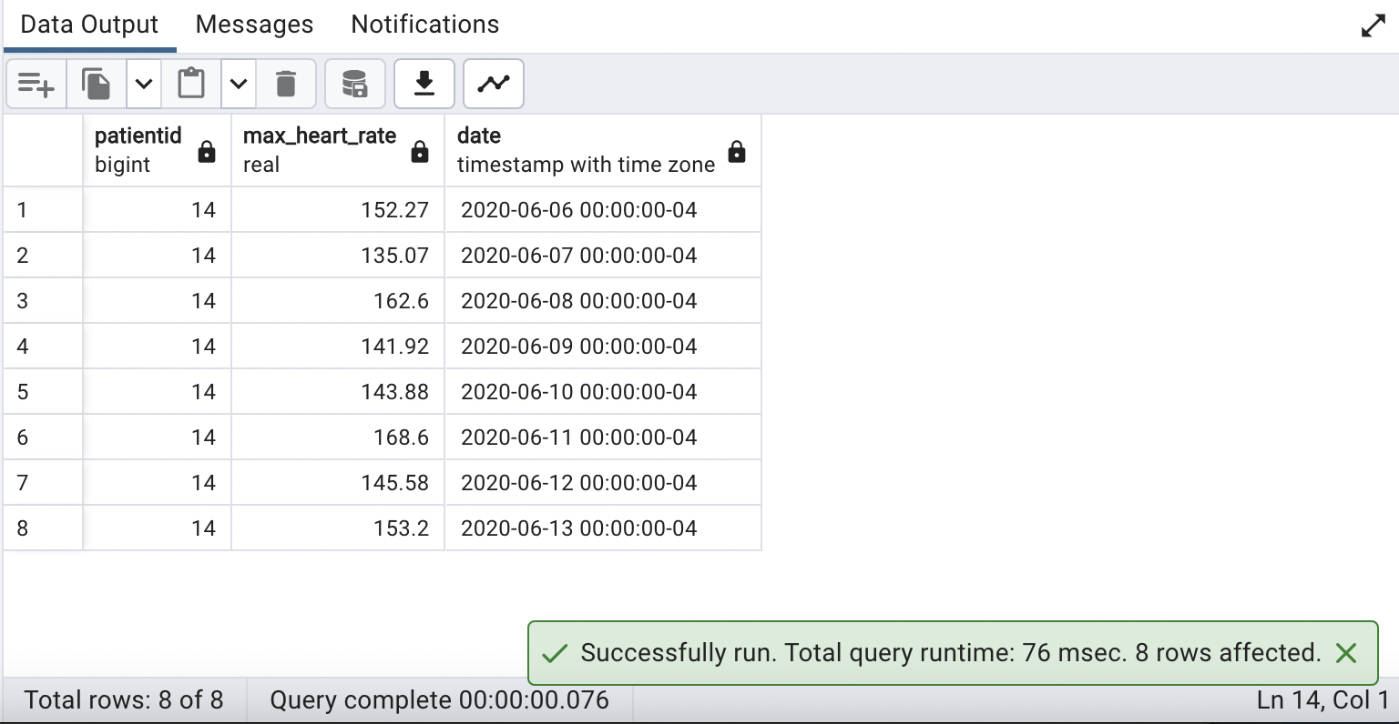

**78. What is the standard deviation from mean for all patients for the table HR?**

**QUERY:**

| **SELECT d.patientid,STDDEV(hr.mean_hr) AS standard_deviation *--STDDEV function to calculate standard deviation***  **FROM demographics d**  **JOIN hr ON d.patientid=hr.patientid**  **GROUP BY d.patientid**  **ORDER BY d.patientid; *--Gives the Patients ID in ascending order*** |
| --- |

**OUTPUT:**

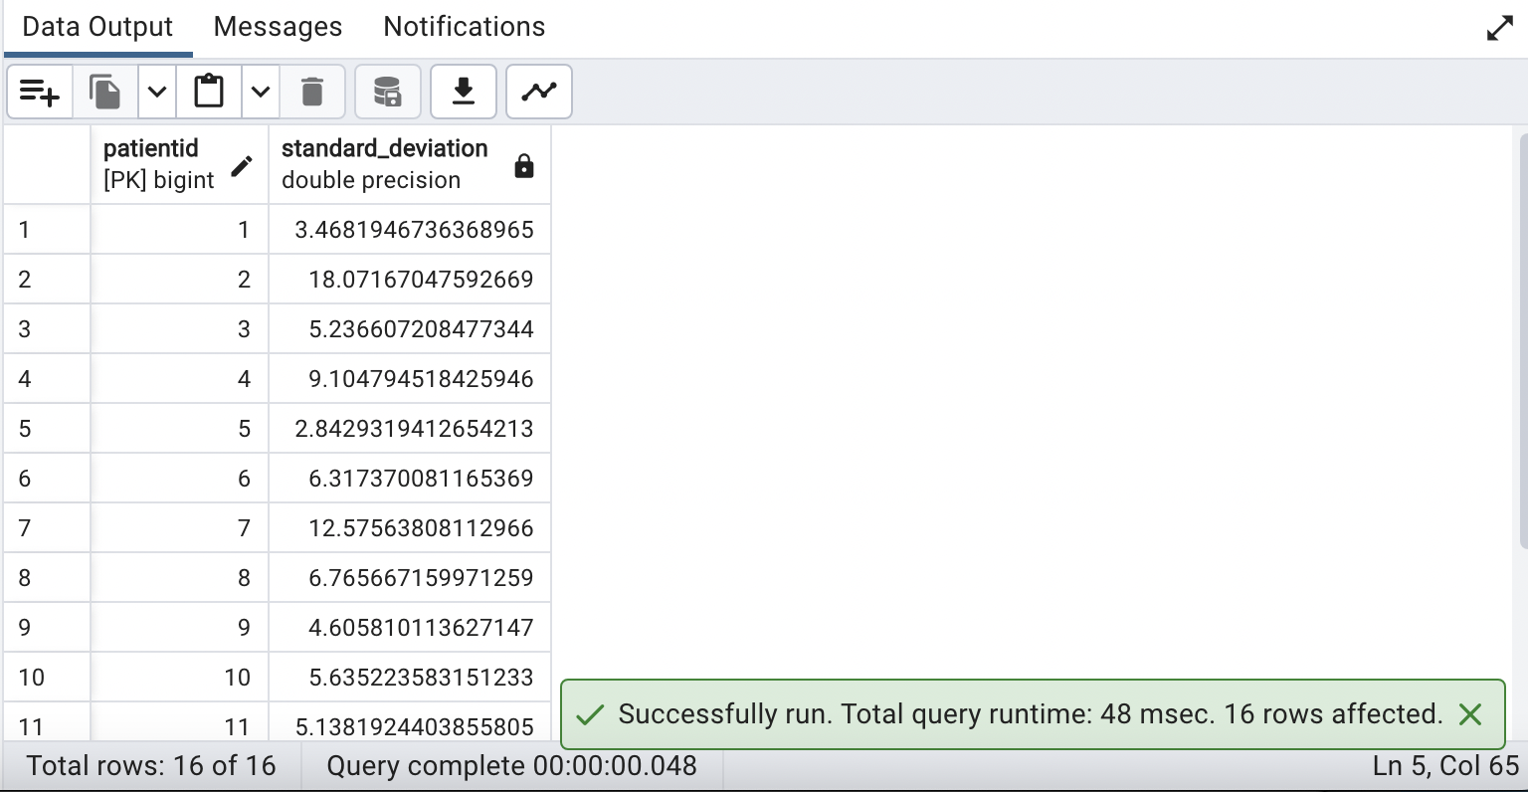

**79. Give the demographic details of the patient with event type ID of 16.**

**QUERY:**

| **SELECT distinct(d.patientid),d.gender,d.dob,d.firstname,d.lastname**  **FROM**  **demographics d**  **JOIN**  **dexcom dc ON d.patientid = dc.patientid**  **WHERE**  **dc.eventid = 16; *--Filtering patients with event type is equal to 16.*** |
| --- |

**OUTPUT:**

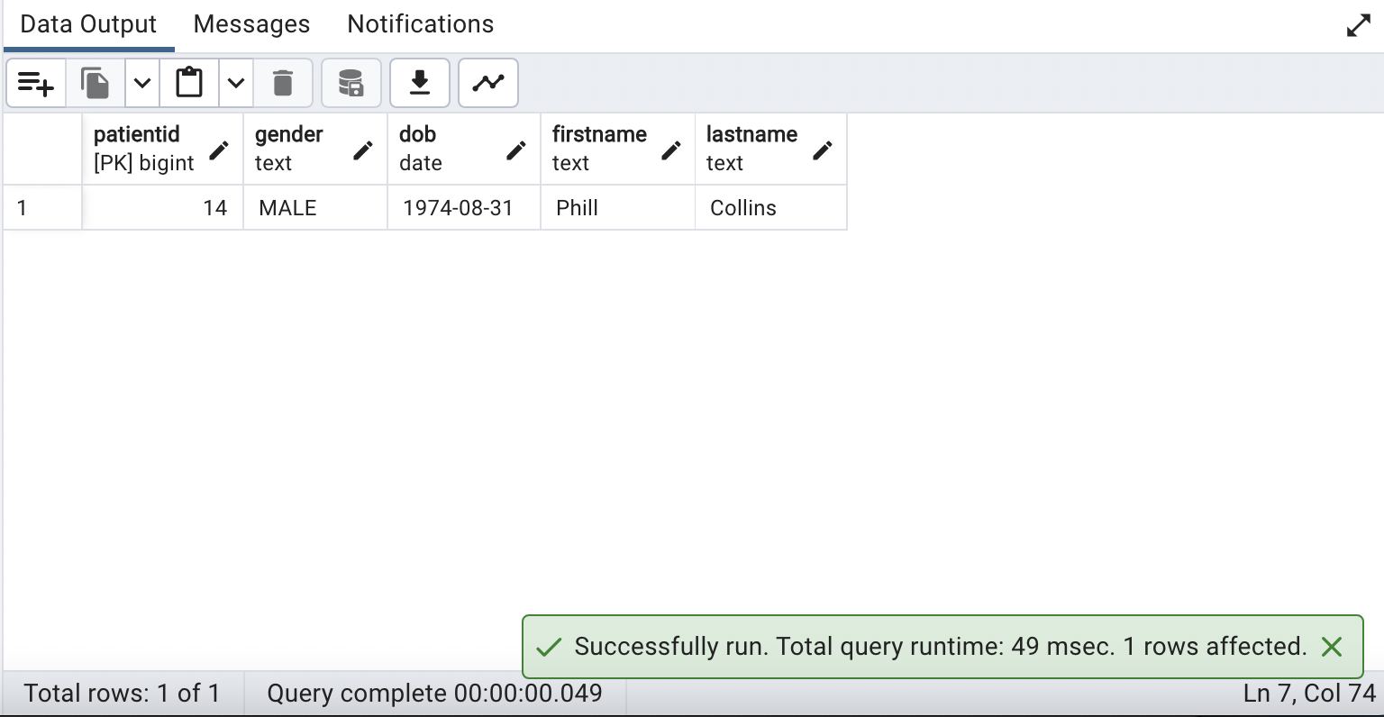

**80. Display list of patients along with their gender having a tachycardia mean HR.**

**QUERY:**

| **SELECT d.patientid,d.gender, AVG(hr.mean_hr) AS Tachycardia_mean_HR**  **FROM demographics d JOIN hr ON d.patientid = hr.patientid**  **GROUP BY d.patientid**  **HAVING**  **AVG(hr.mean_hr) > 100; *--Tachycardiais the medical term for a heart rate over 100 beats a minute.*** |
| --- |

**OUTPUT:**

